# PRACTICAL NO: 01

**Q) Create a website of your name that shows your information..(**[**https://localhost/Username**](https://localhost/Username)**)**

**DESIGN:**

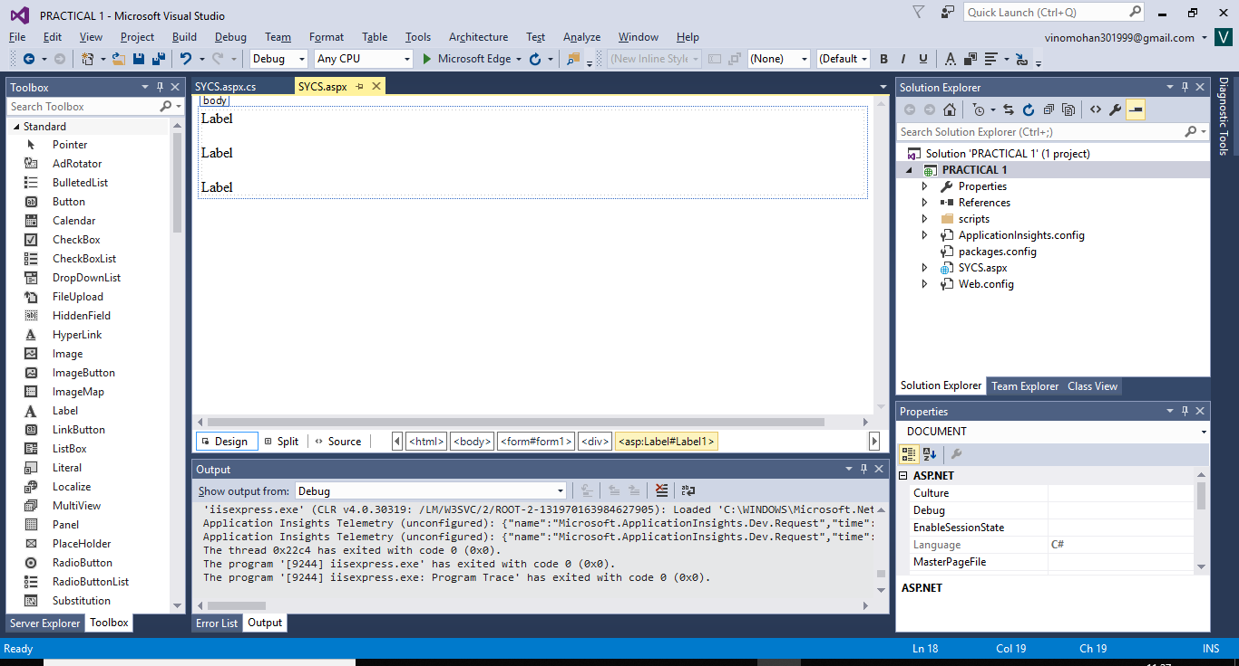

**WebForm.aspx:**

<%@ Page Language="C#" AutoEventWireup="true" CodeBehind="SYCS.aspx.cs" Inherits="PRACTICAL_1.SYCS" %>

<!DOCTYPE html>

<html xmlns="http://www.w3.org/1999/xhtml">

<head runat="server">

<title></title>

</head>

<body>

<form id="form1" runat="server">

<div>

<asp:Label ID="Label1" runat="server" Text="Label"></asp:Label>

&nbsp;&nbsp;&nbsp;&nbsp;&nbsp;&nbsp;&nbsp;

<br />

<br />

<asp:Label ID="Label2" runat="server" Text="Label"></asp:Label>

&nbsp;&nbsp;&nbsp;&nbsp;&nbsp;&nbsp;&nbsp;

<br />

<br />

<asp:Label ID="Label3" runat="server" Text="Label"></asp:Label>

&nbsp;&nbsp;&nbsp;&nbsp;&nbsp;&nbsp;&nbsp;&nbsp;&nbsp;

</div>

</form>

</body>

</html>

**WebForm.aspx.cs:**

using System;

using System.Collections.Generic;

using System.Linq;

using System.Web;

using System.Web.UI;

using System.Web.UI.WebControls;

namespace PRACTICAL_1

{

public partial class SYCS : System.Web.UI.Page

{

protected void Page_Load(object sender, EventArgs e)

{

Label1.Text = "Name : SYCS ";

Label2.Text = "ADDRESS : ANDHERI ";

Label3.Text = "PASSWORD : BHAVANS ";

}

}

}

**OUTPUT:**

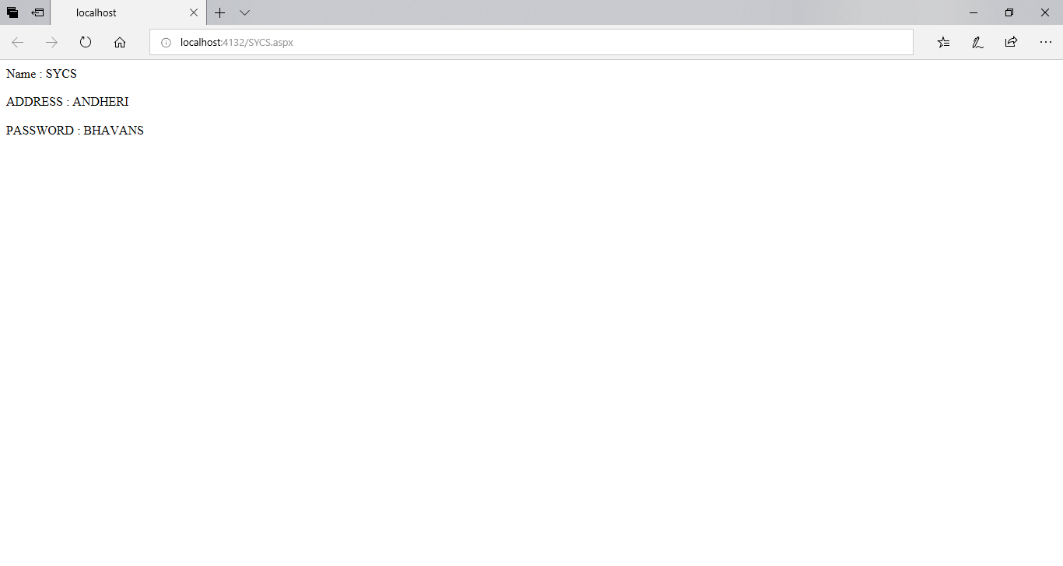

# PRATICAL No: 02

**Q) Implement a Basic Calculator [without using functions]**

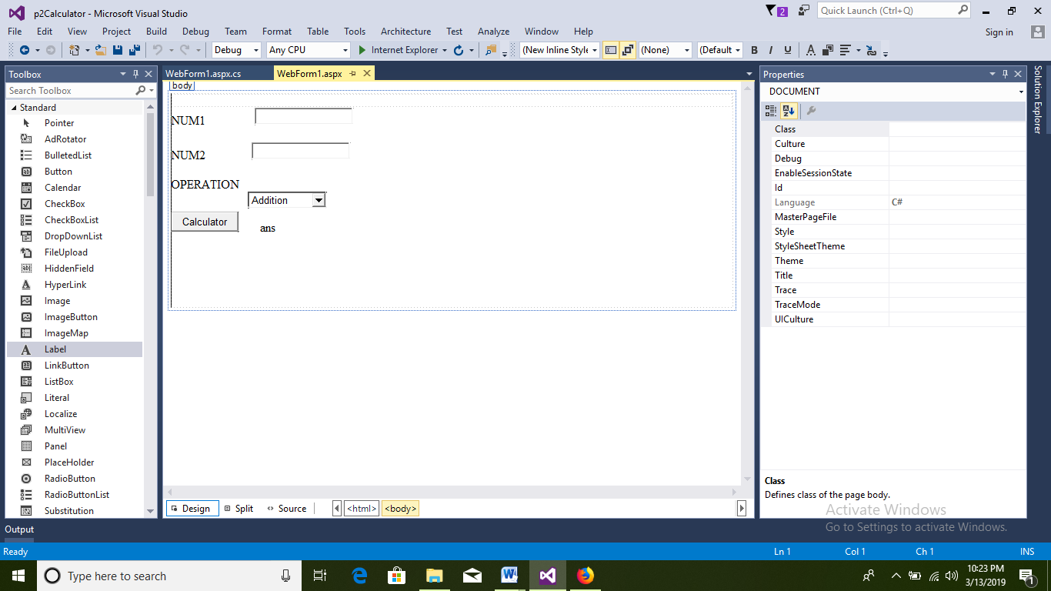**.**

**Webform.aspx**

<%@PageLanguage="C#"AutoEventWireup="true"CodeBehind="WebForm1.aspx.cs"Inherits="p2Calculator.WebForm1"%>

<!DOCTYPEhtml>

<htmlxmlns="http://www.w3.org/1999/xhtml">

<headrunat="server">

<title></title>

</head>

<body>

<formid="form1"runat="server">

<div>

</div>

<asp:LabelID="Label1"runat="server"Text="NUM1"></asp:Label>

<asp:TextBoxID="TextBox1"runat="server"></asp:TextBox>

<br/>

<br/>

<asp:LabelID="Label2"runat="server"Text="NUM2"></asp:Label>

<asp:TextBoxID="TextBox2"runat="server"OnTextChanged="TextBox2_TextChanged"></asp:TextBox>

<asp:LabelID="Label3"runat="server"Text="OPERATION"></asp:Label>

<br/>

<asp:ListBoxID="ListBox1"runat="server"Rows="1">

<asp:ListItem>Addition</asp:ListItem>

<asp:ListItem>Subtraction</asp:ListItem>

<asp:ListItem>Multiplication</asp:ListItem>

<asp:ListItem>Division</asp:ListItem>

</asp:ListBox>

<br/>

<asp:ButtonID="Button1"runat="server"OnClick="Button1_Click"Text="Calculator"/>

<asp:LabelID="Label4"runat="server"Text="ans"></asp:Label>

<p>

</p>

</form>

</body>

</html>

**Webform.aspx.cs**

using System;

usingSystem.Collections.Generic;

usingSystem.Linq;

usingSystem.Web;

usingSystem.Web.UI;

usingSystem.Web.UI.WebControls;

namespace p2Calculator

{

publicpartialclassWebForm1 : System.Web.UI.Page

{

protectedvoidPage_Load(object sender, EventArgs e)

{

}

protectedvoid TextBox2_TextChanged(object sender, EventArgs e)

{

}

protectedvoid Button1_Click(object sender, EventArgs e)

{

double num1, num2, ans;

num1 = Convert.ToDouble(TextBox1.Text);

num2 = Convert.ToDouble(TextBox2.Text);

if (ListBox1.SelectedIndex==0) {

Label4.Text = Convert.ToString(num1 + num2);

}

elseif (ListBox1.SelectedIndex == 1)

{

Label4.Text = Convert.ToString(num1 - num2);

}

elseif (ListBox1.SelectedIndex == 2)

{

Label4.Text = Convert.ToString(num1 * num2);

}

elseif (ListBox1.SelectedIndex == 3)

{

Label4.Text = Convert.ToString(num1 / num2);

}

}

}

}

**OUTPUT:**

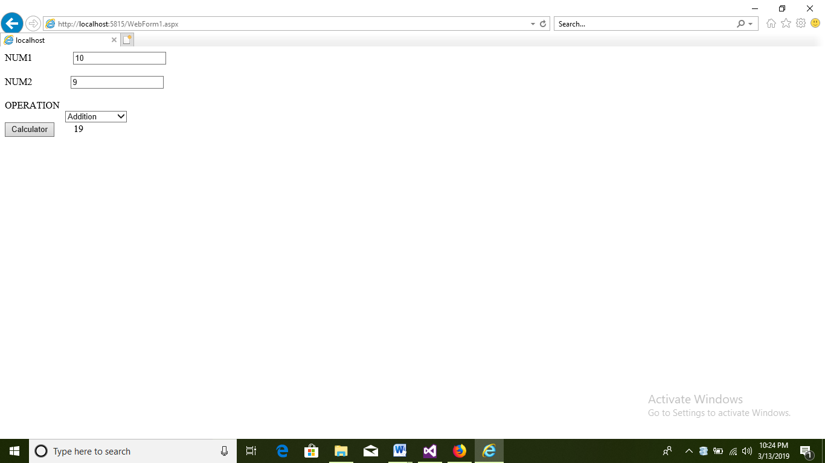

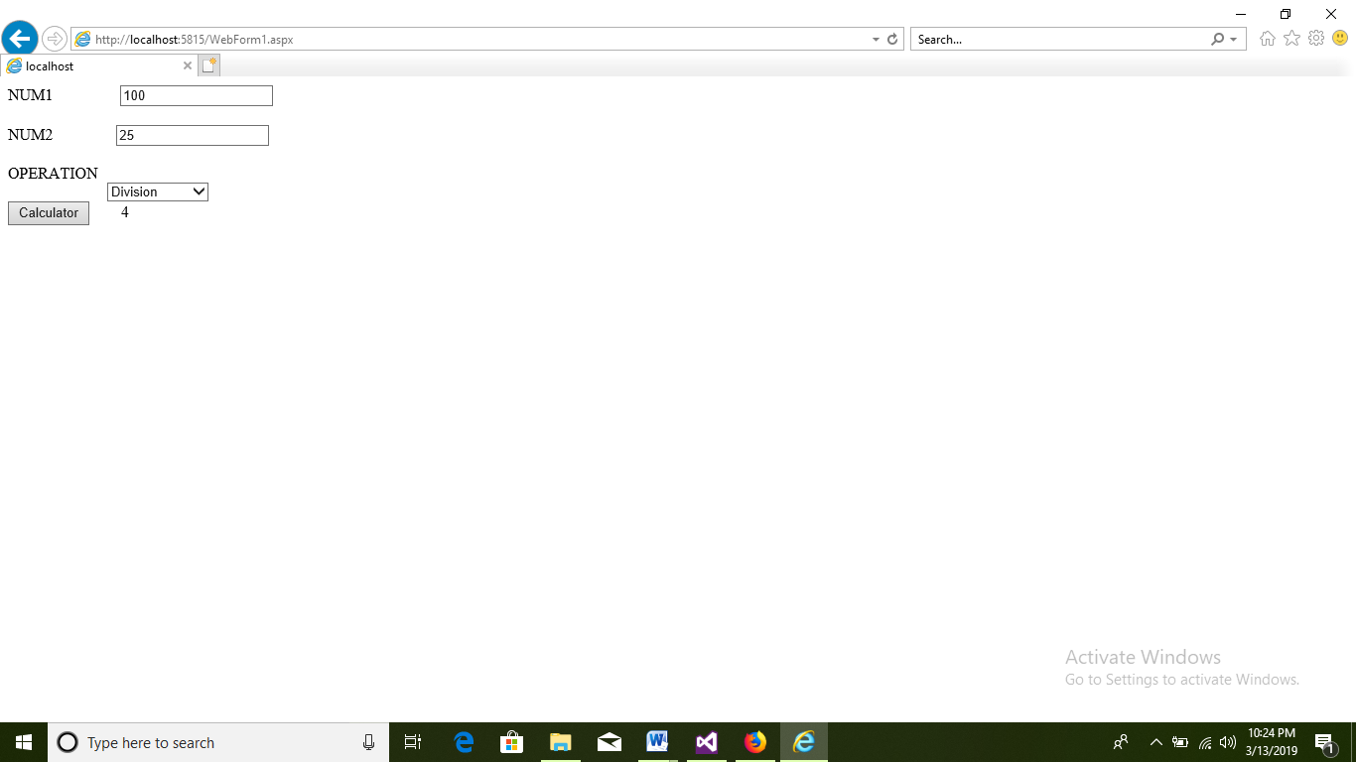

# PRACTICAL NO: 03

**Q) A software company wants to conduct placements for graduates in Mumbai or Pune. Design a web form to input student details such as name using textbox, course name such as BSc Comp Sci/IT/Phy/Maths using radio button, Marks in SSC,HSC, FY & SY along with Year of Passing using text boxes & Location such as Mumbai/Pune using combo box. The student is shortlisted only if he/she has min 60% in SSC & HSC, FY & SY average should be min 55% & there should not be any gap in education. When student clicks on Register button, the data is submitted to ASP.NET page which informs the student whether he/she qualifies and place of interview in Mumbai or Pune as given by the student.**

**Design page**

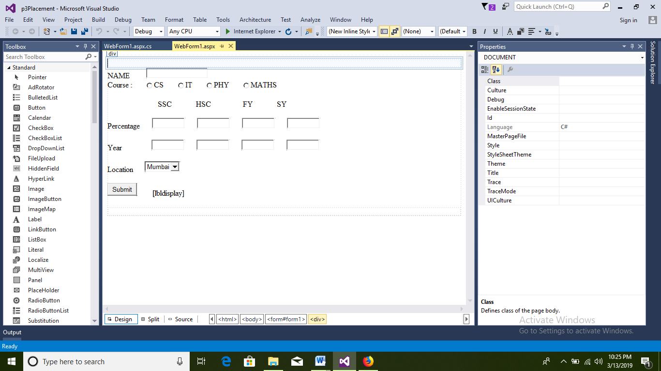

**Webform.aspx**

<%@PageLanguage="C#"AutoEventWireup="true"CodeBehind="WebForm1.aspx.cs"Inherits="p3Placement.WebForm1"%>

<!DOCTYPEhtml>

<htmlxmlns="http://www.w3.org/1999/xhtml">

<headrunat="server">

<title></title>

</head>

<body>

<formid="form1"runat="server">

<div>

</div>

<asp:LabelID="Label1"runat="server"Text="NAME"></asp:Label>

<asp:TextBoxID="name"runat="server"style="margin-left: 30px"></asp:TextBox>

<br/>

<asp:LabelID="Label9"runat="server"Text="Course :"></asp:Label>

<asp:RadioButtonID="rcs"Text="CS"runat="server"style="margin-left: 25px"GroupName="rb"/>

<asp:RadioButtonID="rit"Text="IT"runat="server"style="margin-left: 25px"GroupName="rb"/>

<asp:RadioButtonID="rphy"Text="PHY"runat="server"style="margin-left: 25px"GroupName="rb"/>

<asp:RadioButtonID="rmaths"Text="MATHS"runat="server"style="margin-left: 25px"GroupName="rb"/>

<asp:LabelID="Label2"runat="server"Text="SSC"style="margin-left: 60px"></asp:Label>

<asp:LabelID="Label5"runat="server"Text="HSC"style="margin-left: 50px"></asp:Label>

<asp:LabelID="Label6"runat="server"Text="FY"style="margin-left: 50px"></asp:Label>

<asp:LabelID="Label7"runat="server"Text="SY"style="margin-left: 50px"></asp:Label>

<br/

<asp:LabelID="Label3"runat="server"Text="Percentage"></asp:Label>

<asp:TextBoxID="txtssc"runat="server"Width="60px"style="margin-left: 25px"></asp:TextBox>

<asp:TextBoxID="txthsc"runat="server"Width="60px"style="margin-left: 25px"></asp:TextBox>

<asp:TextBoxID="txtfy"runat="server"Width="60px"style="margin-left: 25px"></asp:TextBox>

<asp:TextBoxID="txtsy"runat="server"Width="60px"style="margin-left: 25px"></asp:TextBox>

<br/>

<br/>

<asp:LabelID="year"runat="server"Text="Year"></asp:Label>

<asp:TextBoxID="ssc_y"runat="server"Width="60px"style="margin-left: 25px"></asp:TextBox>

<asp:TextBoxID="hsc_y"runat="server"Width="60px"style="margin-left: 25px"></asp:TextBox>

<asp:TextBoxID="fy_y"runat="server"Width="60px"style="margin-left: 25px"></asp:TextBox>

<asp:TextBoxID="sy_y"runat="server"Width="60px"style="margin-left: 25px"></asp:TextBox>

<br/>

<br/>

<asp:LabelID="loc"runat="server"Text="Location"></asp:Label>

<asp:DropDownListID="DropDownList1"runat="server">

<asp:ListItem>Mumbai</asp:ListItem>

<asp:ListItem>Pune</asp:ListItem>

</asp:DropDownList>

<br/>

<br/>

<asp:ButtonID="Button1"runat="server"Text="Submit"OnClick="Button1_Click"/>

<asp:LabelID="lbldisplay"runat="server"></asp:Label>

<br/>

</form>

</body>

</html>

**Webform.aspx.cs**

using System;

usingSystem.Collections.Generic;

usingSystem.Linq;

usingSystem.Web;

usingSystem.Web.UI;

usingSystem.Web.UI.WebControls;

namespace p3Placement

{

publicpartialclassWebForm1 : System.Web.UI.Page

{

protectedvoid Button1_Click(object sender, EventArgs e)

{

Doublefy_m, sy_m, ssc_m, hsc_m, av1, av2, fy_yr, sy_yr, ssc_yr, hsc_yr;

ssc_m =Convert.ToDouble(txtssc.Text);

hsc_m = Convert.ToDouble(txthsc.Text);

fy_m = Convert.ToDouble(txtfy.Text);

sy_m = Convert.ToDouble(txtsy.Text);

ssc_yr = Convert.ToDouble(ssc_y.Text);

hsc_yr = Convert.ToDouble(hsc_y.Text);

fy_yr = Convert.ToDouble(fy_y.Text);

sy_yr = Convert.ToDouble(sy_y.Text);

av1 = (ssc_m + hsc_m) / 2;

av2= (fy_m + sy_m) / 2;

if(av1>=60 && av2>=55 &&(hsc_yr-ssc_yr==2) && (sy_yr-fy_yr==1) && (fy_yr-hsc_yr==1))

{

lbldisplay.Text = "You are qualified for placement";

}

else

{

lbldisplay.Text = "You are not qualified for placement";

}

}

}

}

**OUTPUT:**

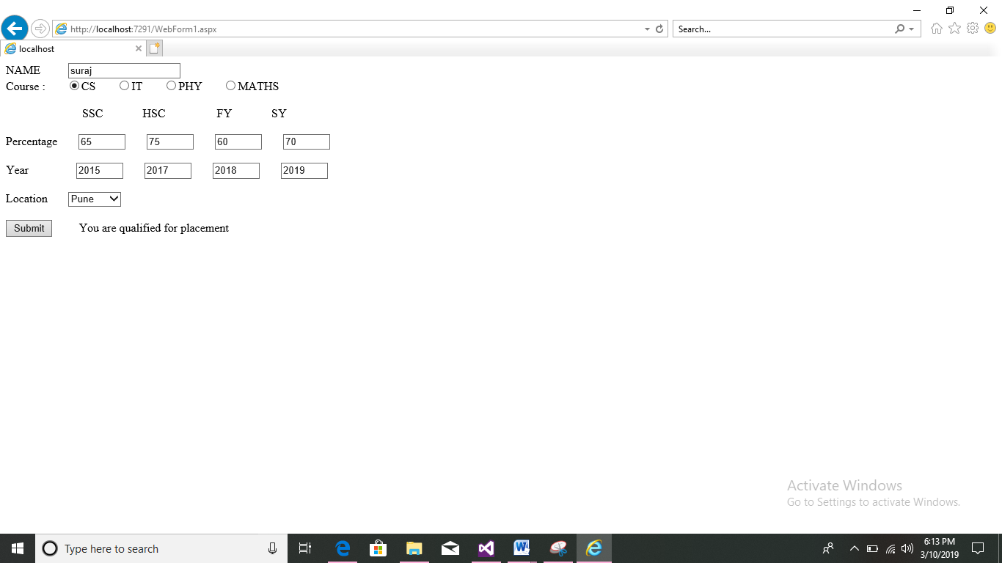

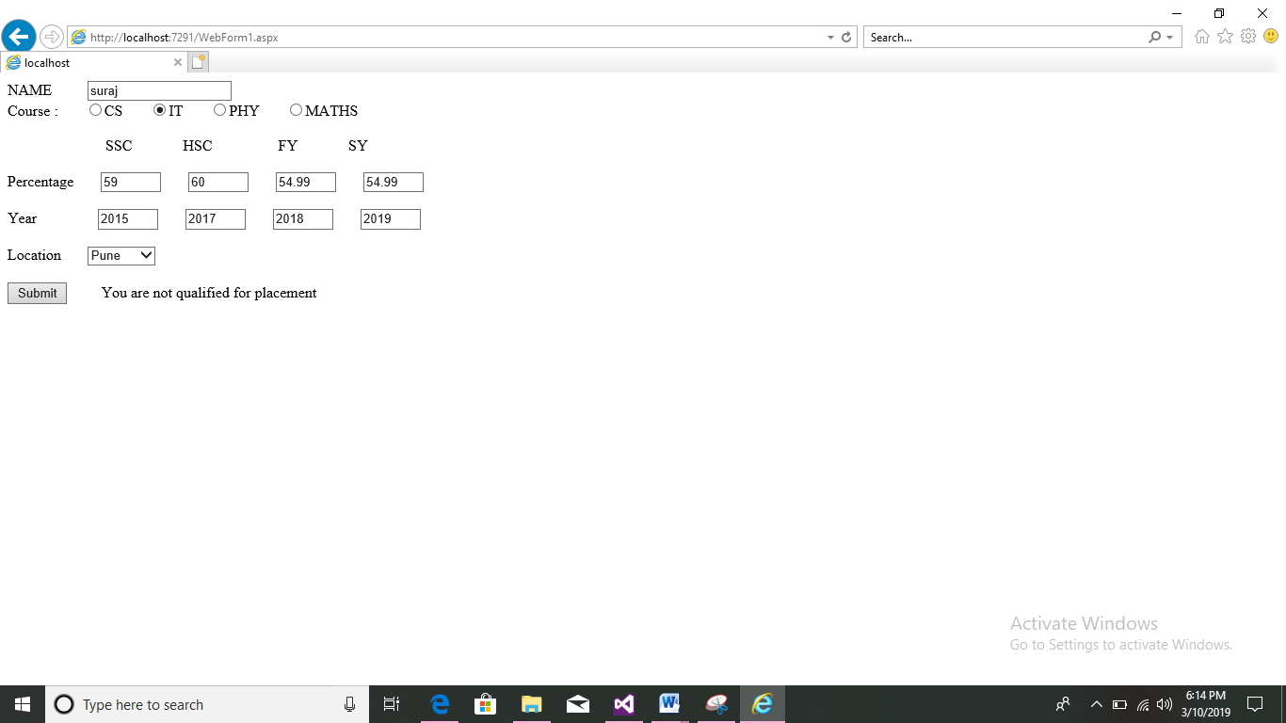

# PRACTICAL NO:04

**Q) Design a Login Form containing User Name and password. The password should contain max 8 characters. When user name and password matches with predefined values, a welcome message should be displayed otherwise error message should be displayed. Maximum 3 attempts should be allowed for wrong passwords otherwise the application should end [Use If]**

**Design:**

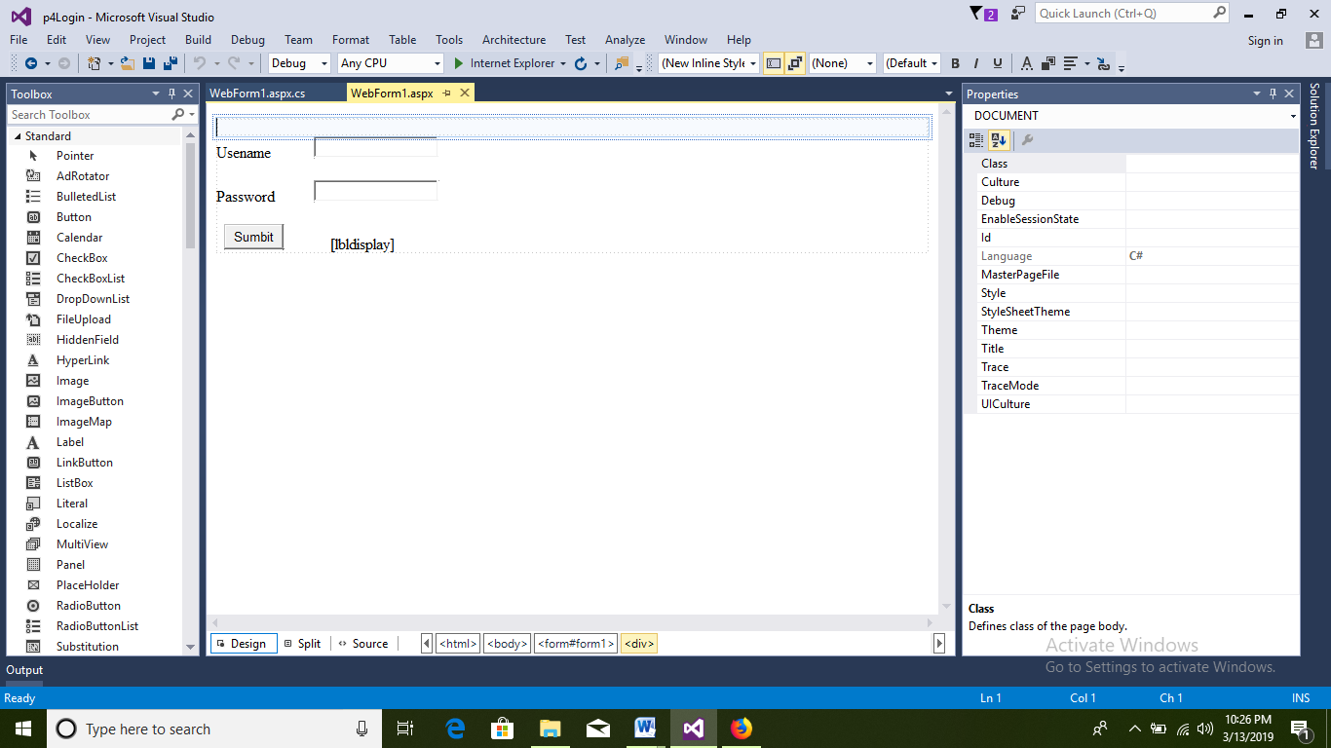

<%@PageLanguage="C#"AutoEventWireup="true"CodeBehind="WebForm1.aspx.cs"Inherits="p4Login.WebForm1"%>

<!DOCTYPEhtml>

<htmlxmlns="http://www.w3.org/1999/xhtml">

<headrunat="server">

<title></title>

</head>

<body>

<formid="form1"runat="server">

<div>

</div>

<asp:LabelID="Label1"runat="server"Text="Usename"></asp:Label>

<asp:TextBoxID="txtuser"runat="server"></asp:TextBox>

<br/>

<br/>

<asp:LabelID="Label2"runat="server"Text="Password"></asp:Label>

<asp:TextBoxID="txtpass"runat="server"></asp:TextBox>

<br/>

<br/>

<asp:ButtonID="btnlogin"runat="server"OnClick="Button1_Click"Text="Sumbit"/>

<asp:LabelID="lbldisplay"runat="server"></asp:Label>

<br/>

</form>

</body>

</html>

**Webform.aspx.cs**

using System;

usingSystem.Collections.Generic;

usingSystem.Linq;

usingSystem.Web;

usingSystem.Web.UI;

usingSystem.Web.UI.WebControls;

namespace p4Login

{

publicpartialclassWebForm1 : System.Web.UI.Page

{

staticint count = 3;

String username, password, user, pass;

protectedvoid Button1_Click(object sender, EventArgs e)

{

username = "suraj006";

password = "sun12345";

user = txtuser.Text;

pass = txtpass.Text;

if (user.Equals(username) &&pass.Equals(password)){

lbldisplay.Text = "Login successful";

}

else{

count--;

if (count == 0) {

lbldisplay.Text = "maximum attempt reached";

ClientScript.RegisterStartupScript(typeof(p4Login.WebForm1), "closePage", "window.close();", true);

}

else

{

lbldisplay.Text = "incorrect details you have " + count + " attempt remains";

}

}

}

}

}

**OUTPUT:**

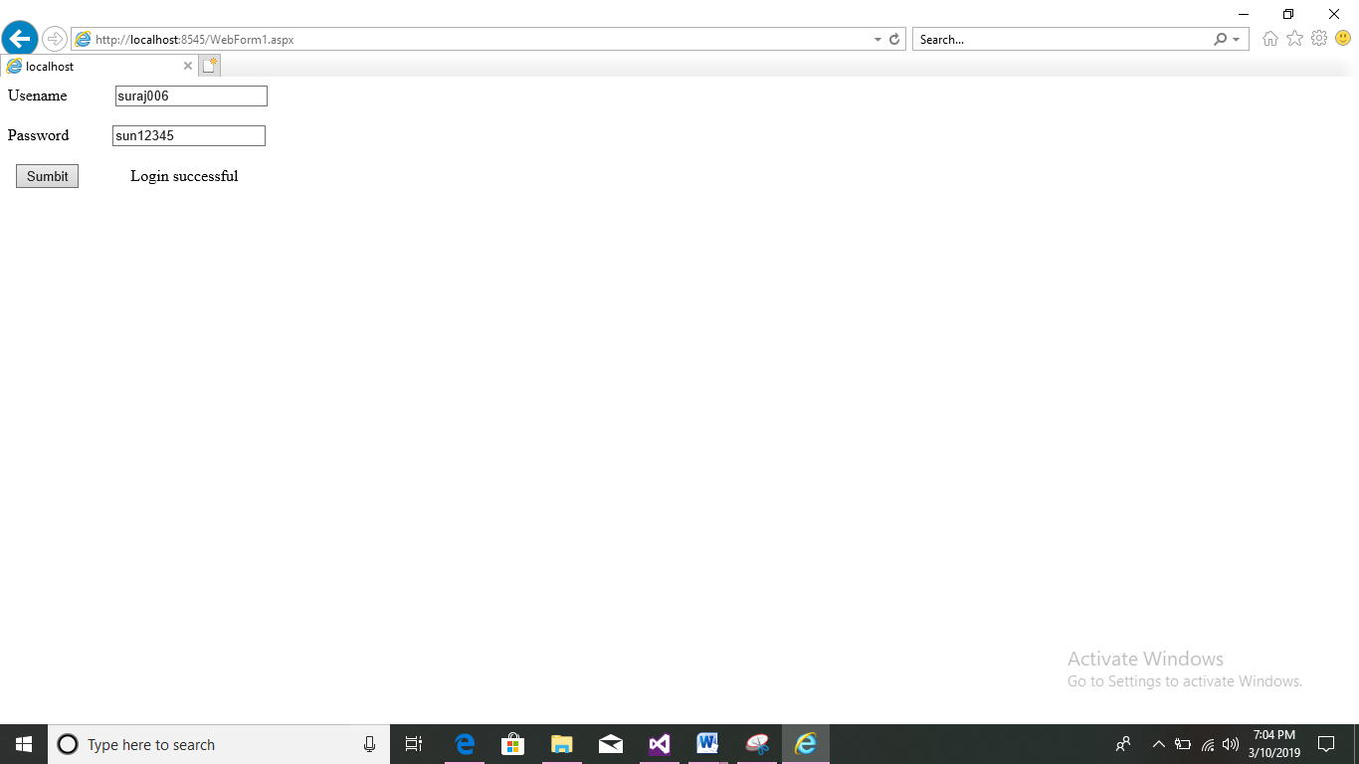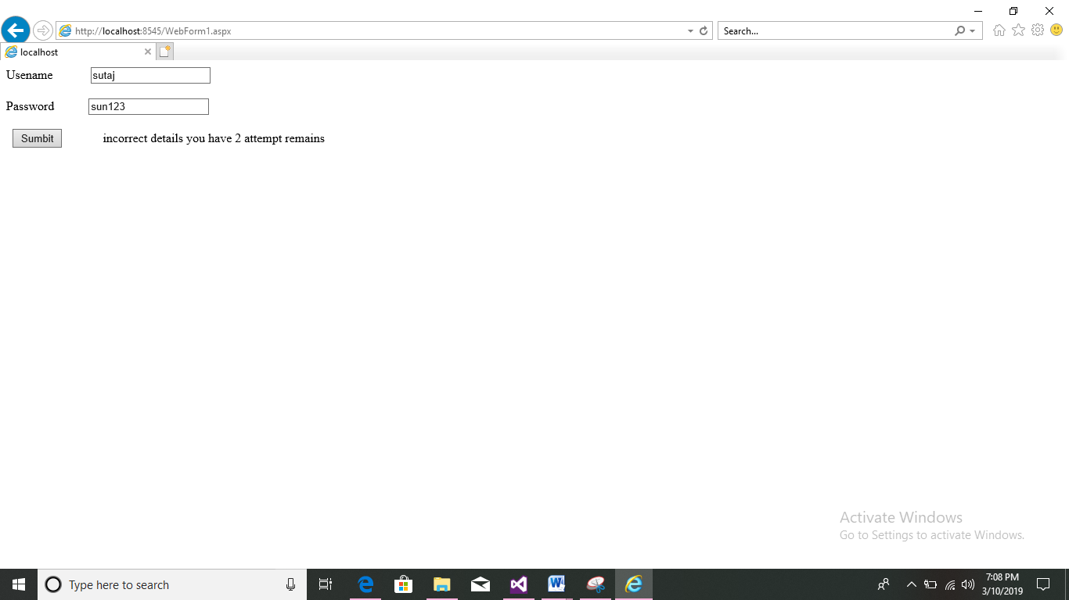 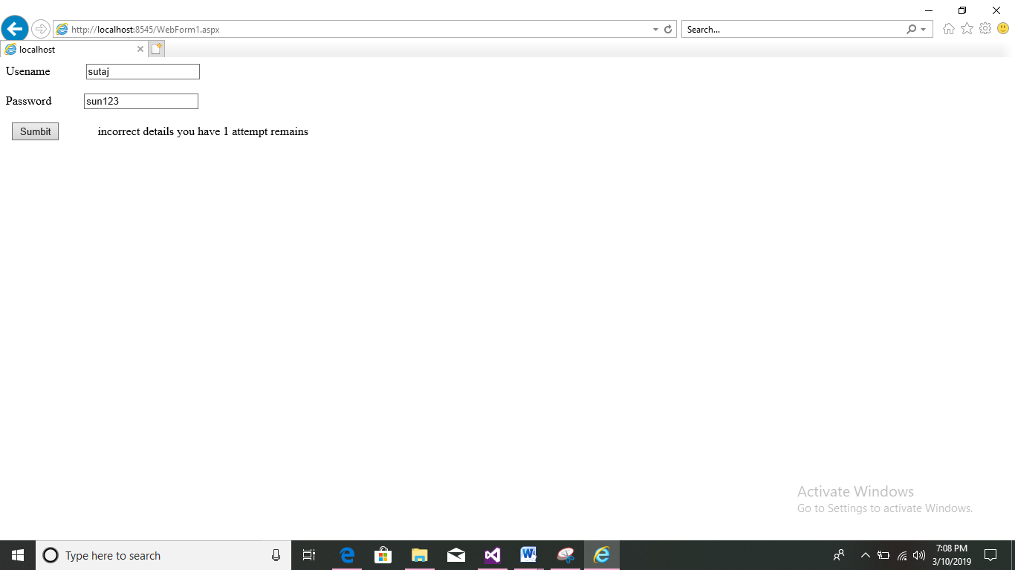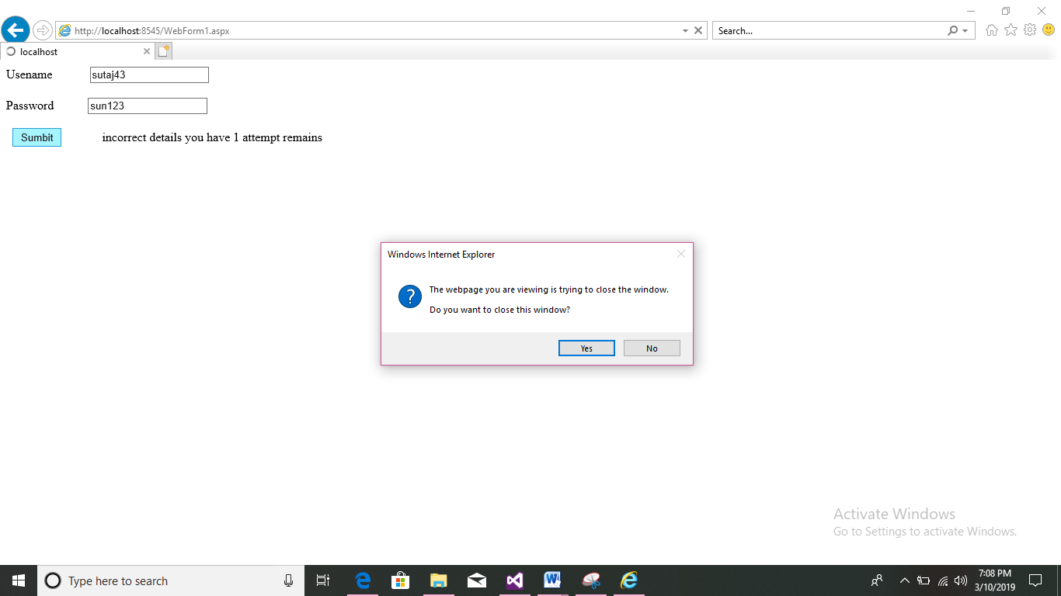

# PRACTICAL NO: 05

**Q.) Create a form that accepts 2 numbers from 2 text fields, an operation(+,-,*,/) from third text field. When you click “Result” button, the result of the expression should be displayed in 4rth disabled text-field. Include a radio button to choose whether the result should be integer or float. [use switch case]**

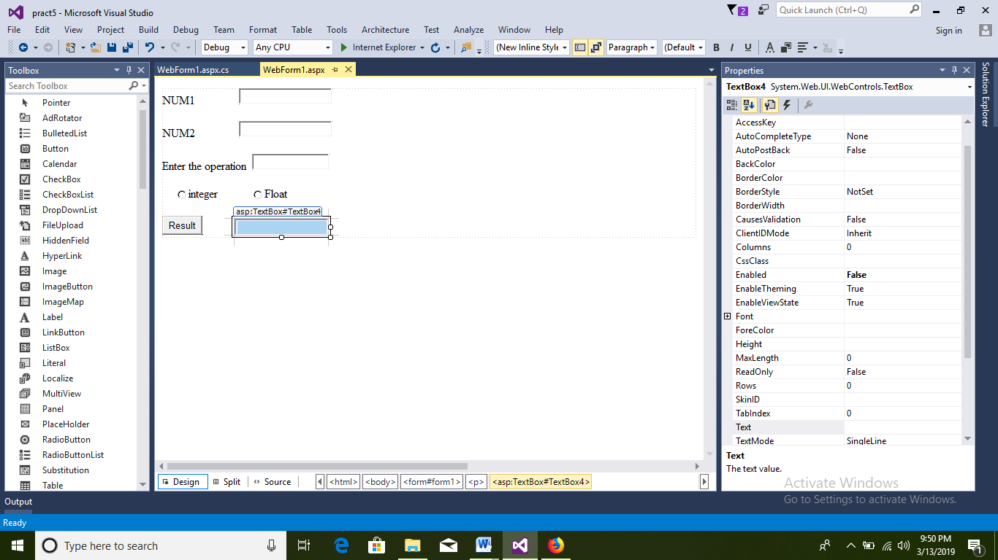Design

**Webform1.aspx**

<%@PageLanguage="C#"AutoEventWireup="true"CodeBehind="WebForm1.aspx.cs"Inherits="pract5.WebForm1"%>

<!DOCTYPEhtml>

<htmlxmlns="http://www.w3.org/1999/xhtml">

<headrunat="server">

<title></title>

</head>

<body>

<formid="form1"runat="server">

<div>

<asp:LabelID="Label1"runat="server"Text="NUM1"></asp:Label>

<asp:TextBoxID="TextBox1"runat="server"></asp:TextBox>

</div>

<p>

<asp:LabelID="Label2"runat="server"Text="NUM2"></asp:Label>

<asp:TextBoxID="TextBox2"runat="server"></asp:TextBox>

</p>

<p>

<asp:LabelID="Label3"runat="server"Text="Enter the operation"></asp:Label>

<asp:TextBoxID="TextBox3"runat="server"Width="98px"></asp:TextBox>

</p>

<p>

<asp:RadioButtonID="RadioButton1"runat="server"GroupName="rb1"TabIndex="1"Text="integer"/>

<asp:RadioButtonID="RadioButton2"runat="server"GroupName="rb1"TabIndex="2"Text="Float"/>

</p>

<p>

<asp:ButtonID="Button1"runat="server"OnClick="Button1_Click"Text="Result"/>

<asp:TextBoxID="TextBox4"runat="server"Enabled="False"></asp:TextBox>

</p>

</form>

</body>

</html>

**Webform1.aspx.cs**

using System;

usingSystem.Collections.Generic;

usingSystem.Linq;

usingSystem.Web;

usingSystem.Web.UI;

usingSystem.Web.UI.WebControls;

namespace pract5

{

publicpartialclassWebForm1 : System.Web.UI.Page

{

protectedvoid Button1_Click(object sender, EventArgs e)

{

double num1 = Convert.ToDouble(TextBox1.Text);

double num2 = Convert.ToDouble(TextBox2.Text);

if(RadioButton1.Checked)

{

if (TextBox3.Text=="+")

{

TextBox4.Enabled = true;

TextBox4.Text =(Convert.ToInt32(num1 + num2)).ToString();

}

elseif(TextBox3.Text=="-")

{

TextBox4.Enabled = true;

TextBox4.Text = (Convert.ToInt32(num1 - num2)).ToString();

}

elseif(TextBox3.Text=="*")

{

TextBox4.Enabled = true;

TextBox4.Text = (Convert.ToInt32(num1 * num2)).ToString();

}

elseif (TextBox3.Text=="/")

{

TextBox4.Enabled = true;

TextBox4.Text = (Convert.ToInt32(num1 / num2)).ToString();

}

}

elseif(RadioButton2.Checked)

{

if (TextBox3.Text == "+")

{

TextBox4.Enabled = true;

TextBox4.Text = (num1 + num2).ToString();

}

elseif (TextBox3.Text == "-")

{

TextBox4.Enabled = true;

TextBox4.Text = (num1 - num2).ToString();

}

elseif (TextBox3.Text == "*")

{

TextBox4.Enabled = true;

TextBox4.Text = (num1 * num2).ToString();

}

elseif (TextBox3.Text == "/")

{

TextBox4.Enabled = true;

TextBox4.Text = (num1 / num2).ToString();

}

}

}

}

}

**OUTPUT:**

**Disable textfield**

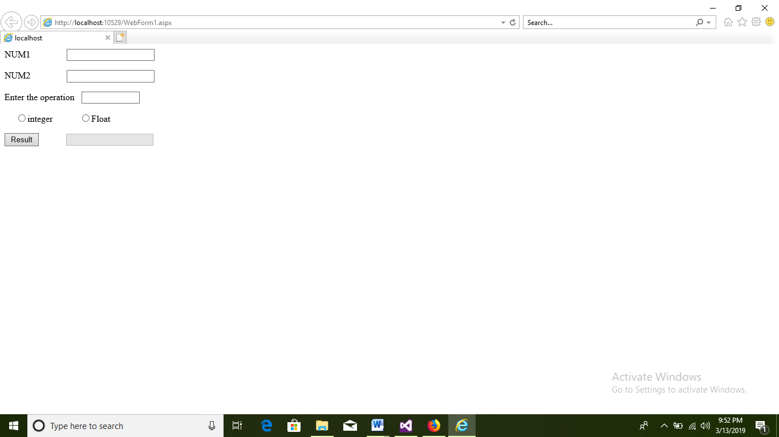

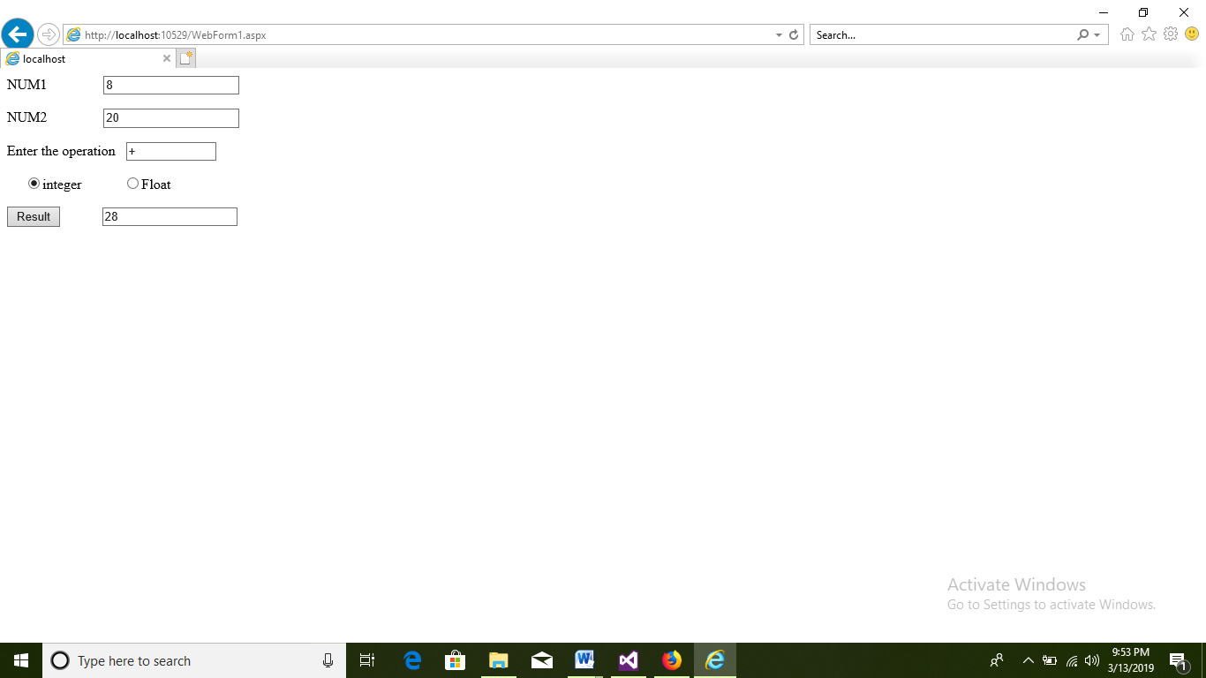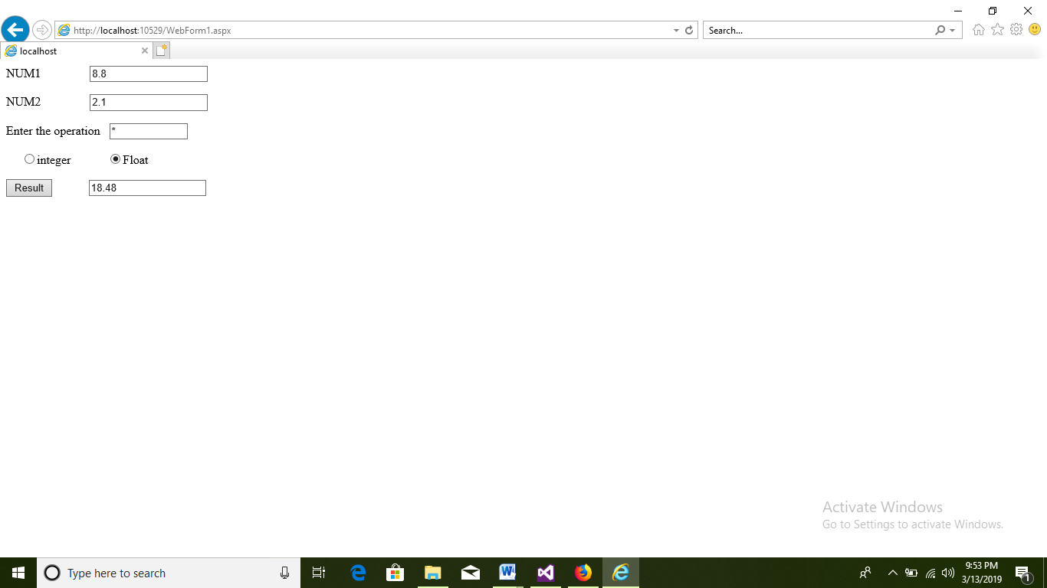

# PRACTICAL NO: 06

**Q) Implement a Basic Calculator [using Functions].**

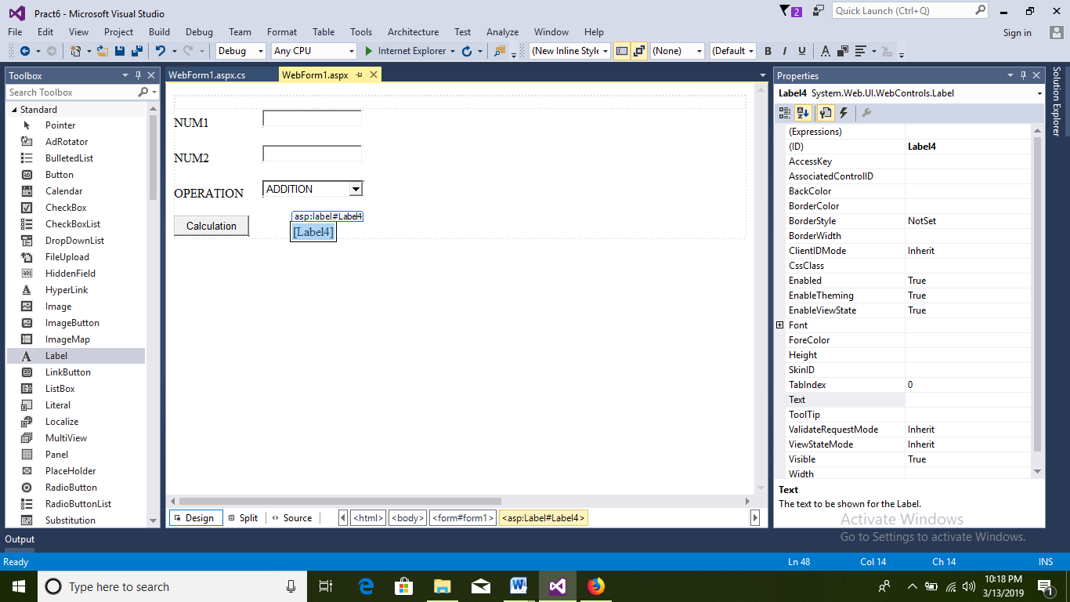

**Webform.aspx**

<%@PageLanguage="C#"AutoEventWireup="true"CodeBehind="WebForm1.aspx.cs"Inherits="Pract6.WebForm1"%>

<!DOCTYPEhtml>

<htmlxmlns="http://www.w3.org/1999/xhtml">

<headrunat="server">

<title></title>

</head>

<body>

<formid="form1"runat="server">

<div>

</div>

<asp:LabelID="Label1"runat="server"Text="NUM1"></asp:Label>

&nbsp;&nbsp;&nbsp;&nbsp;&nbsp;&nbsp;&nbsp;&nbsp;&nbsp;&nbsp;&nbsp;&nbsp;&nbsp;&nbsp;&nbsp;&nbsp;

<asp:TextBoxID="TextBox1"runat="server"></asp:TextBox>

<br/>

<br/>

<asp:LabelID="Label2"runat="server"Text="NUM2"></asp:Label>

&nbsp;&nbsp;&nbsp;&nbsp;&nbsp;&nbsp;&nbsp;&nbsp;&nbsp;&nbsp;&nbsp;&nbsp;&nbsp;&nbsp;&nbsp;&nbsp;

<asp:TextBoxID="TextBox2"runat="server"></asp:TextBox>

<br/>

<br/>

<asp:LabelID="Label3"runat="server"Text="OPERATION"></asp:Label>

&nbsp;&nbsp;&nbsp;&nbsp;&nbsp;

<asp:DropDownListID="DropDownList1"runat="server">

<asp:ListItem>ADDITION</asp:ListItem>

<asp:ListItem>SUBTRACTION</asp:ListItem>

<asp:ListItem>MULTIPLICATION</asp:ListItem>

<asp:ListItem>DIVISION</asp:ListItem>

</asp:DropDownList>

<br/>

<br/>

<asp:ButtonID="Button1"runat="server"OnClick="Button1_Click"Text="Calculation"/>

&nbsp;&nbsp;&nbsp;&nbsp;&nbsp;&nbsp;&nbsp;&nbsp;&nbsp;&nbsp;&nbsp;&nbsp;&nbsp;

<asp:LabelID="Label4"runat="server"></asp:Label>

</form>

</body>

</html>

**Webform.aspx.cs**

using System;

usingSystem.Collections.Generic;

usingSystem.Linq;

usingSystem.Web;

usingSystem.Web.UI;

usingSystem.Web.UI.WebControls;

namespace Pract6

{

publicpartialclassWebForm1 : System.Web.UI.Page

{

staticdouble num1, num2, result;

publicdouble add(double x, double y)

{

return (x + y);

}

publicdouble sub(double x, double y)

{

return(x-y);

}

publicdoublemul(double x, double y)

{

return (x * y);

}

publicdouble div(double x, double y)

{

return (x / y);

}

protectedvoidPage_Load(object sender, EventArgs e)

{

}

protectedvoid Button1_Click(object sender, EventArgs e)

{

num1 = Convert.ToDouble(TextBox1.Text);

num2 = Convert.ToDouble(TextBox2.Text);

if (DropDownList1.SelectedIndex==0)

{

result=add(num1, num2);

Label4.Text = "Addition is: " + result.ToString();

}

elseif(DropDownList1.SelectedIndex==1)

{

result = sub(num1, num2);

Label4.Text = "Subtraction is: " + result.ToString();

}

elseif(DropDownList1.SelectedIndex==2)

{

result = mul(num1, num2);

Label4.Text = "Multiplication is: " + result.ToString();

}

elseif(DropDownList1.SelectedIndex==3)

{

result = div(num1, num2);

Label4.Text = "division is: " + result.ToString();

}

}

}

}

**OUTPUT:**

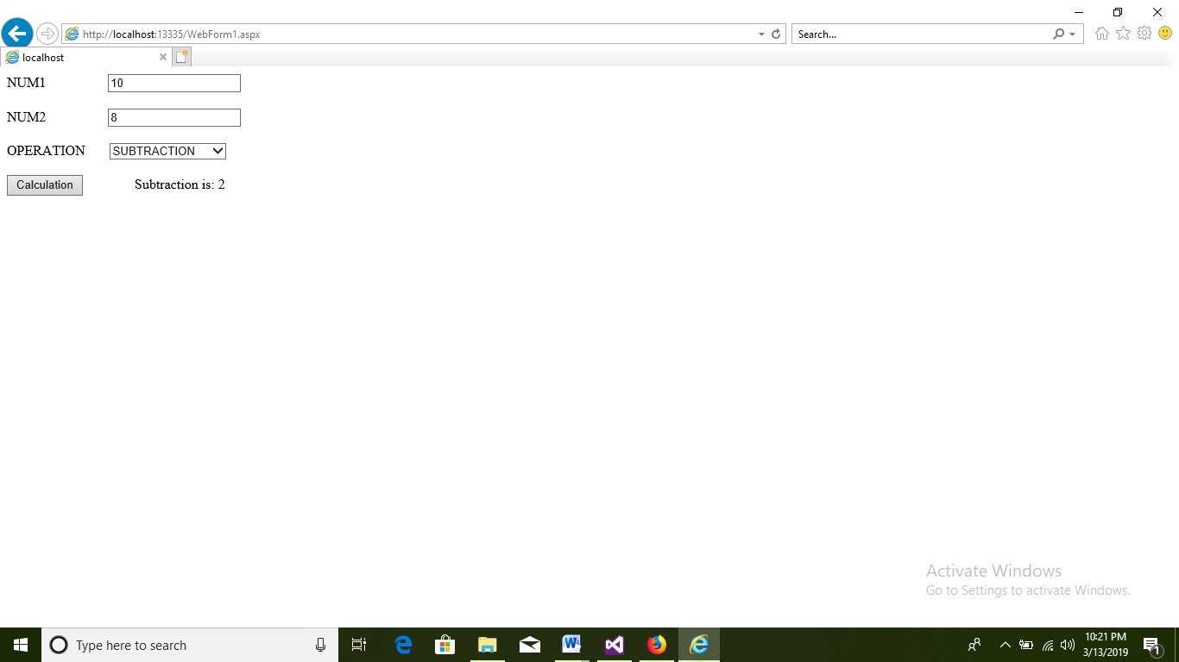

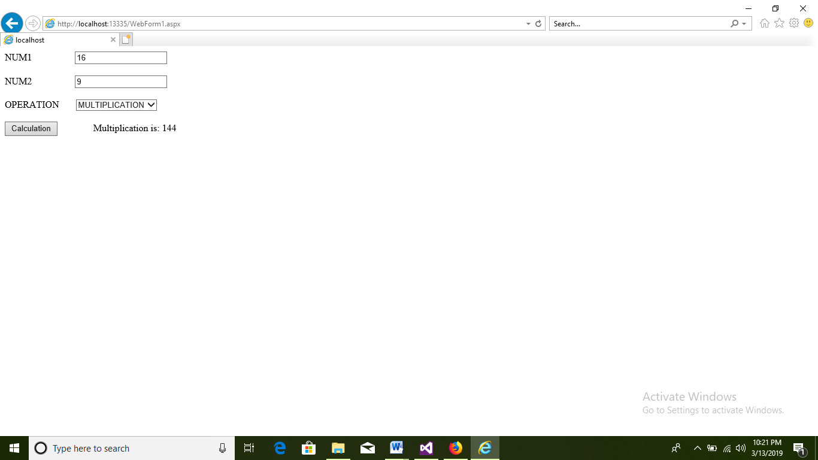

# PRACTICAL NO: 07

**Q) Create an ASP.Net project that accepts Principal Amount, No. Of Years, Rate Of Interest from 3 text fields. When you click on “Calculate Interest” button the data is send to a function that returns Simple Interest. When you click on ”Final Amount” button the final amount by adding principal amount & interest should be displayed.(Use Functions)**

**Design page**

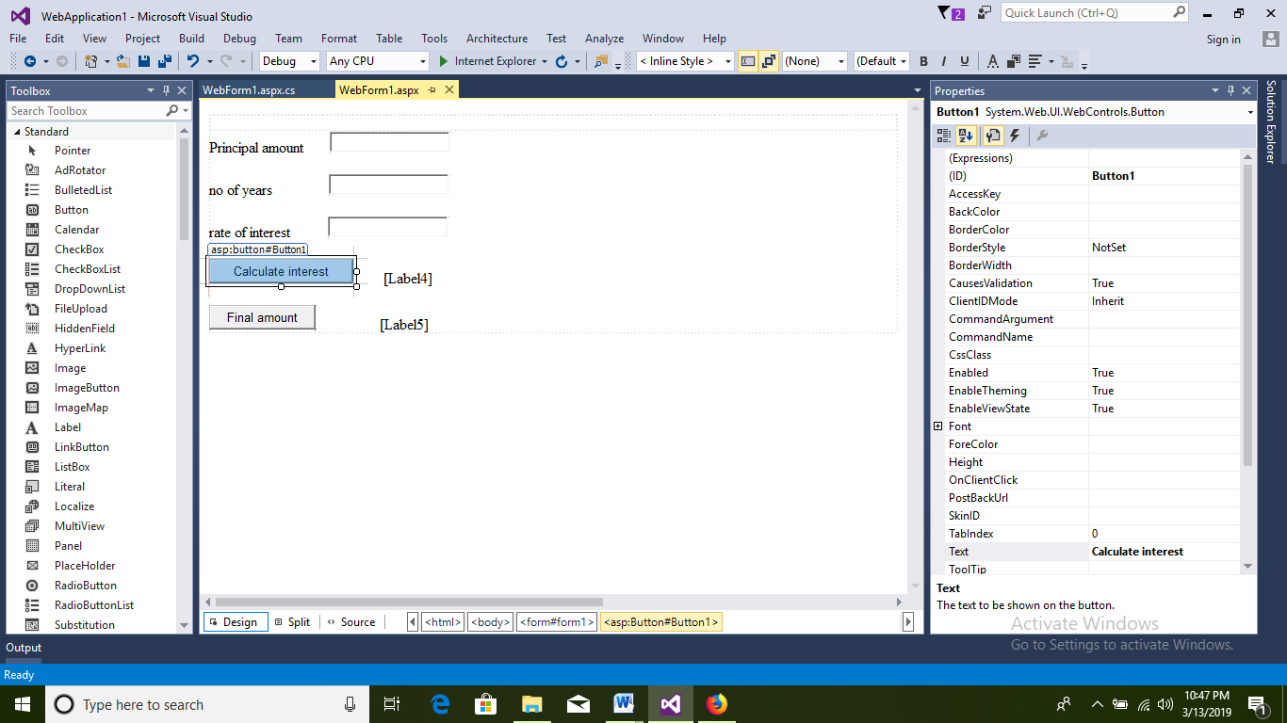

**Webform.aspx**

<%@PageLanguage="C#"AutoEventWireup="true"CodeBehind="WebForm1.aspx.cs"Inherits="WebApplication1.WebForm1"%>

<!DOCTYPEhtml>

<htmlxmlns="http://www.w3.org/1999/xhtml">

<headrunat="server">

<title></title>

</head>

<body>

<formid="form1"runat="server">

<div>

</div>

<asp:LabelID="Label1"runat="server"Text="Principal amount"></asp:Label>

&nbsp;&nbsp;&nbsp;&nbsp;&nbsp;&nbsp;

<asp:TextBoxID="TextBox1"runat="server"></asp:TextBox>

<br/>

<br/>

<asp:LabelID="Label2"runat="server"Text="no of years"></asp:Label>

&nbsp;&nbsp;&nbsp;&nbsp;&nbsp;&nbsp;&nbsp;&nbsp;&nbsp;&nbsp;&nbsp;&nbsp;&nbsp;&nbsp;

<asp:TextBoxID="TextBox2"runat="server"></asp:TextBox>

<br/>

<br/>

<asp:LabelID="Label3"runat="server"Text="rate of interest"></asp:Label>

&nbsp;&nbsp;&nbsp;&nbsp;&nbsp;&nbsp;&nbsp;&nbsp;&nbsp;

<asp:TextBoxID="TextBox3"runat="server"></asp:TextBox>

<br/>

<br/>

<asp:ButtonID="Button1"runat="server"OnClick="Button1_Click"style="height: 26px"Text="Calculate interest"/>

&nbsp;&nbsp;&nbsp;&nbsp;&nbsp;&nbsp;&nbsp;

<asp:LabelID="Label4"runat="server"></asp:Label>

<br/>

<br/>

<asp:ButtonID="Button2"runat="server"OnClick="Button2_Click"Text="Final amount"/>

&nbsp;&nbsp;&nbsp;&nbsp;&nbsp;&nbsp;&nbsp;&nbsp;&nbsp;&nbsp;&nbsp;&nbsp;&nbsp;&nbsp;&nbsp;&nbsp;

<asp:LabelID="Label5"runat="server"></asp:Label>

</form>

</body>

</html>

**Webform.aspx.cs**

using System;

usingSystem.Collections.Generic;

usingSystem.Linq;

usingSystem.Web;

usingSystem.Web.UI;

usingSystem.Web.UI.WebControls;

namespace WebApplication1

{

publicpartialclassWebForm1 : System.Web.UI.Page

{

staticdoublecal_interest, calculate, calculate1;

staticdouble p, r, n, final_amount;

publicdouble interest(double x, double y, double z)

{

cal_interest = x * y * z / 100;

returncal_interest;

}

publicdouble final(double x, double interest)

{

final_amount = x + interest;

returnfinal_amount;

}

protectedvoid Button1_Click(object sender, EventArgs e)

{

p = double.Parse(TextBox1.Text);

n = double.Parse(TextBox2.Text);

r = double.Parse(TextBox3.Text);

calculate = interest(p, r, n);

Label4.Text = calculate + "";

}

protectedvoid Button2_Click(object sender, EventArgs e)

{

calculate1 = final(p, calculate);

Label5.Text = calculate1 + "";

}

}

}

**OUTPUT:**

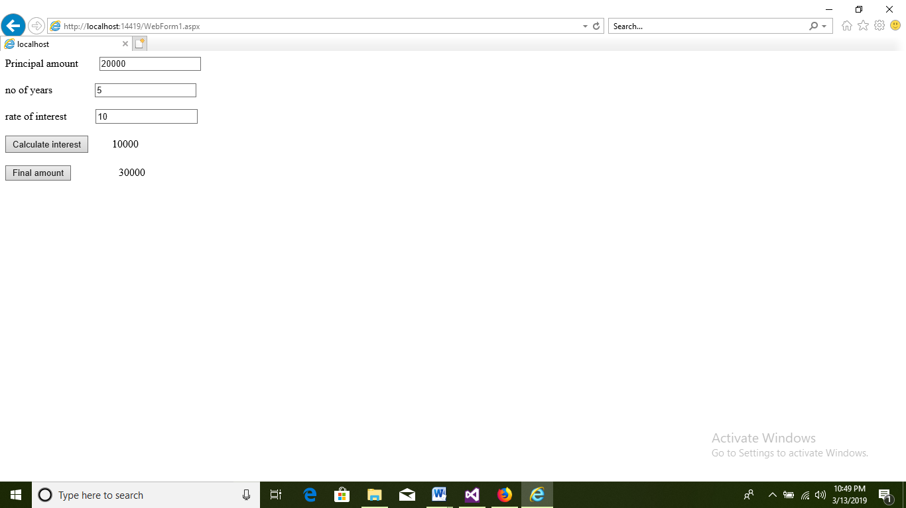

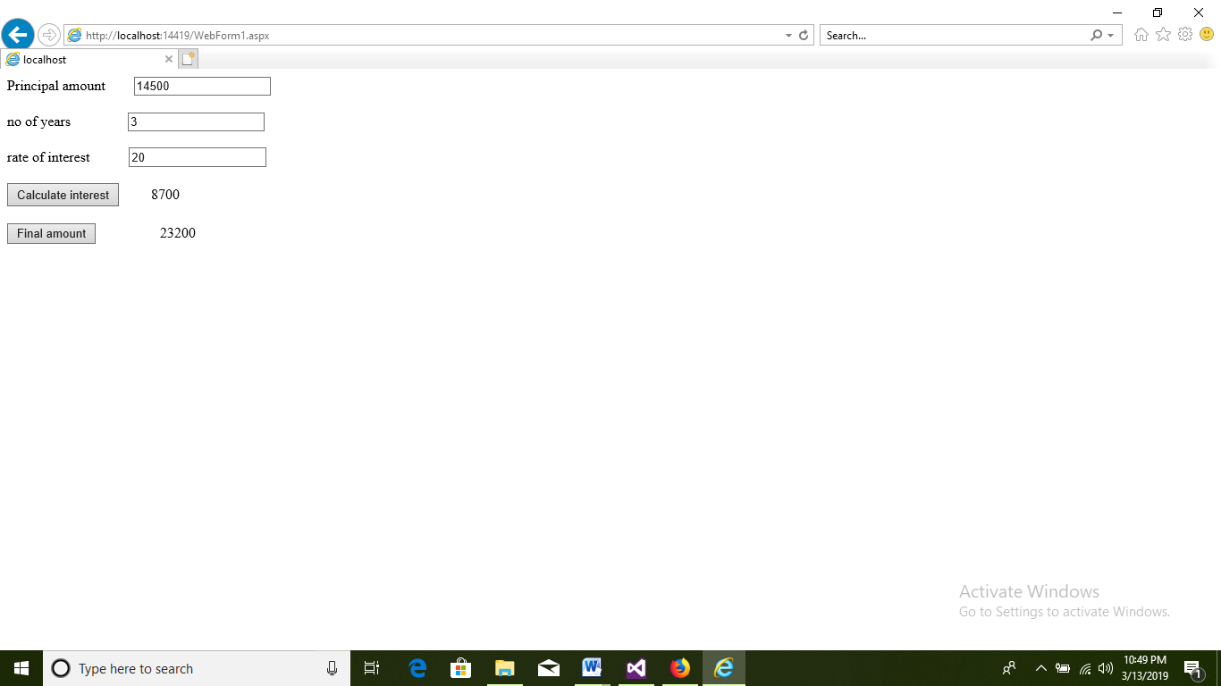

# PRACTICAL NO: 08

**Q) Create a Reservation Form for Mumbai-to-Pune Journey containing 3 text fields to enter names, 3 text fields to enter age, & a text field to show Final Bill. It should also contain a radio button showing the type of journey (A.C./Non A.C.). Charges of A.C./Non A.C. modes of journey are fixed but only for child with age < 5 & senior citizen with age > 60 the rates are half. 4% service charges are applied on Final Amount. As per the passenger enter the Final Bill.**

**Design page:**

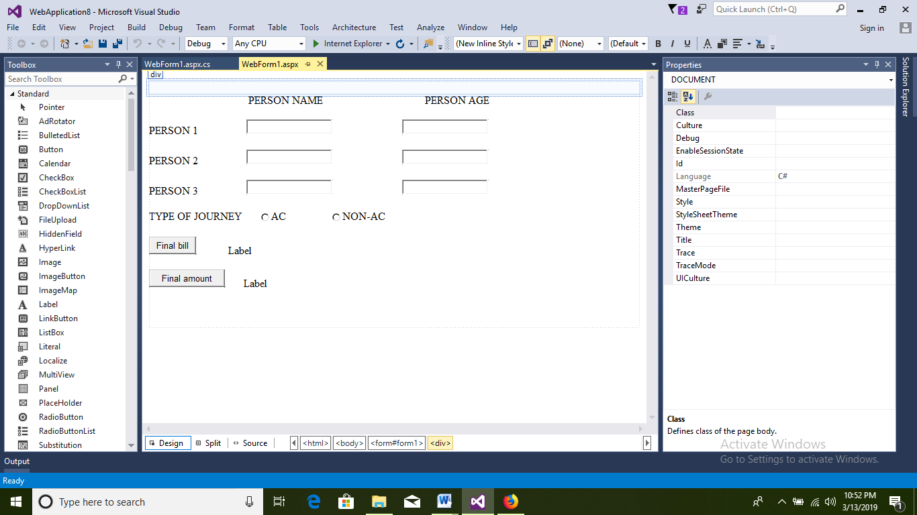

**Webform1.aspx:**

<%@PageLanguage="C#"AutoEventWireup="true"CodeBehind="WebForm1.aspx.cs"Inherits="WebApplication8.WebForm1"%>

<!DOCTYPEhtml>

<htmlxmlns="http://www.w3.org/1999/xhtml">

<headrunat="server">

<title></title>

</head>

<body>

<formid="form1"runat="server">

<div>

</div>

<asp:LabelID="Label1"runat="server"Text="PERSON NAME"></asp:Label>

<asp:LabelID="Label2"runat="server"Text="PERSON AGE"></asp:Label>

<p>

<asp:LabelID="Label3"runat="server"Text="PERSON 1"></asp:Label>

<asp:TextBoxID="txtname1"runat="server"></asp:TextBox>

<asp:TextBoxID="txtage1"runat="server"></asp:TextBox>

</p>

<p>

<asp:LabelID="Label4"runat="server"Text="PERSON 2"></asp:Label>

<asp:TextBoxID="txtname2"runat="server"></asp:TextBox>

<asp:TextBoxID="txtage2"runat="server"></asp:TextBox>

</p>

<p>

<asp:LabelID="Label5"runat="server"Text="PERSON 3"></asp:Label>

<asp:TextBoxID="txtname3"runat="server"></asp:TextBox>

<asp:TextBoxID="txtage3"runat="server"OnTextChanged="txtage3_TextChanged"></asp:TextBox>

</p>

<asp:LabelID="Label6"runat="server"Text="TYPE OF JOURNEY"></asp:Label>

<asp:RadioButtonID="rac"runat="server"GroupName="rb1"Text="AC"/>

<asp:RadioButtonID="rnac"runat="server"GroupName="rb1"Text="NON-AC"OnCheckedChanged="rnac_CheckedChanged"/>

<p>

<asp:ButtonID="btnbill"runat="server"OnClick="btnbill_Click"Text="Final bill"/>

<asp:LabelID="Label7"runat="server"Text="Label"></asp:Label>

</p>

<asp:ButtonID="btnamount"runat="server"Text="Final amount"OnClick="btnamount_Click"/>

<asp:LabelID="Label8"runat="server"Text="Label"></asp:Label>

<br/>

<br/>

<br/>

<br/>

</form>

</body>

</html>

**Webform1.aspx.cs:**

using System;

usingSystem.Collections.Generic;

usingSystem.Linq;

usingSystem.Web;

usingSystem.Web.UI;

usingSystem.Web.UI.WebControls;

namespace WebApplication8

{

publicpartialclassWebForm1 : System.Web.UI.Page

{

staticString n1, n2, n3,amt;

staticint a1, a2, a3;

protectedvoidbtnamount_Click(object sender, EventArgs e)

{

Label8.Text = amt;

}

protectedvoidrnac_CheckedChanged(object sender, EventArgs e)

{

}

staticdouble bill1,bill2,bill3,bill4,bill5,bill6,fbill,abill, amount=0, sc;

protectedvoid txtage3_TextChanged(object sender, EventArgs e)

{

}

protectedvoidPage_Load(object sender, EventArgs e)

{

}

protectedvoidbtnbill_Click(object sender, EventArgs e)

{

try

{

n1 = txtname1.Text;

n2 = txtname2.Text;

n3 = txtname3.Text;

a1 = Convert.ToInt32(txtage1.Text);

a2 = Convert.ToInt32(txtage2.Text);

a3 = Convert.ToInt32(txtage3.Text);

sc = 0.04;

if (rac.Checked)

{

if (a1 > 5 && a1 < 60)

{

bill1=1500;

}

else

{

bill1=750;

}

if (a2 > 5 && a2 < 60)

{

bill2=1500;

}

else

{

bill2=750;

}

if (a3 > 5 && a3 < 60)

{

bill3=1500;

}

else

{

bill3=750;

}

fbill = bill1 + bill2 + bill3;

amount = sc * 1500 + fbill;

Label7.Text = "final bill is " + fbill.ToString();

amt= "total amount is" + amount.ToString();

}

elseif(rnac.Checked)

{

if (a1 > 5 && a1 < 60)

{

bill4=500;

}

else

{

bill4=250;

}

if (a2 > 5 && a2 < 60)

{

bill5=500;

}

else

{

bill5=250;

}

if (a3 > 5 && a3 < 60)

{

bill6=500;

}

else

{

bill6=250;

}

abill = bill4 + bill5 + bill6;

amount = sc * 500 + abill;

Label7.Text = "final bill is " + abill.ToString();

amt = "total amount is" + amount.ToString();

}

}

catch(Exception ex)

{

Label7.Text = "error is " + ex;

}

}

}

}

**OUTPUT:**

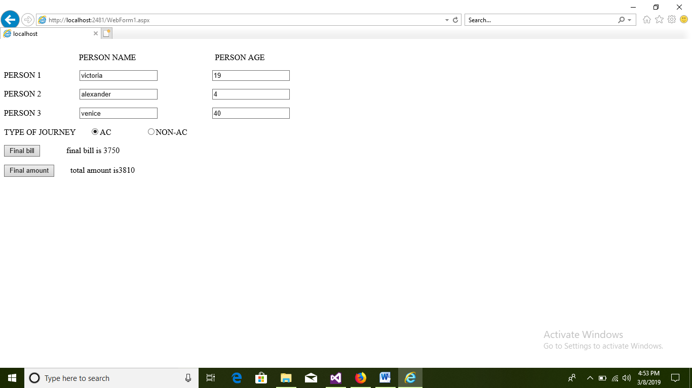

# PRACTICAL NO: 09

**Q) Add validations – name should not be null, age should be within (21 to 100) & Email should be in specific format, password field should not be empty, retype password data should be same as password field.**

**DESIGN:**

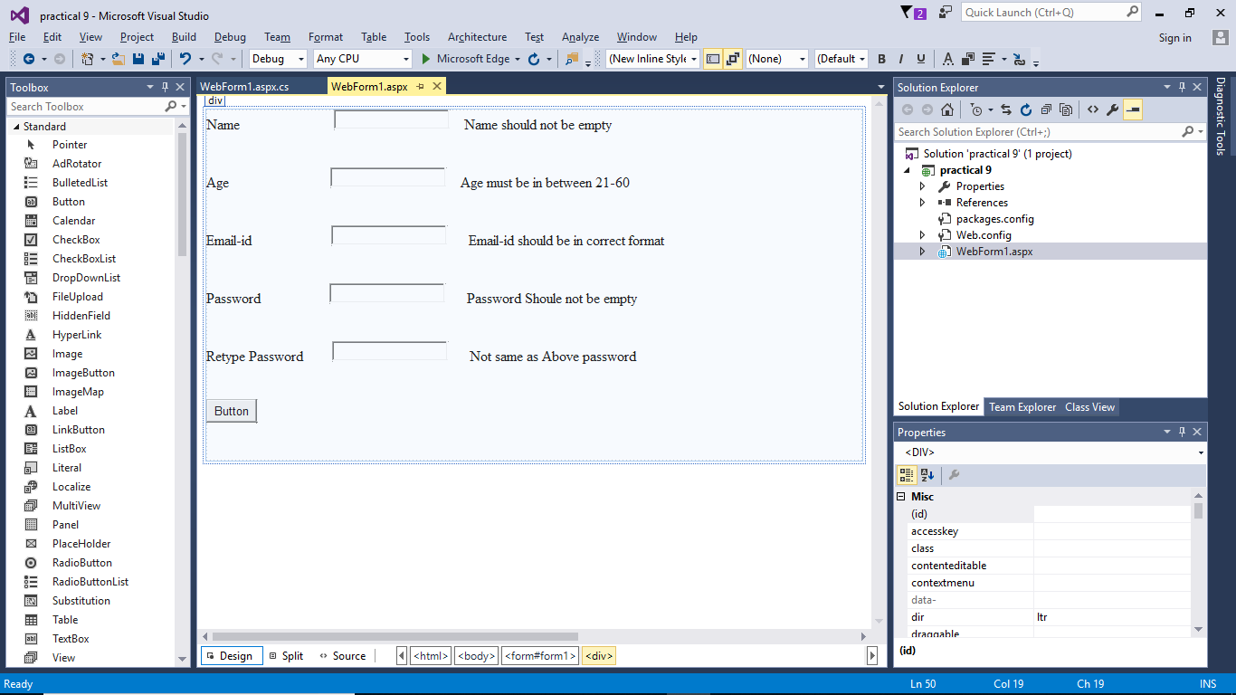

**Webform.aspx:**

<%@ Page Language="C#" AutoEventWireup="true" CodeBehind="WebForm1.aspx.cs" Inherits="practical_9.WebForm1" %>

<!DOCTYPE html>

<html xmlns="http://www.w3.org/1999/xhtml">

<head runat="server">

<title></title>

</head>

<body>

<form id="form1" runat="server">

<div>

<asp:Label ID="Label1" runat="server" Text="Name"></asp:Label>

&nbsp;&nbsp;&nbsp;&nbsp;&nbsp;&nbsp;&nbsp;&nbsp;&nbsp;&nbsp;&nbsp;&nbsp;&nbsp;&nbsp;&nbsp;&nbsp;&nbsp;&nbsp;&nbsp;&nbsp;&nbsp;&nbsp;&nbsp;&nbsp;&nbsp;

<asp:TextBox ID="TextBox1" runat="server" CausesValidation="True"></asp:TextBox>

&nbsp;&nbsp;&nbsp;

<asp:RequiredFieldValidator ID="RequiredFieldValidator1" runat="server" ControlToValidate="TextBox1" EnableClientScript="False" ErrorMessage="Name should not be empty">Name should not be empty</asp:RequiredFieldValidator>

<br />

<br />

<br />

Age&nbsp;&nbsp;&nbsp;&nbsp;&nbsp;&nbsp;&nbsp;&nbsp;&nbsp;&nbsp;&nbsp;&nbsp;&nbsp;&nbsp;&nbsp;&nbsp;&nbsp;&nbsp;&nbsp;&nbsp;&nbsp;&nbsp;&nbsp;&nbsp;&nbsp;&nbsp;&nbsp;

<asp:TextBox ID="TextBox2" runat="server" CausesValidation="True"></asp:TextBox>

&nbsp;&nbsp;&nbsp;

<asp:RangeValidator ID="RangeValidator1" runat="server" ControlToValidate="TextBox2" EnableClientScript="False" ErrorMessage="Age must be in between 21-60" MaximumValue="60" MinimumValue="21">Age must be in between 21-60</asp:RangeValidator>

<br />

<br />

<br />

Email-id&nbsp;&nbsp;&nbsp;&nbsp;&nbsp;&nbsp;&nbsp;&nbsp;&nbsp;&nbsp;&nbsp;&nbsp;&nbsp;&nbsp;&nbsp;&nbsp;&nbsp;&nbsp;&nbsp;&nbsp;&nbsp;

<asp:TextBox ID="TextBox3" runat="server" CausesValidation="True"></asp:TextBox>

&nbsp;&nbsp;&nbsp;&nbsp;&nbsp;

<asp:RegularExpressionValidator ID="RegularExpressionValidator1" runat="server" ControlToValidate="TextBox3" EnableClientScript="False" ErrorMessage="Email-id should be in correct format" ValidationExpression="\w+([-+.']\w+)*@\w+([-.]\w+)*\.\w+([-.]\w+)*">Email-id should be in correct format</asp:RegularExpressionValidator>

<br />

<br />

<br />

Password&nbsp;&nbsp;&nbsp;&nbsp;&nbsp;&nbsp;&nbsp;&nbsp;&nbsp;&nbsp;&nbsp;&nbsp;&nbsp;&nbsp;&nbsp;&nbsp;&nbsp;&nbsp;

<asp:TextBox ID="TextBox4" runat="server" CausesValidation="True"></asp:TextBox>

&nbsp;&nbsp;&nbsp;&nbsp;&nbsp;

<asp:RequiredFieldValidator ID="RequiredFieldValidator2" runat="server" ControlToValidate="TextBox4" EnableClientScript="False" ErrorMessage="Password Shoule not be empty">Password Shoule not be empty</asp:RequiredFieldValidator>

<br />

<br />

<br />

Retype Password&nbsp;&nbsp;&nbsp;&nbsp;&nbsp;&nbsp;&nbsp;

<asp:TextBox ID="TextBox5" runat="server" CausesValidation="True"></asp:TextBox>

&nbsp;&nbsp;&nbsp;&nbsp;&nbsp;

<asp:CompareValidator ID="CompareValidator1" runat="server" ControlToCompare="TextBox4" ControlToValidate="TextBox5" CultureInvariantValues="True" EnableClientScript="False" ErrorMessage="Not same as Above password">Not same as Above password</asp:CompareValidator>

<br />

<br />

<br />

<asp:Button ID="Button1" runat="server" OnClick="Button1_Click" Text="Button" />

&nbsp;&nbsp;&nbsp;

<br />

<br />

</div>

</form>

</body>

</html>

**OUTPUT:**

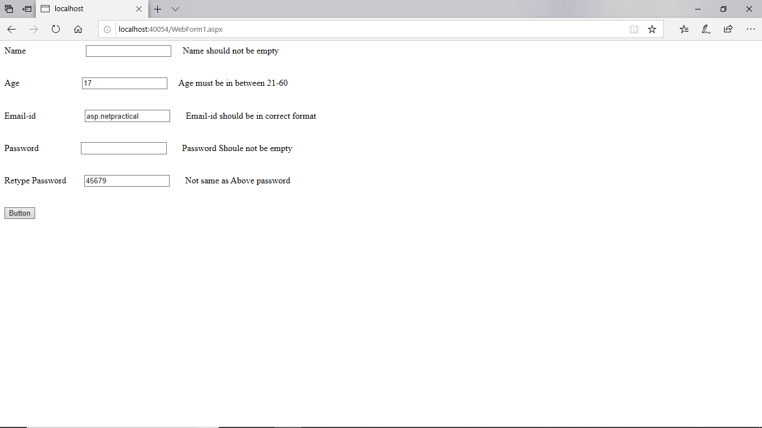

# PRACTICAL NO: 10

**Q) Design ASP.NET page with Rich controls:**

**A) CALENDAR**:

DESIGN:

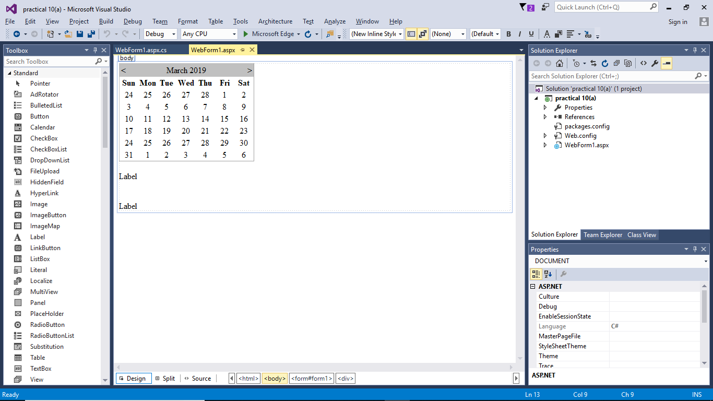

**WebForm.aspx:**

<%@ Page Language="C#" AutoEventWireup="true" CodeBehind="WebForm1.aspx.cs" Inherits="practical_10_a_.WebForm1" %>

<!DOCTYPE html>

<html xmlns="http://www.w3.org/1999/xhtml">

<head runat="server">

<title></title>

</head>

<body>

<form id="form1" runat="server">

<div>

<asp:Calendar ID="Calendar1" runat="server"></asp:Calendar>

<br />

<asp:Label ID="Label1" runat="server" Text="Label"></asp:Label>

<br />

<br />

<br />

<asp:Label ID="Label2" runat="server" Text="Label"></asp:Label>

<br />

</div>

</form>

</body>

</html>

**WebForm.aspx.cs:**

using System;

using System.Collections.Generic;

using System.Linq;

using System.Web;

using System.Web.UI;

using System.Web.UI.WebControls;

namespace practical_10_a_

{

public partial class WebForm1 : System.Web.UI.Page

{

protected void Page_Load(object sender, EventArgs e)

{

Label1.Text = "Todays date is "+Calendar1.TodaysDate.ToShortDateString();

Label2.Text = "selected date is "+Calendar1.SelectedDate.ToShortDateString();

}

}

}

**B) Ad Rotator**

**DESIGN:**

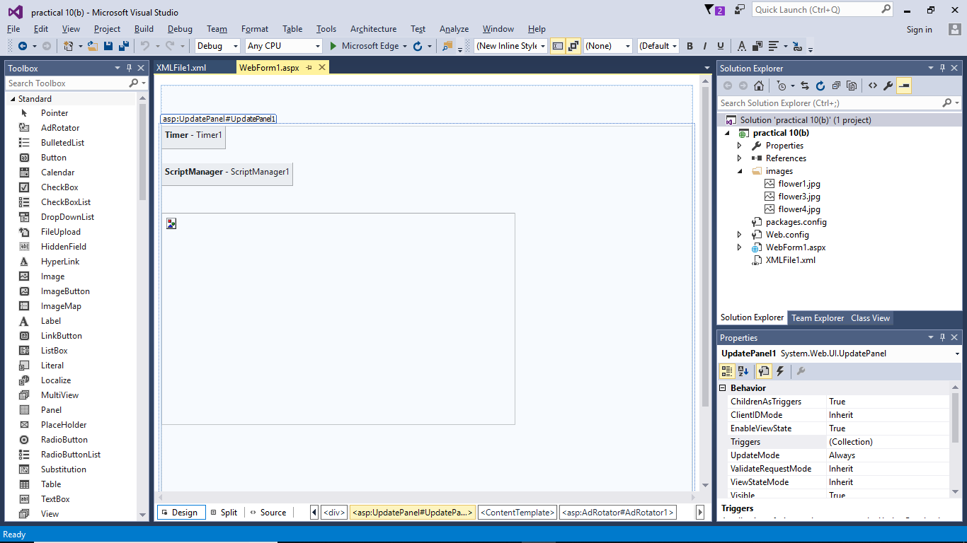

**WebForm.aspx:**

<%@ Page Language="C#" AutoEventWireup="true" CodeBehind="WebForm1.aspx.cs" Inherits="practical_10_b_.WebForm1" %>

<!DOCTYPE html>

<html xmlns="http://www.w3.org/1999/xhtml">

<head runat="server">

<title></title>

</head>

<body>

<form id="form1" runat="server">

<div>

<br />

<br />

<br />

<asp:UpdatePanel ID="UpdatePanel1" runat="server">

<ContentTemplate>

<asp:Timer ID="Timer1" runat="server" Interval="600">

</asp:Timer>

<br />

<asp:ScriptManager ID="ScriptManager1" runat="server">

</asp:ScriptManager>

<br />

<br />

<asp:AdRotator ID="AdRotator1" runat="server" AdvertisementFile="~/XMLFile1.xml" Height="300px" Width="500px" />

<br />

</ContentTemplate>

</asp:UpdatePanel>

<br />

<br />

<br />

<br />

</div>

</form>

</body>

</html>

**XMlFIle.xml:**

<?xml version="1.0" encoding="utf-8" ?>

<Advertisements>

<Ad>

<ImageUrl>~/images/flower1.jpg</ImageUrl>

</Ad>

<Ad>

<ImageUrl>~/images/flower3.jpg</ImageUrl>

</Ad>

<Ad>

<ImageUrl>~/images/flower4.jpg</ImageUrl>

</Ad>

</Advertisements>

**OUTPUT:**

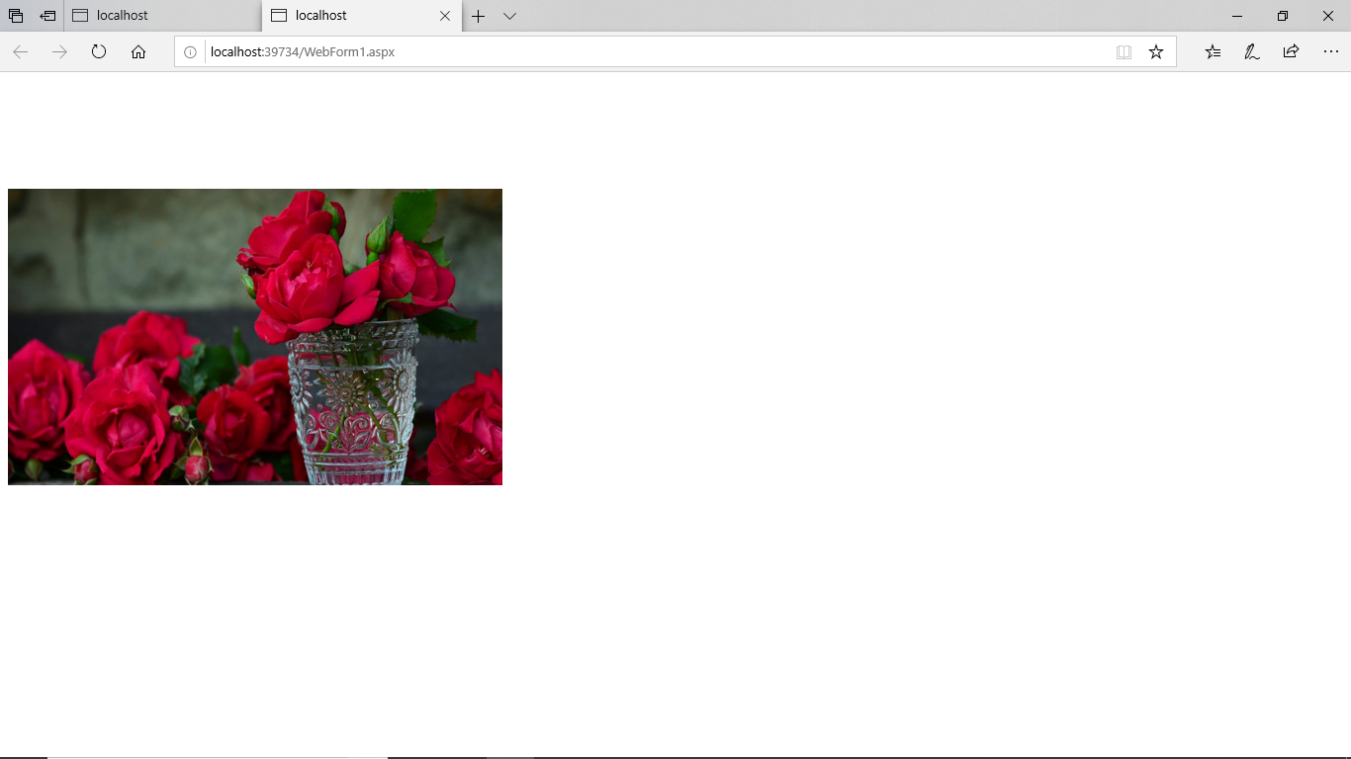 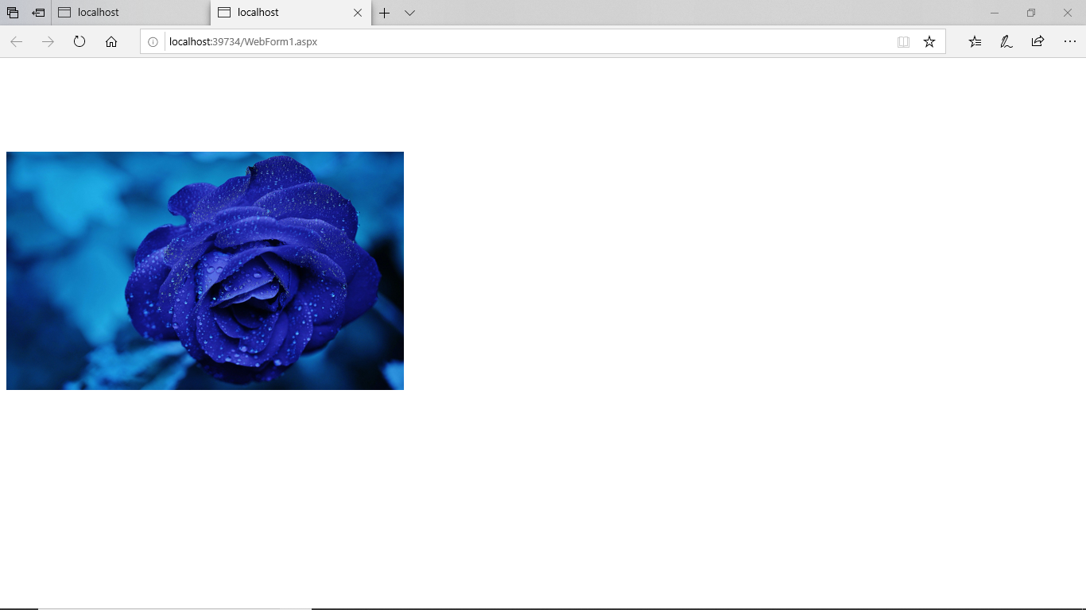

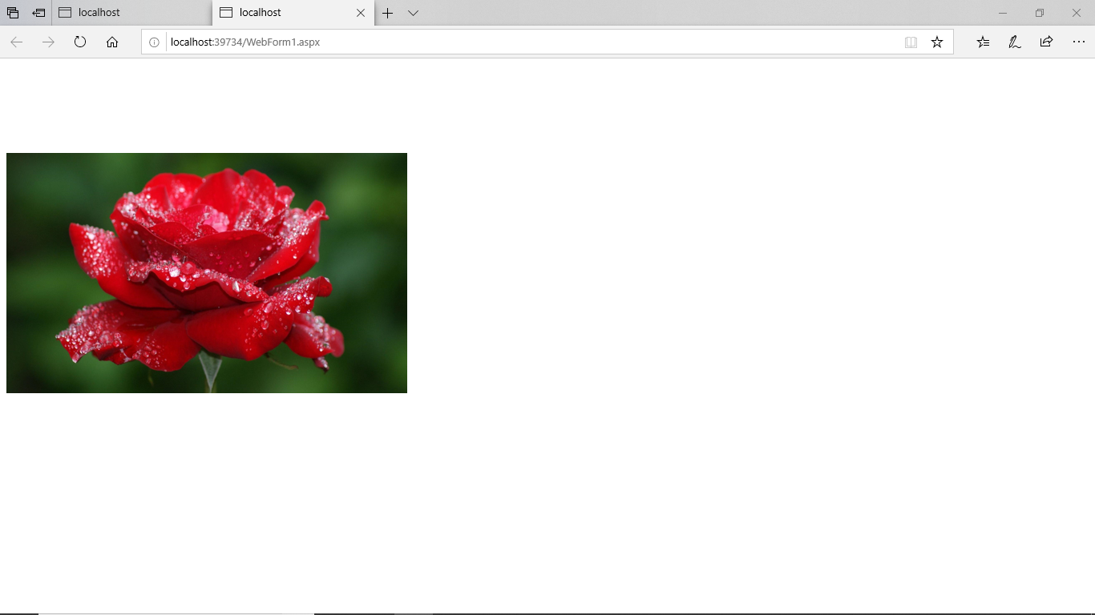

**C) MultiView Control:**

**DESIGN:**

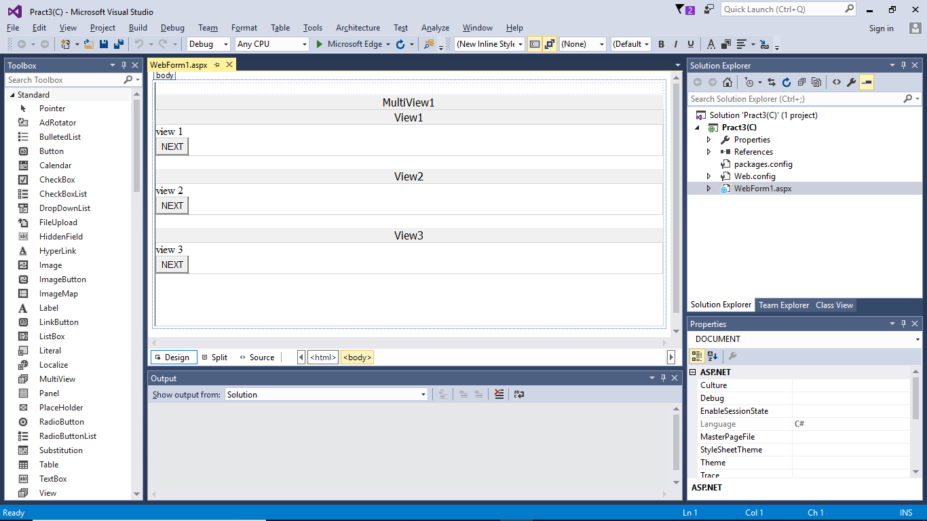

**WebForm.aspx:**

<%@ Page Language="C#" AutoEventWireup="true" CodeBehind="WebForm1.aspx.cs" Inherits="Pract3_C_.WebForm1" %>

<!DOCTYPE html>

<html xmlns="http://www.w3.org/1999/xhtml">

<head runat="server">

<title></title>

</head>

<body>

<form id="form1" runat="server">

<div>

</div>

<asp:MultiView ID="MultiView1" runat="server" ActiveViewIndex="0">

<asp:View ID="View1" runat="server">

view 1<br />

<asp:Button ID="Button1" runat="server" CommandName="NextView" Text="NEXT" OnClick="Button1_Click" />

<br />

</asp:View>

<br />

<asp:View ID="View2" runat="server">

view 2<br />

<asp:Button ID="Button2" runat="server" CommandName="NextView" Text="NEXT" />

</asp:View>

<br />

<asp:View ID="View3" runat="server">

view 3<br />

<asp:Button ID="NEXT" runat="server" CommandArgument="0" CommandName="SwitchViewByIndex" Text="NEXT" />

<br />

</asp:View>

<br />

<br />

<br />

<br />

</asp:MultiView>

</form>

</body>

</html>

**OUTPUT:**

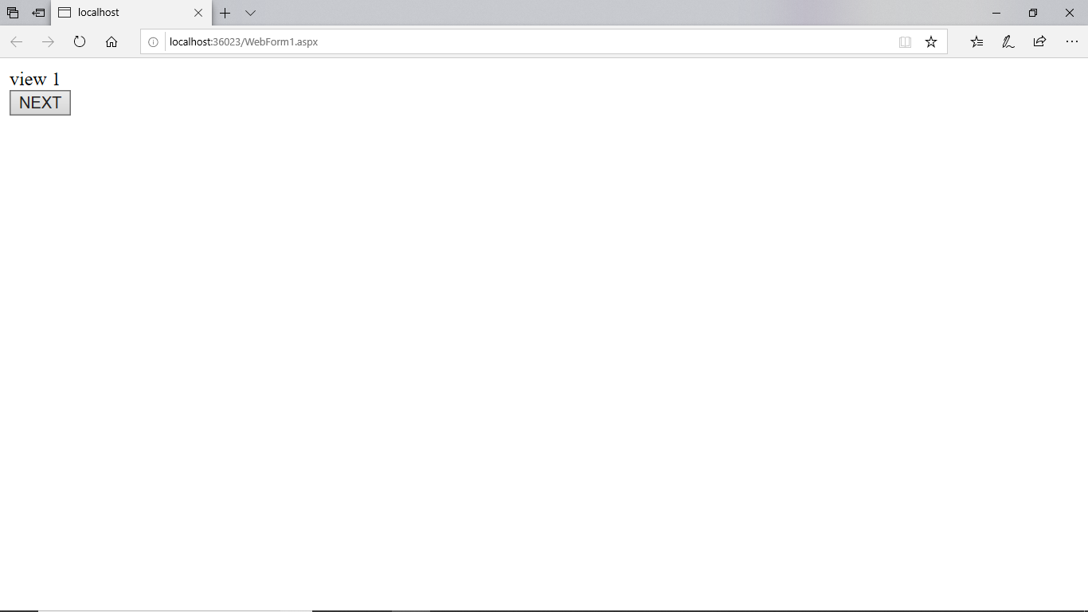

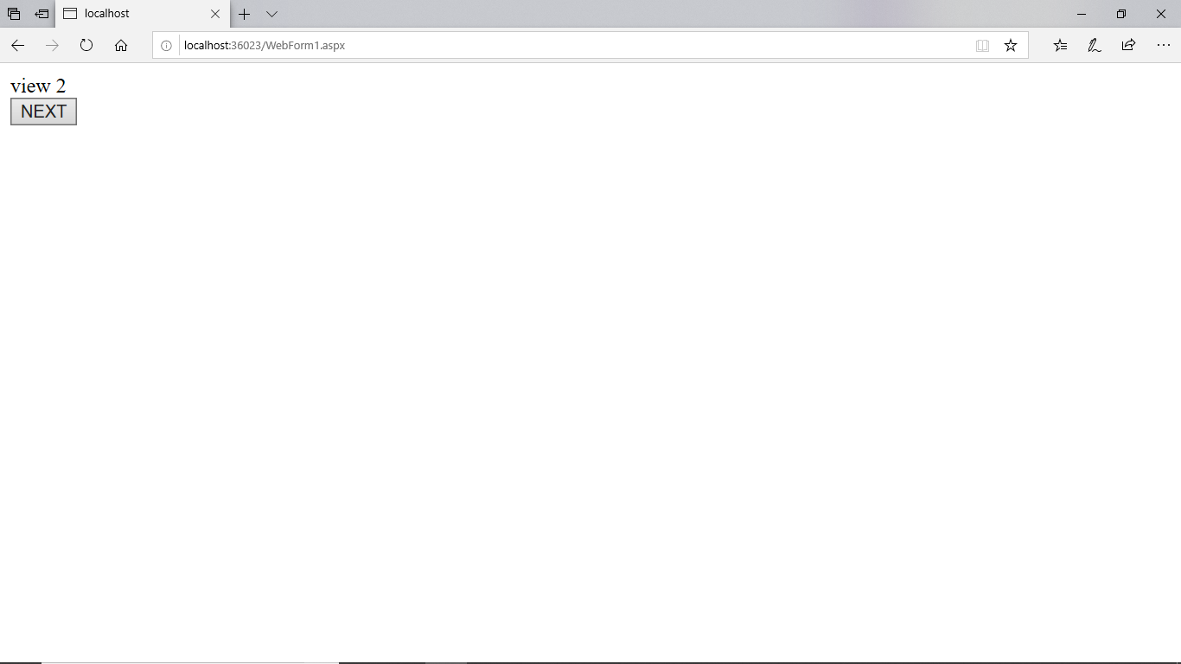

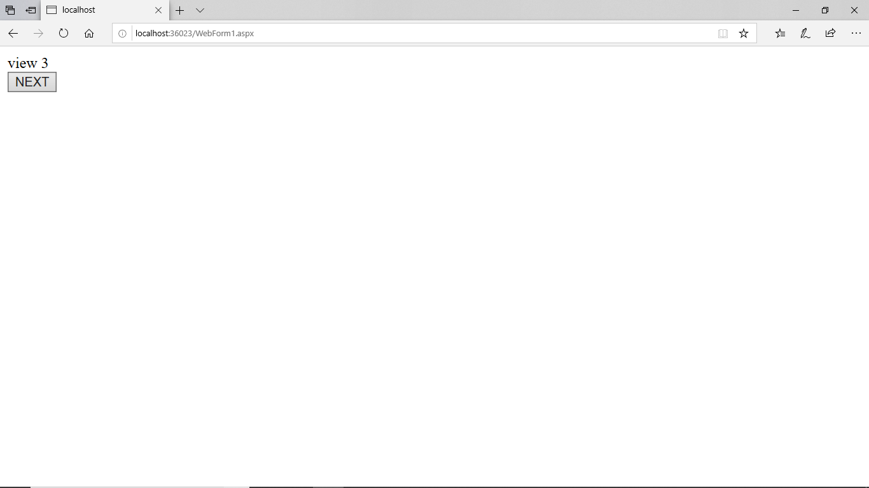

# PRACTICAL NO: 11(B)

**WebForm1.aspx**

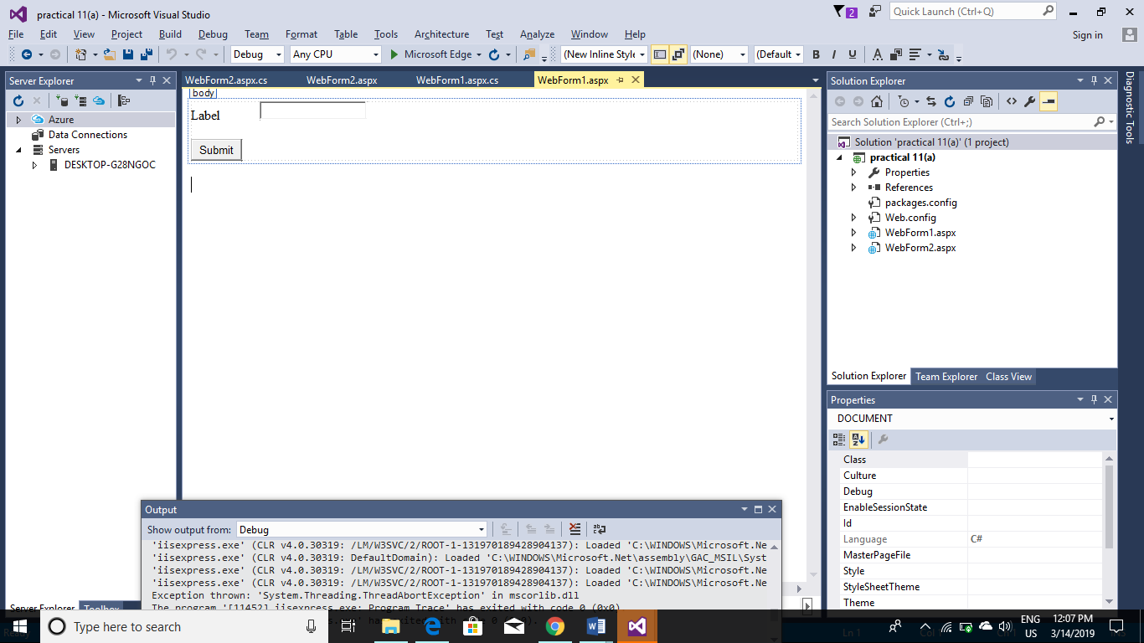

<%@ Page Language="C#" AutoEventWireup="true" CodeBehind="WebForm1.aspx.cs" Inherits="practical_11_a_.WebForm1" %>

<!DOCTYPE html>

<html xmlns="http://www.w3.org/1999/xhtml">

<head runat="server">

<title></title>

</head>

<body>

<form id="form1" runat="server">

<div>

<asp:Label ID="Label1" runat="server" Text="Label"></asp:Label>

<asp:TextBox ID="TextBox1" runat="server"></asp:TextBox>

<br />

<br />

<asp:Button ID="Button1" runat="server" OnClick="Button1_Click" Text="Submit" />

<br />

</div>

</form>

</body>

</html>

**WebForm1.aspx.cs**

using System;

using System.Collections.Generic;

using System.Linq;

using System.Web;

using System.Web.UI;

using System.Web.UI.WebControls;

namespace practical_11_a_

{

public partial class WebForm1 : System.Web.UI.Page

{

protected void Button1_Click(object sender, EventArgs e)

{

Session["uname"] = TextBox1.Text;

Response.Redirect("WebForm2.aspx");

}

}

}

**WebForm2.aspx**

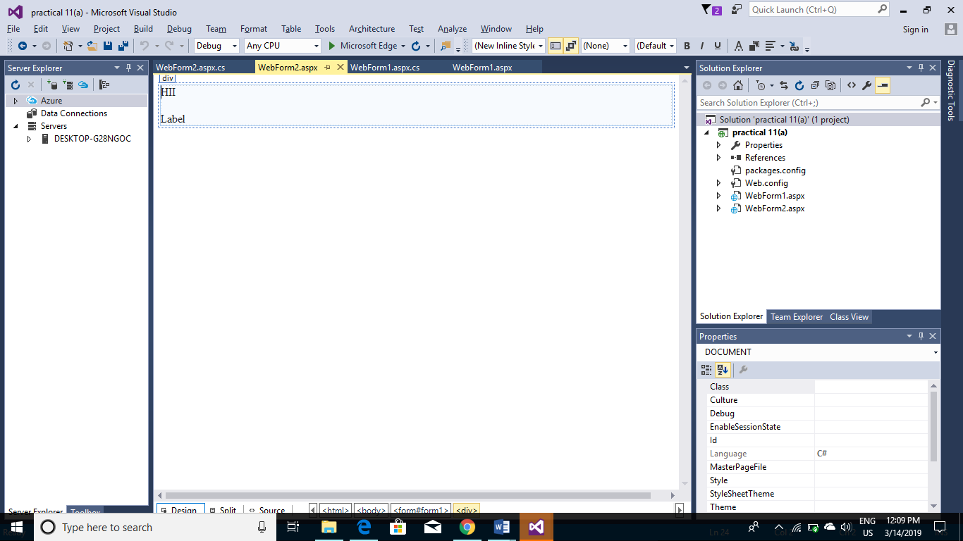

<%@ Page Language="C#" AutoEventWireup="true" CodeBehind="WebForm2.aspx.cs" Inherits="practical_11_a_.WebForm2" %>

<!DOCTYPE html>

<html xmlns="http://www.w3.org/1999/xhtml">

<head runat="server">

<title></title>

</head>

<body>

<form id="form1" runat="server">

<div>

HII

<br />

<br />

<asp:Label ID="Label1" runat="server" Text="Label"></asp:Label>

</div>

</form>

</body>

</html>

**WebForm2.aspx.cs**

using System;

using System.Collections.Generic;

using System.Linq;

using System.Web;

using System.Web.UI;

using System.Web.UI.WebControls;

namespace practical_11_a_

{

public partial class WebForm2 : System.Web.UI.Page

{

protected void Page_Load(object sender, EventArgs e)

{

Label1.Text = "GOOD MORNING " + Session["uname"];

}

}

}

OUTPUT :

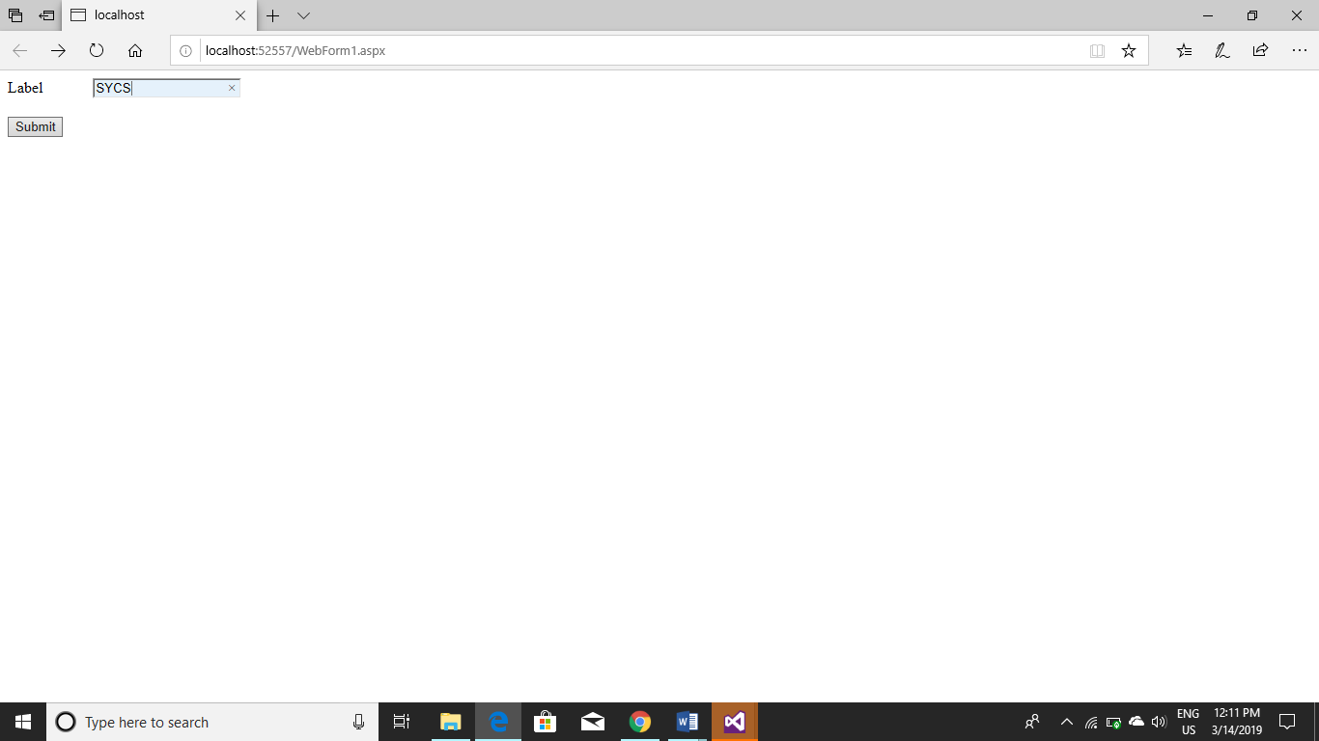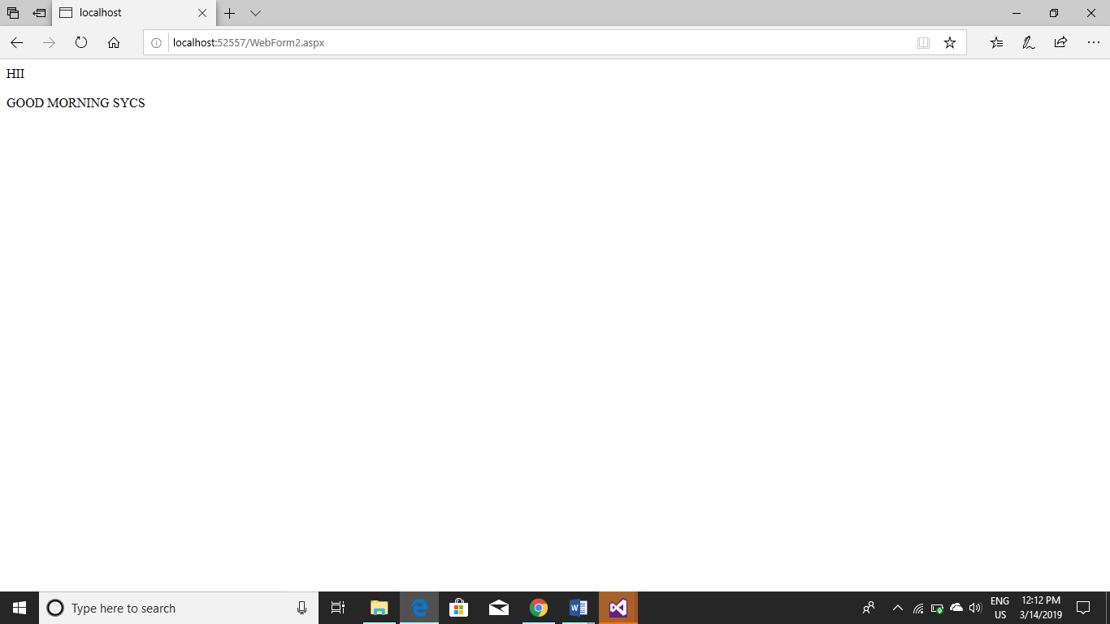

# PRACTICAL NO: 11

**Q) Design ASP.NET Pages for State Management using :**

**A) Session State**

**DESIGN:**

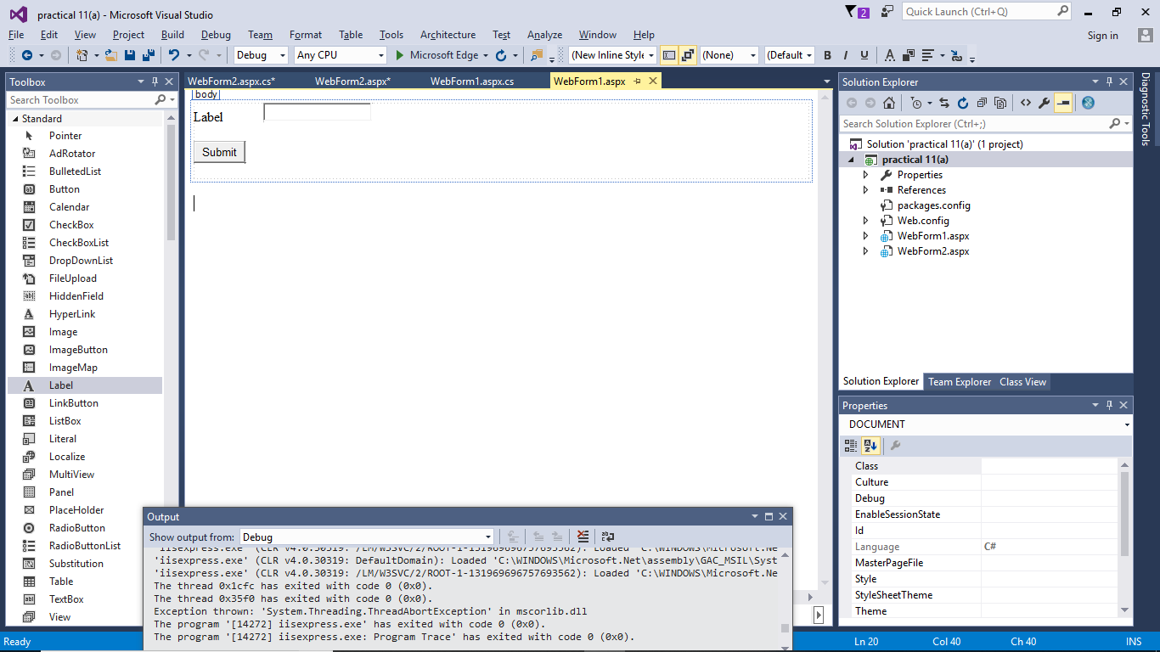

**WebForm1.aspx.cs:**

using System;

using System.Collections.Generic;

using System.Linq;

using System.Web;

using System.Web.UI;

using System.Web.UI.WebControls;

namespace practical_11_a_

{

public partial class WebForm1 : System.Web.UI.Page

{

protected void Page_Load(object sender, EventArgs e)

{

}

protected void Button1_Click(object sender, EventArgs e)

{

Session["uname"] = TextBox1.Text;

Response.Redirect("WebForm2.aspx");

}

}

}

**WebForm 2 DESIGN page:**

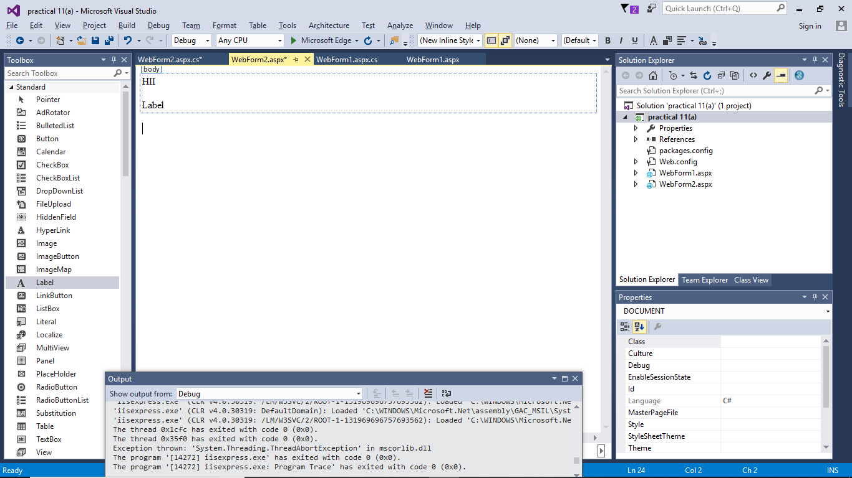

**WebForm2.aspx.cs:**

using System;

using System.Collections.Generic;

using System.Linq;

using System.Web;

using System.Web.UI;

using System.Web.UI.WebControls;

namespace practical_11_a_

{

public partial class WebForm2 : System.Web.UI.Page

{

protected void Page_Load(object sender, EventArgs e)

{

Label1.Text = "GOOD MORNING " + Session["uname"];

}

}

}

**OUTPUT:**

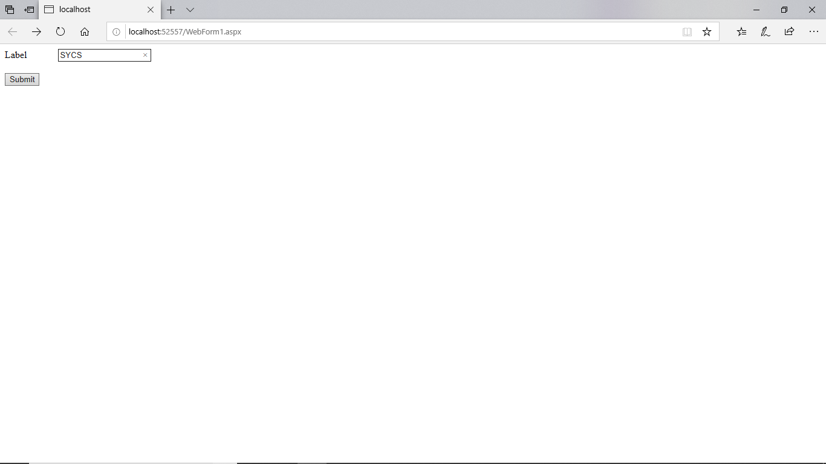

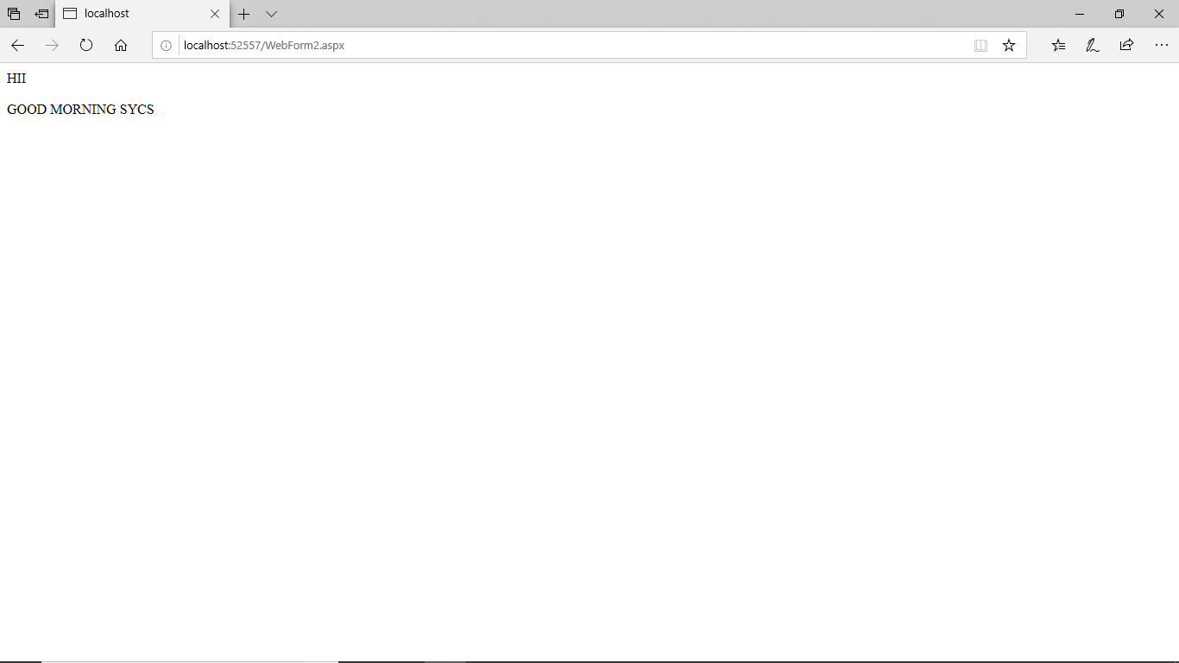

**B) Query String.**

**WEBFORM 1 DESIGN PAGE:**

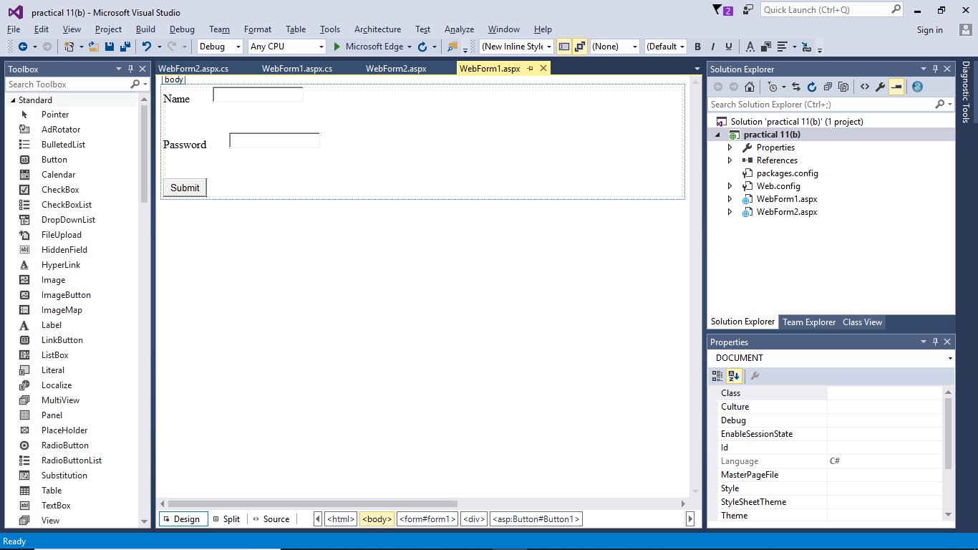

**WebForm1.aspx.cs:**

using System;

using System.Collections.Generic;

using System.Linq;

using System.Web;

using System.Web.UI;

using System.Web.UI.WebControls;

namespace practical_11_b_

{

public partial class WebForm1 : System.Web.UI.Page

{

protected void Page_Load(object sender, EventArgs e)

{

}

protected void Button1_Click(object sender, EventArgs e)

{

Response.Redirect("WebForm2.aspx/?username=" + TextBox1.Text + "&pswd= " + TextBox2.Text);

}

}

}

**WEBFORM 2 DESIGN PAGE:**

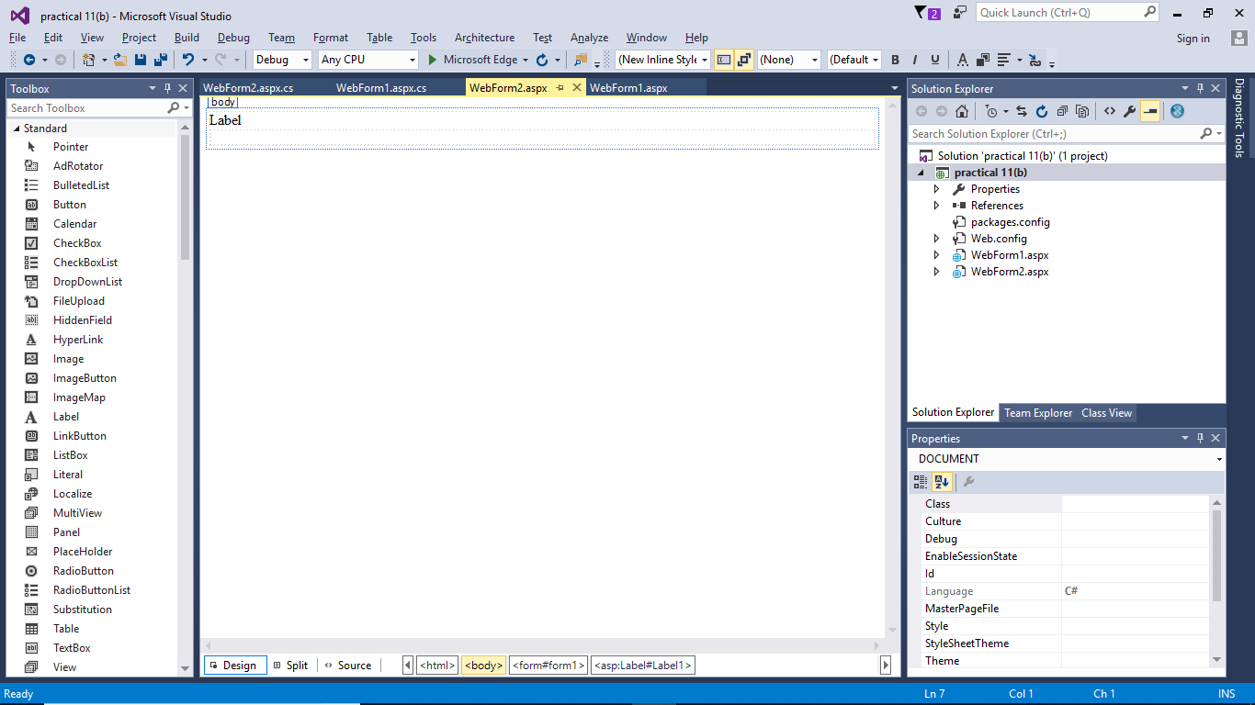

**WebForm2.aspx.cs:**

using System;

using System.Collections.Generic;

using System.Linq;

using System.Web;

using System.Web.UI;

using System.Web.UI.WebControls;

namespace practical_11_b_

{

public partial class WebForm2 : System.Web.UI.Page

{

protected void Page_Load(object sender, EventArgs e)

{

Label1.Text = Request.QueryString["username"] + Request.QueryString["pswd"];

}

}

}

**OUTPUT:**

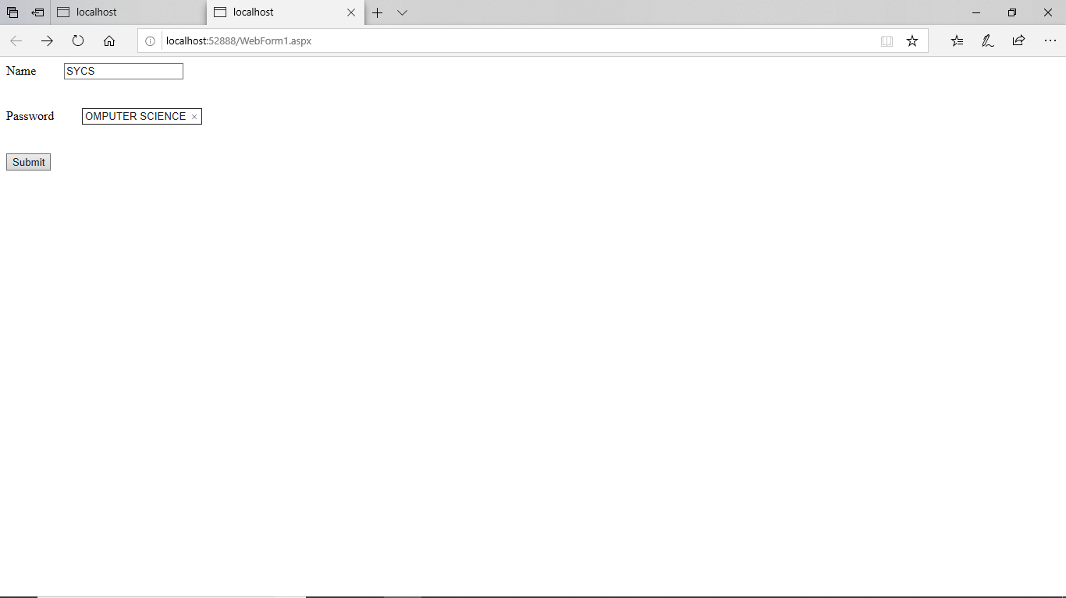

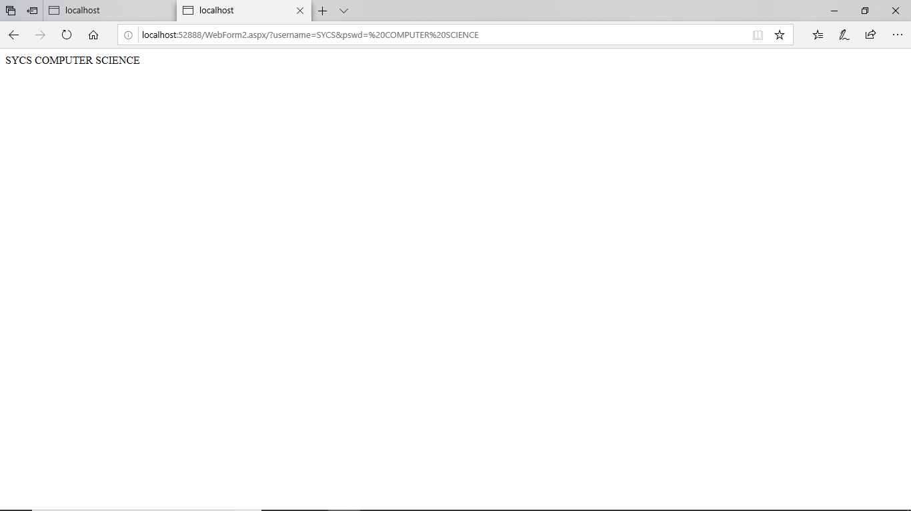

# PRACTICAL NO: 13

**Q) Design an ASP.NET master web page and use it other (at least 2-3) content pages.**

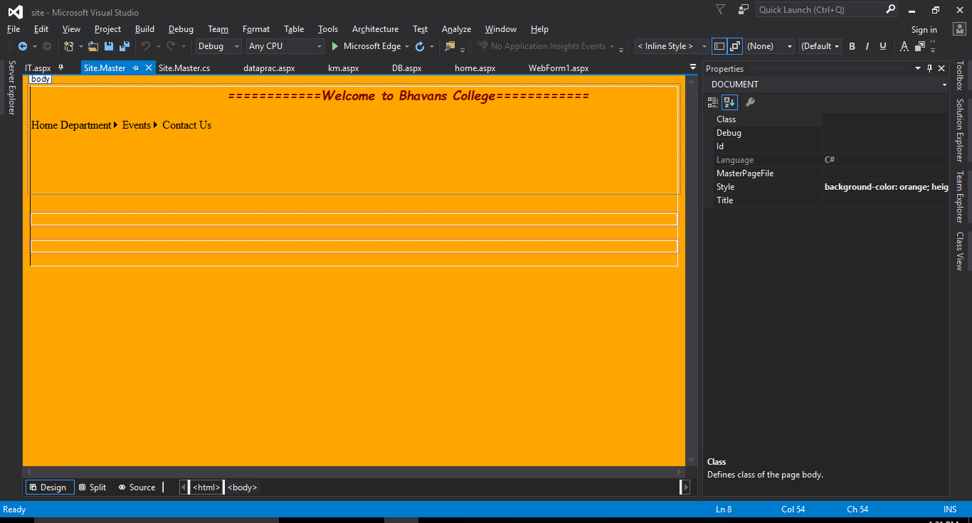

**Home.aspx:**

<%@ Page Title="" Language="C#" MasterPageFile="~/Site.Master" AutoEventWireup="true" CodeBehind="home.aspx.cs" Inherits="site.home" %>

<asp:Content ID="Content1" ContentPlaceHolderID="head" runat="server">

</asp:Content>

<asp:Content ID="Content2" ContentPlaceHolderID="ContentPlaceHolder1" runat="server">

<p>

&nbsp;&nbsp;&nbsp;&nbsp;&nbsp;&nbsp;&nbsp;&nbsp;&nbsp;&nbsp;&nbsp;&nbsp;&nbsp;&nbsp;&nbsp;&nbsp;&nbsp;&nbsp;&nbsp;&nbsp;&nbsp;&nbsp;&nbsp;&nbsp;&nbsp;&nbsp;&nbsp;&nbsp;&nbsp;&nbsp;&nbsp;&nbsp;&nbsp;&nbsp;&nbsp;&nbsp;&nbsp;&nbsp;&nbsp;&nbsp;&nbsp;&nbsp;&nbsp;&nbsp;&nbsp;&nbsp;&nbsp;&nbsp;&nbsp;&nbsp;

This is the Home Page........................</p>

</asp:Content>

**Cs.aspx**

<%@ Page Title="" Language="C#" MasterPageFile="~/Site.Master" AutoEventWireup="true" CodeBehind="cs.aspx.cs" Inherits="site.cs" %>

<asp:Content ID="Content1" ContentPlaceHolderID="head" runat="server">

</asp:Content>

<asp:Content ID="Content2" ContentPlaceHolderID="ContentPlaceHolder1" runat="server">

<p style="font-family: Broadway; font-size: medium; font-style: italic; font-weight: bolder; color: #3366FF">

ComputerScience Department Welcomes You All!!</p>

</asp:Content>

<asp:Content ID="Content3" ContentPlaceHolderID="ContentPlaceHolder2" runat="server">

<p style="font-family: &quot;Britannic Bold&quot;; font-size: large; font-weight: lighter; font-style: italic; color: #3366FF">

This is Fun!</p>

</asp:Content>

**WebForm1.aspx:**

<%@ Page Title="" Language="C#" MasterPageFile="~/Site.Master" AutoEventWireup="true" CodeBehind="WebForm1.aspx.cs" Inherits="site.WebForm1" %>

<asp:Content ID="Content1" ContentPlaceHolderID="head" runat="server">

</asp:Content>

<asp:Content ID="Content2" ContentPlaceHolderID="ContentPlaceHolder1" runat="server">

</asp:Content>

<asp:Content ID="Content3" ContentPlaceHolderID="ContentPlaceHolder2" runat="server">

</asp:Content>

**Output:**

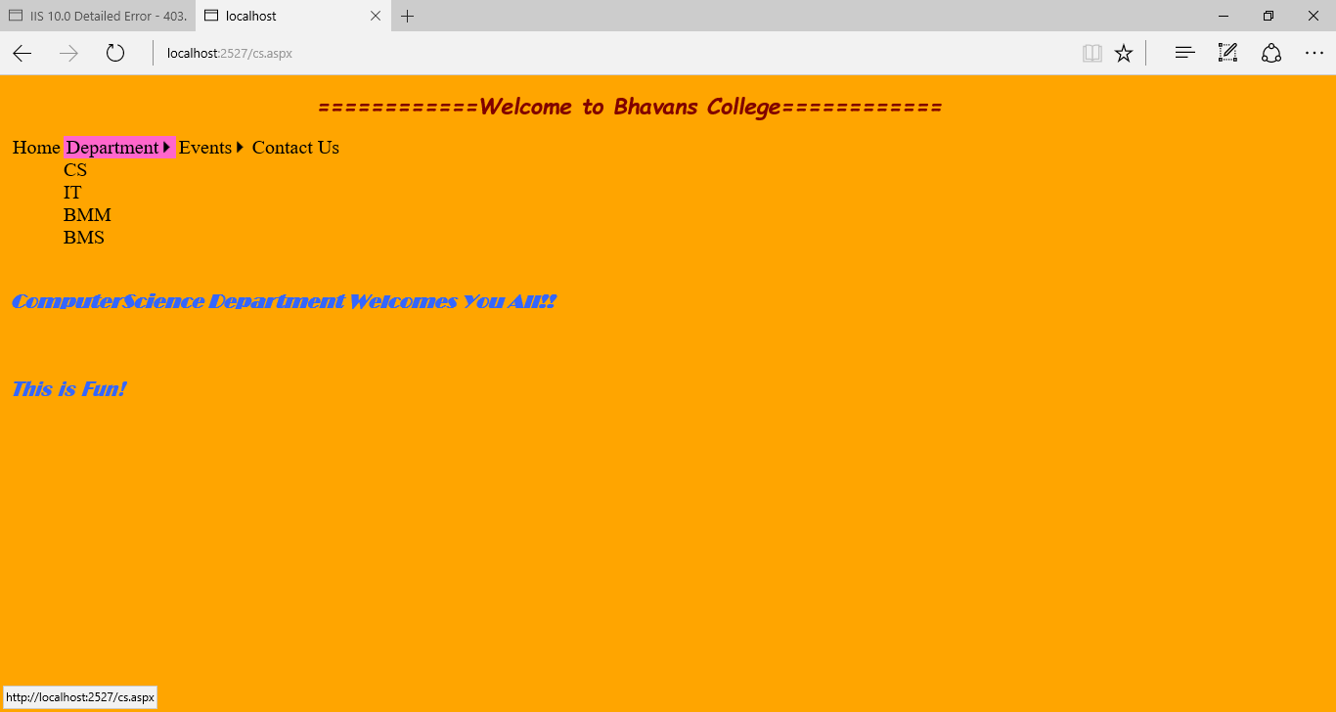

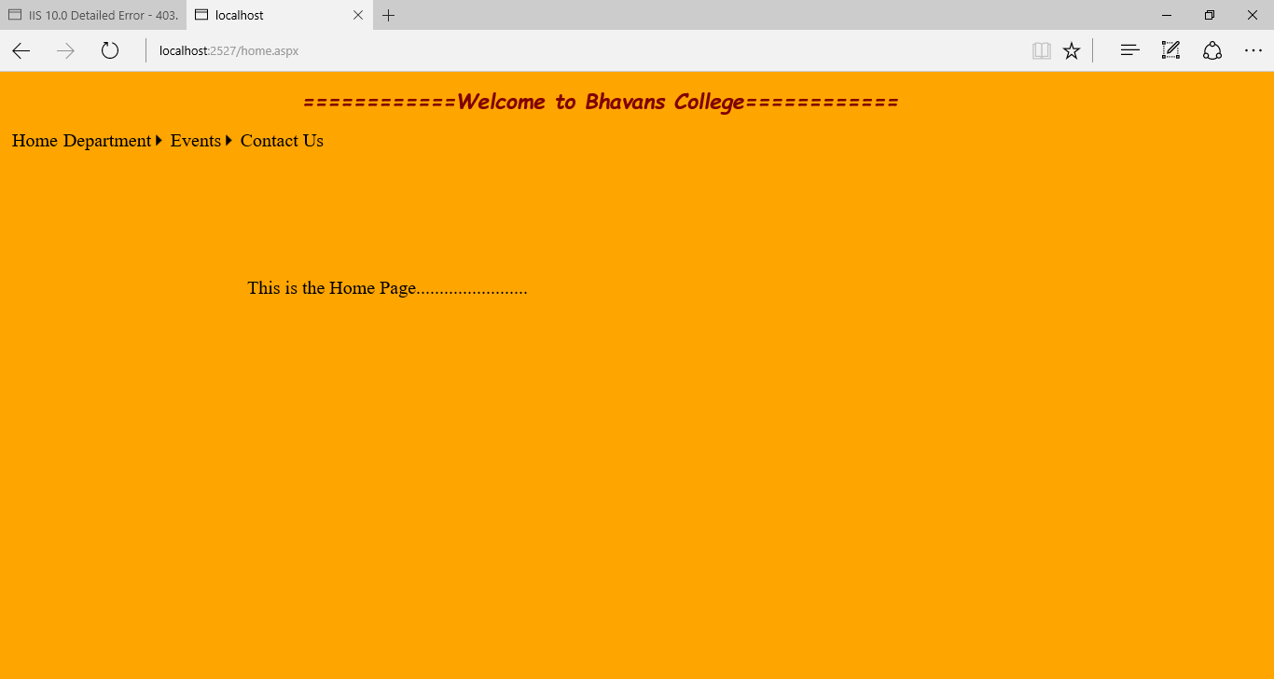

# PRACTICAL NO: 12

**Q) A news channel wants to conduct a survey of some famous personalities of the year. The user initially inputs his/her name, age and email. The survey will be valid only if user is above 18 years of age and has an email id. First page allows user to select Best Sportsperson, 2nd page asks Best Writer and the third – Best Minister through dropdownlist. At the end, it shows a thank you message with user’s name and shows all the choices made by him/her.**

**DESIGN:**

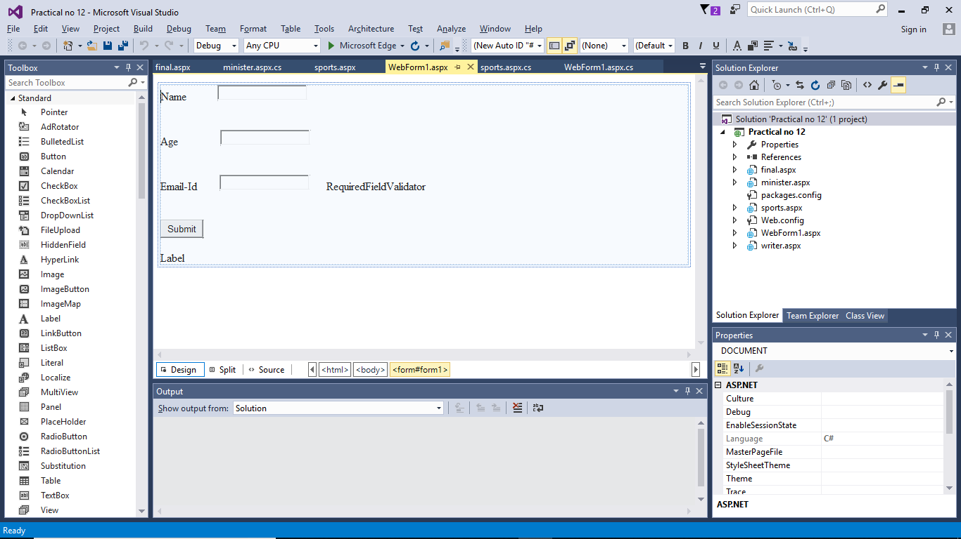

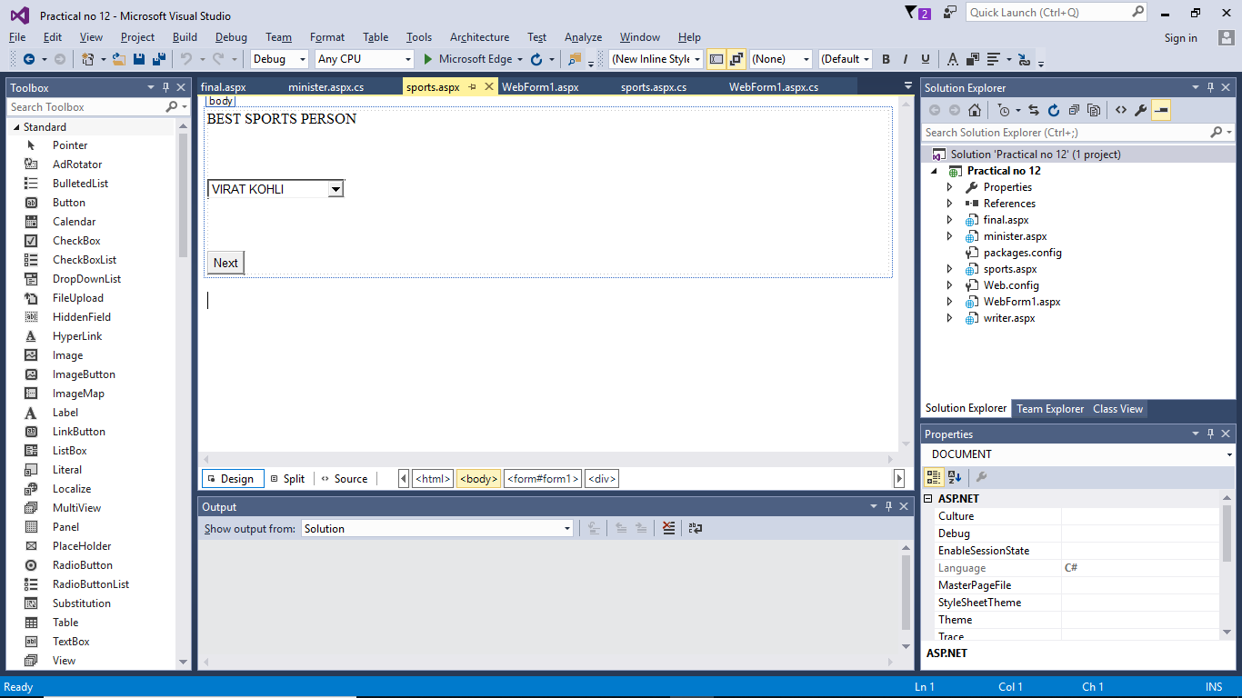 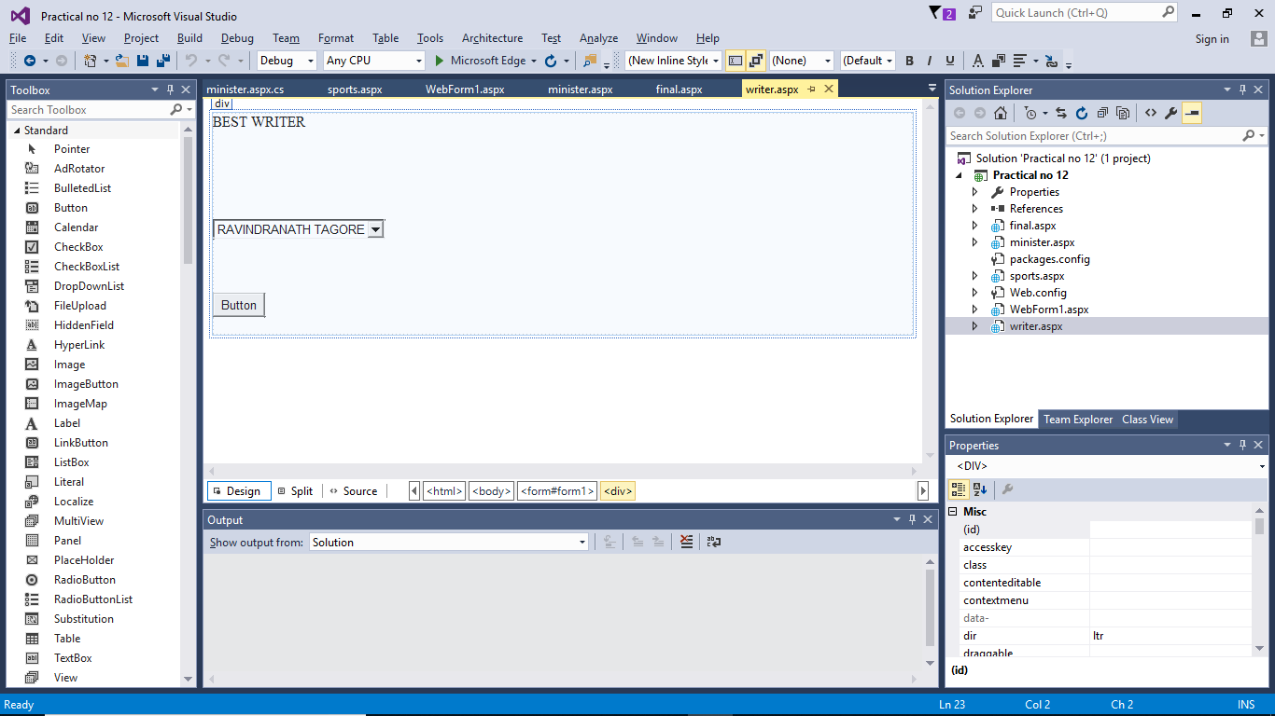

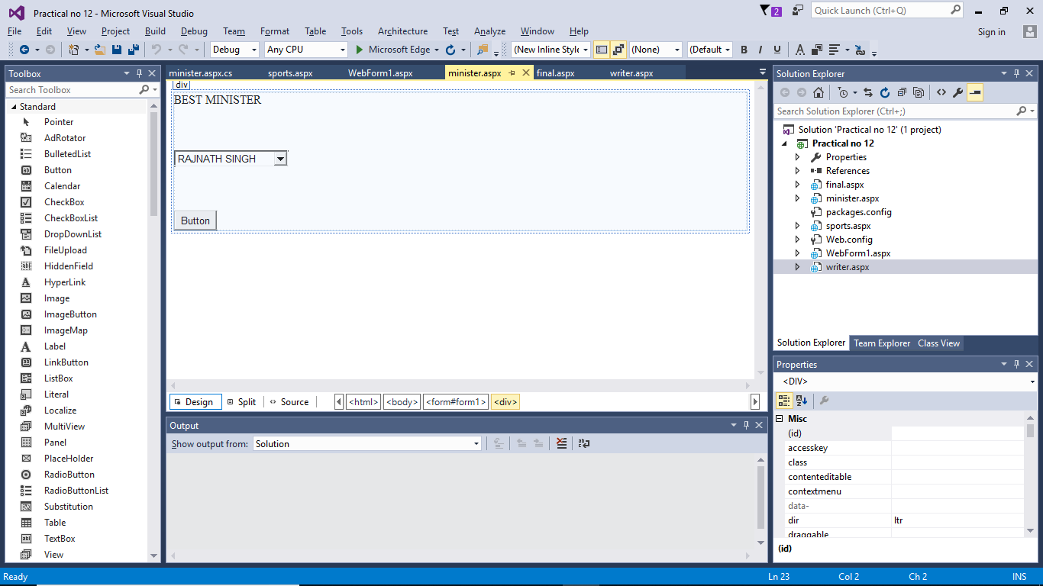 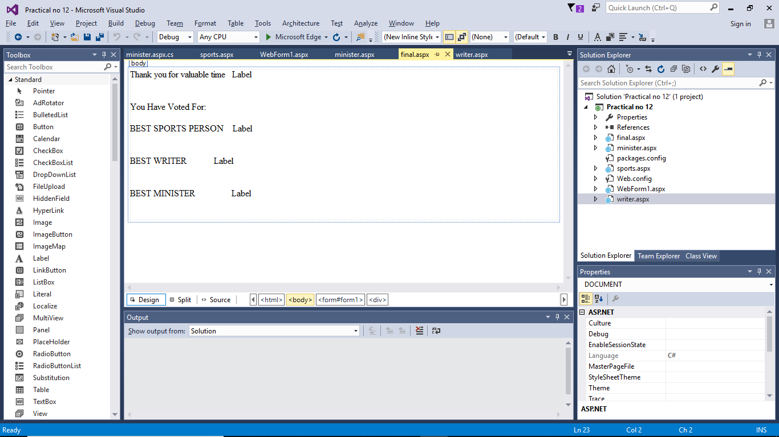

**Webform.aspx:**

<%@ Page Language="C#" AutoEventWireup="true" CodeBehind="WebForm1.aspx.cs" Inherits="Practical_no_12.WebForm1" %>

<!DOCTYPE html>

<html xmlns="http://www.w3.org/1999/xhtml">

<head runat="server">

<title></title>

</head>

<body>

<form id="form1" runat="server">

<asp:Label ID="lblname" runat="server" Text="Name"></asp:Label>

&nbsp;&nbsp;&nbsp;&nbsp;&nbsp;&nbsp;&nbsp;&nbsp;&nbsp;&nbsp;

<asp:TextBox ID="txtname" runat="server"></asp:TextBox>

<br />

<br />

<br />

<asp:Label ID="lblage" runat="server" Text="Age"></asp:Label>

&nbsp;&nbsp;&nbsp;&nbsp;&nbsp;&nbsp;&nbsp;&nbsp;&nbsp;&nbsp;&nbsp;&nbsp;&nbsp;&nbsp;

<asp:TextBox ID="txtage" runat="server"></asp:TextBox>

<br />

<br />

<br />

<asp:Label ID="lblemail" runat="server" Text="Email-Id"></asp:Label>

&nbsp;&nbsp;&nbsp;&nbsp;&nbsp;&nbsp;&nbsp;

<asp:TextBox ID="txtemail" runat="server"></asp:TextBox>

&nbsp;&nbsp;&nbsp;&nbsp;&nbsp;

<asp:RequiredFieldValidator ID="RequiredFieldValidator1" runat="server" ControlToValidate="txtemail" EnableClientScript="False" ErrorMessage="RequiredFieldValidator"></asp:RequiredFieldValidator>

<br />

<br />

<br />

<asp:Button ID="Button1" runat="server" OnClick="Button1_Click" Text="Submit" />

<br />

<br />

<div>

<asp:Label ID="Label1" runat="server" Text="Label"></asp:Label>

</div>

</form>

</body>

</html>

**WebForm.aspx.cs:**

using System;

using System.Collections.Generic;

using System.Linq;

using System.Web;

using System.Web.UI;

using System.Web.UI.WebControls;

namespace Practical_no_12

{

public partial class WebForm1 : System.Web.UI.Page

{

protected void Page_Load(object sender, EventArgs e)

{

}

protected void Button1_Click(object sender, EventArgs e)

{

Session["username"] = txtname.Text;

int age = Convert.ToInt32(txtage.Text);

if (age>=18)

{

Response.Redirect("sports.aspx");

}

else

{

Label1.Text = "Your Age is less than 18 years";

}

}

}

}

**Sports.aspx**:

<%@ Page Language="C#" AutoEventWireup="true" CodeBehind="sports.aspx.cs" Inherits="Practical_no_12.survey1" %>

<!DOCTYPE html>

<html xmlns="http://www.w3.org/1999/xhtml">

<head runat="server">

<title></title>

</head>

<body>

<form id="form1" runat="server">

<div>

BEST SPORTS PERSON<br />

<br />

<br />

<br />

<asp:DropDownList ID="ddl1" runat="server">

<asp:ListItem>VIRAT KOHLI</asp:ListItem>

<asp:ListItem>ROHIT SHARMA</asp:ListItem>

<asp:ListItem>MS DHONI(LEGEND)</asp:ListItem>

<asp:ListItem>SHIKHAR DHAWAN</asp:ListItem>

<asp:ListItem>JASPRIT BUMRAH</asp:ListItem>

</asp:DropDownList>

<br />

<br />

<br />

<br />

<asp:Button ID="Button1" runat="server" OnClick="Button1_Click" Text="Next" />

</div>

</form>

</body>

</html>

Sports.aspx.cs:

using System;

using System.Collections.Generic;

using System.Linq;

using System.Web;

using System.Web.UI;

using System.Web.UI.WebControls;

namespace Practical_no_12

{

public partial class survey1 : System.Web.UI.Page

{

protected void Page_Load(object sender, EventArgs e)

{

}

protected void Button1_Click(object sender, EventArgs e)

{

Session["sports"] = ddl1.SelectedValue;

Response.Redirect("writer.aspx");

}

}

}

**Writer.aspx:**

<%@ Page Language="C#" AutoEventWireup="true" CodeBehind="writer.aspx.cs" Inherits="Practical_no_12.writer" %>

<!DOCTYPE html>

<html xmlns="http://www.w3.org/1999/xhtml">

<head runat="server">

<title></title>

</head>

<body>

<form id="form1" runat="server">

<div>

BEST WRITER<br />

<br />

<br />

<br />

<br />

<br />

<asp:DropDownList ID="ddl2" runat="server">

<asp:ListItem>RAVINDRANATH TAGORE</asp:ListItem>

<asp:ListItem>A.P.J KALAM</asp:ListItem>

<asp:ListItem>WILLIAM SHEKSPEAR</asp:ListItem>

<asp:ListItem>CHENTAN BHAGAT</asp:ListItem>

<asp:ListItem></asp:ListItem>

</asp:DropDownList>

<br />

<br />

<br />

<br />

<asp:Button ID="Button1" runat="server" OnClick="Button1_Click" Text="Button" />

<br />

<br />

</div>

</form>

</body>

</html>

**Writer.aspx.cs:**

using System;

using System.Collections.Generic;

using System.Linq;

using System.Web;

using System.Web.UI;

using System.Web.UI.WebControls;

namespace Practical_no_12

{

public partial class writer : System.Web.UI.Page

{

protected void Page_Load(object sender, EventArgs e)

{

}

protected void Button1_Click(object sender, EventArgs e)

{

Session["writer"] = ddl2.SelectedValue;

Response.Redirect("minister.aspx");

}

}

}

**Minister.aspx:**

<%@ Page Language="C#" AutoEventWireup="true" CodeBehind="minister.aspx.cs" Inherits="Practical_no_12.minister" %>

<!DOCTYPE html>

<html xmlns="http://www.w3.org/1999/xhtml">

<head runat="server">

<title></title>

</head>

<body>

<form id="form1" runat="server">

<div>

<asp:Label ID="Label1" runat="server" Text="BEST MINISTER"></asp:Label>

<br />

<br />

<br />

<br />

<asp:DropDownList ID="ddl3" runat="server">

<asp:ListItem>RAJNATH SINGH</asp:ListItem>

<asp:ListItem>ARVIND KEJRIWAL</asp:ListItem>

<asp:ListItem>DEVENDRA FADVIS</asp:ListItem>

<asp:ListItem>AMARNAATH</asp:ListItem>

</asp:DropDownList>

<br />

<br />

<br />

<br />

<asp:Button ID="Button1" runat="server" OnClick="Button1_Click" Text="Button" />

</div>

</form>

</body>

</html>

Minister.aspx.cs:

using System;

using System.Collections.Generic;

using System.Linq;

using System.Web;

using System.Web.UI;

using System.Web.UI.WebControls;

namespace Practical_no_12

{

public partial class minister : System.Web.UI.Page

{

protected void Page_Load(object sender, EventArgs e)

{

}

protected void Button1_Click(object sender, EventArgs e)

{

Session["minister"] = ddl3.SelectedValue;

Response.Redirect("final.aspx");

}

}

}

**Final.aspx:**

<%@ Page Language="C#" AutoEventWireup="true" CodeBehind="final.aspx.cs" Inherits="Practical_no_12.final" %>

<!DOCTYPE html>

<html xmlns="http://www.w3.org/1999/xhtml">

<head runat="server">

<title></title>

</head>

<body>

<form id="form1" runat="server">

<div>

<asp:Label ID="Label1" runat="server" Text="Thank you for valuable time"></asp:Label>

&nbsp;&nbsp;

<asp:Label ID="Label9" runat="server" Text="Label"></asp:Label>

<br />

<br />

<br />

<asp:Label ID="Label2" runat="server" Text="You Have Voted For:"></asp:Label>

<br />

<br />

<asp:Label ID="Label3" runat="server" Text="BEST SPORTS PERSON"></asp:Label>

&nbsp;&nbsp;&nbsp;

<asp:Label ID="Label6" runat="server" Text="Label"></asp:Label>

<br />

<br />

<br />

<asp:Label ID="Label4" runat="server" Text="BEST WRITER"></asp:Label>

&nbsp;&nbsp;&nbsp;&nbsp;&nbsp;&nbsp;&nbsp;&nbsp;&nbsp;&nbsp;&nbsp;

<asp:Label ID="Label7" runat="server" Text="Label"></asp:Label>

<br />

<br />

<br />

<asp:Label ID="Label5" runat="server" Text="BEST MINISTER"></asp:Label>

&nbsp;&nbsp;&nbsp;&nbsp;&nbsp;&nbsp;&nbsp;&nbsp;&nbsp;&nbsp;&nbsp;&nbsp;&nbsp;&nbsp;&nbsp;

<asp:Label ID="Label8" runat="server" Text="Label"></asp:Label>

<br />

<br />

<br />

</div>

</form>

</body>

</html>

**Final.aspx.cs:**

using System;

using System.Collections.Generic;

using System.Linq;

using System.Web;

using System.Web.UI;

using System.Web.UI.WebControls;

namespace Practical_no_12

{

public partial class final : System.Web.UI.Page

{

protected void Page_Load(object sender, EventArgs e)

{

Label9.Text = Session["username"].ToString();

Label6.Text = Session["sports"].ToString();

Label7.Text = Session["writer"].ToString();

Label8.Text = Session["minister"].ToString();

}

}

}

**OUTPUT:**

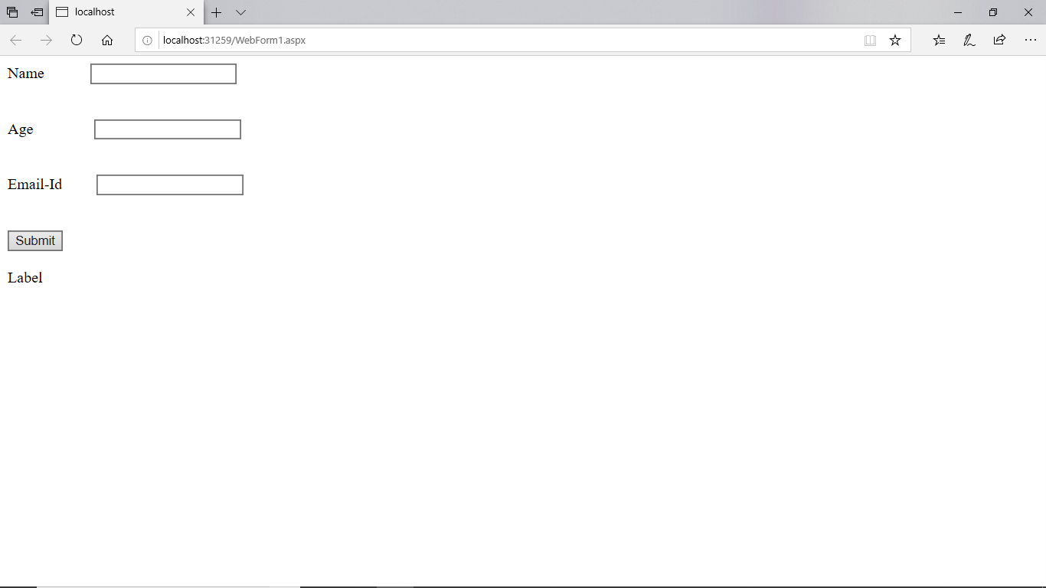 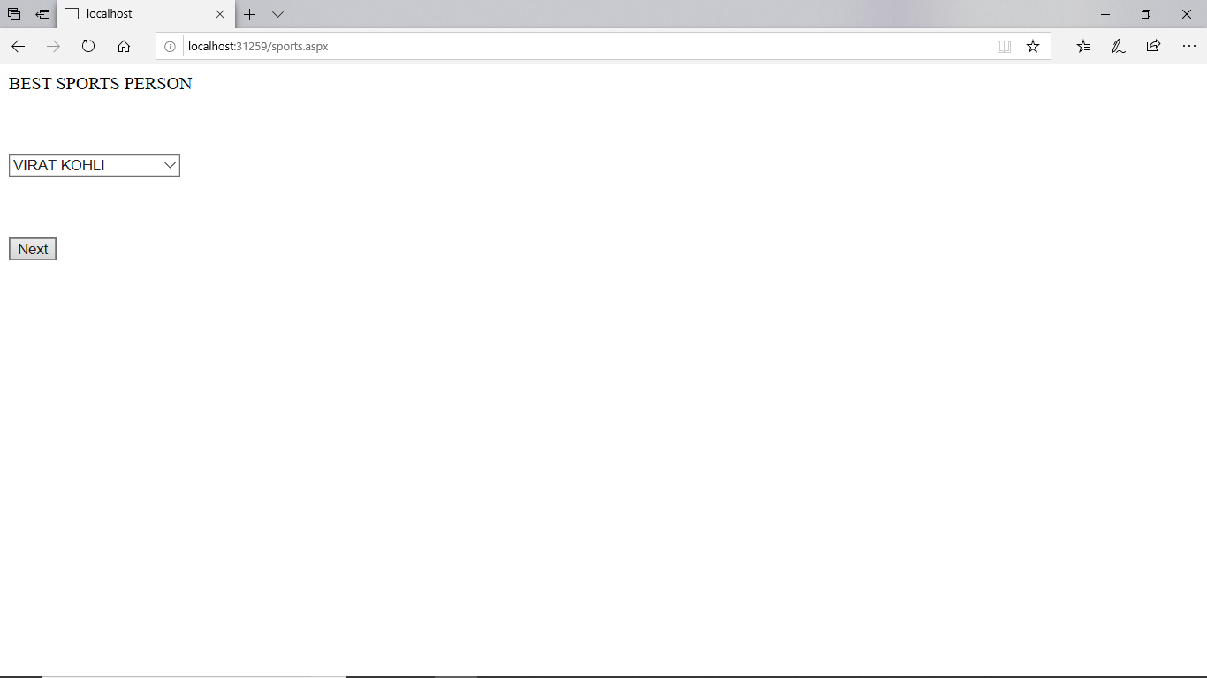

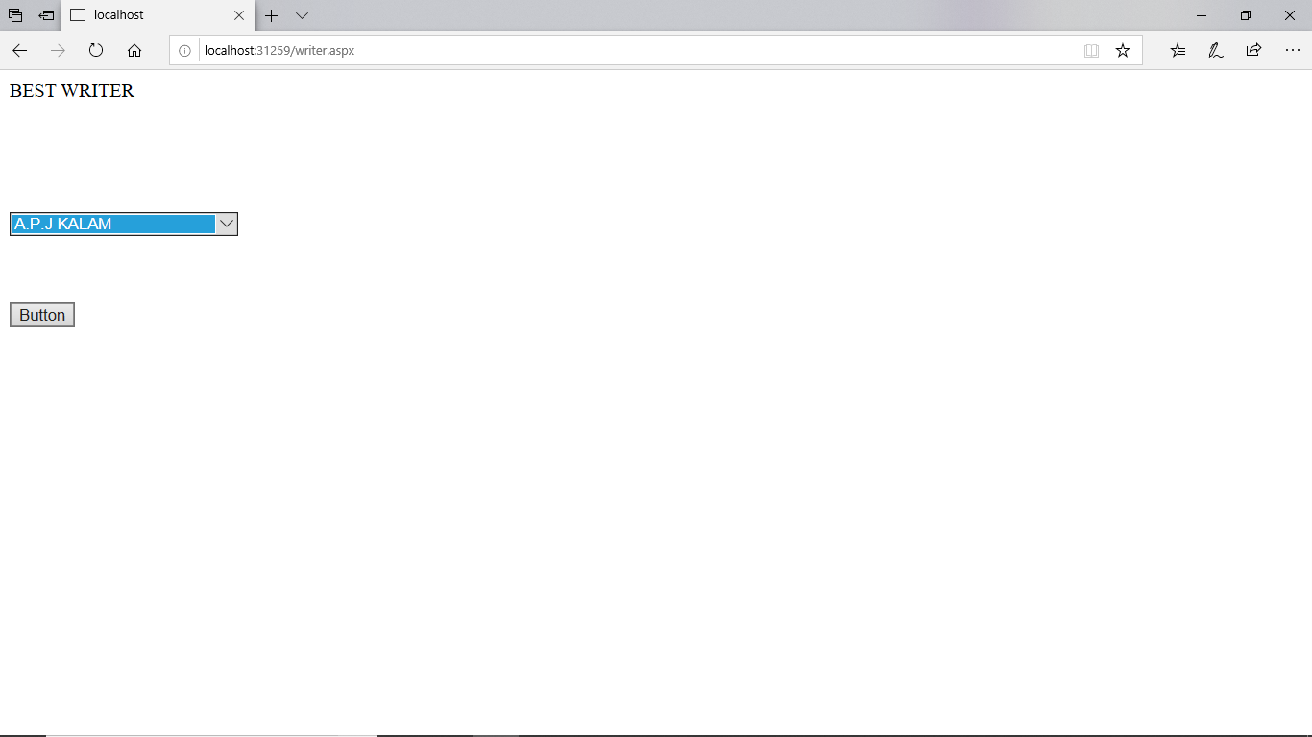 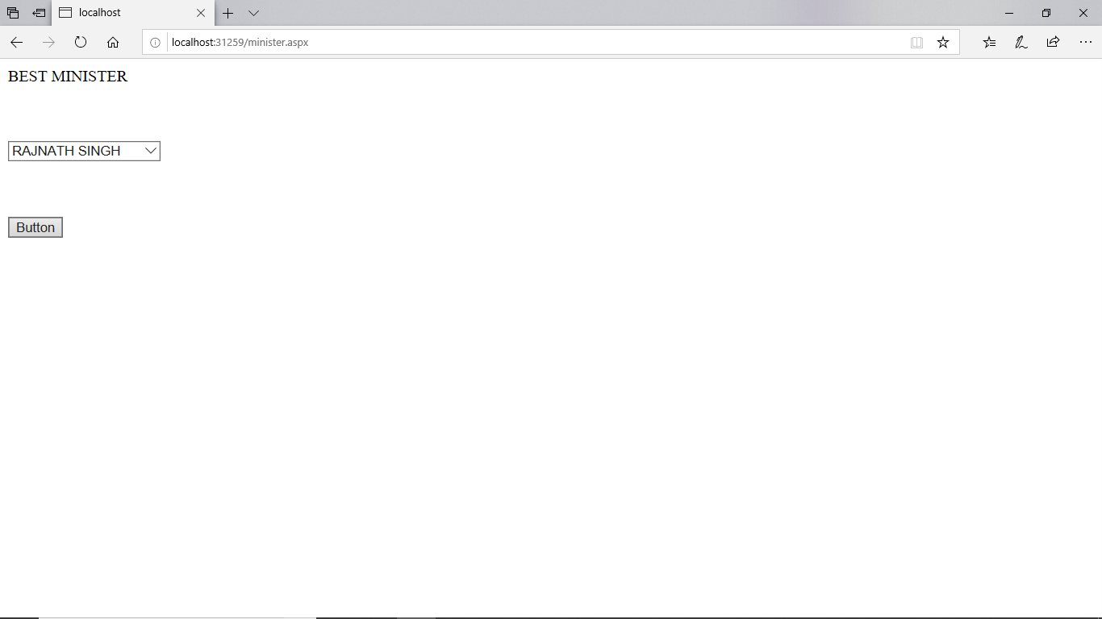

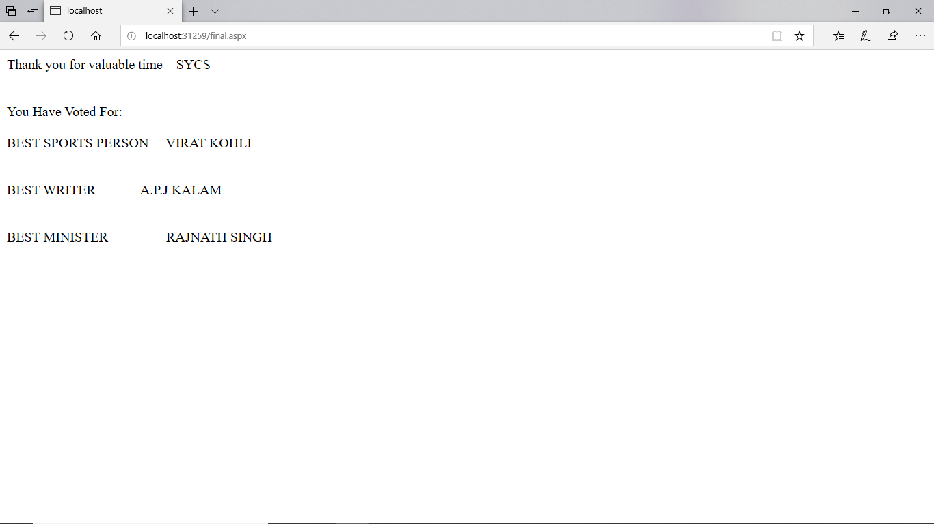

# PRACTICAL NO: 14

**-**

**Q) Design ASP.NET Pages with various Navigation Controls:**

**TreeView Control:**

**DESIGN**:

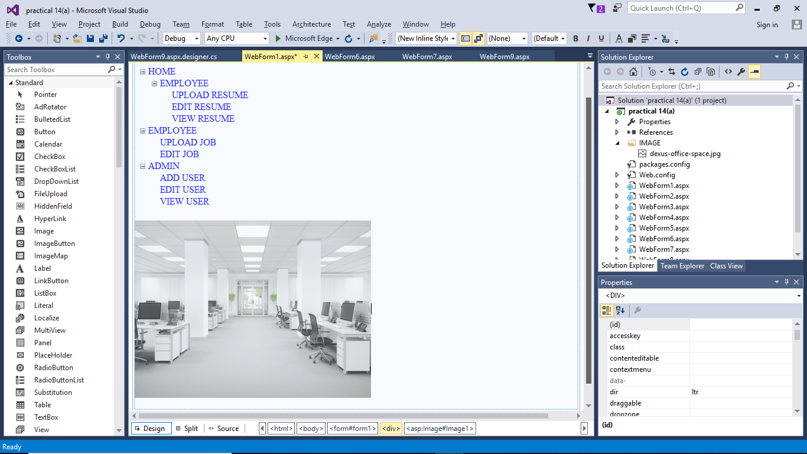

**WebForm.aspx:**

<%@ Page Language="C#" AutoEventWireup="true" CodeBehind="WebForm1.aspx.cs" Inherits="practical_14_a_.WebForm1" %>

<!DOCTYPE html>

<html xmlns="http://www.w3.org/1999/xhtml">

<head runat="server">

<title></title>

</head>

<body>

<form id="form1" runat="server">

<div>

<br />

TREE VIEW<br />

<asp:TreeView ID="TreeView1" runat="server">

<Nodes>

<asp:TreeNode Text="HOME" Value="HOME">

<asp:TreeNode Text="EMPLOYEE" Value="EMPLOYEE">

<asp:TreeNode NavigateUrl="~/WebForm2.aspx" Text="UPLOAD RESUME" Value="UPLOAD RESUME"></asp:TreeNode>

<asp:TreeNode NavigateUrl="~/WebForm3.aspx" Text="EDIT RESUME" Value="EDIT RESUME"></asp:TreeNode>

<asp:TreeNode NavigateUrl="~/WebForm4.aspx" Text="VIEW RESUME" Value="VIEW RESUME"></asp:TreeNode>

</asp:TreeNode>

</asp:TreeNode>

<asp:TreeNode Text="EMPLOYEE" Value="EMPLOYEE">

<asp:TreeNode NavigateUrl="~/WebForm5.aspx" Text="UPLOAD JOB" Value="UPLOAD JOB"></asp:TreeNode>

<asp:TreeNode NavigateUrl="~/WebForm6.aspx" Text="EDIT JOB" Value="EDIT JOB"></asp:TreeNode>

</asp:TreeNode>

<asp:TreeNode Text="ADMIN" Value="ADMIN">

<asp:TreeNode NavigateUrl="~/WebForm7.aspx" Text="ADD USER" Value="ADD USER"></asp:TreeNode>

<asp:TreeNode NavigateUrl="~/WebForm8.aspx" Text="EDIT USER" Value="EDIT USER"></asp:TreeNode>

<asp:TreeNode NavigateUrl="~/WebForm9.aspx" Text="VIEW USER" Value="VIEW USER"></asp:TreeNode>

</asp:TreeNode>

</Nodes>

</asp:TreeView>

<br />

<asp:Image ID="Image1" runat="server" ImageAlign="Middle" ImageUrl="~/IMAGE/dexus-office-space.jpg" Height="300px" Width="400px" />

<br />

<br />

</div>

</form>

</body>

</html>

**Resume page:**

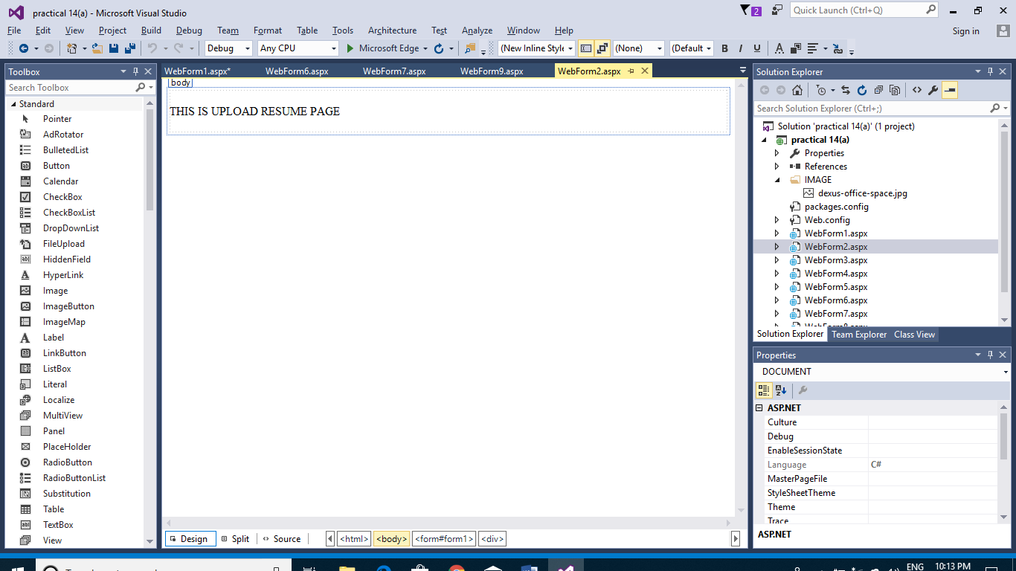

**Resume.aspx:**

<%@ Page Language="C#" AutoEventWireup="true" CodeBehind="WebForm2.aspx.cs" Inherits="practical_14_a_.WebForm2" %>

<!DOCTYPE html>

<html xmlns="http://www.w3.org/1999/xhtml">

<head runat="server">

<title></title>

</head>

<body>

<form id="form1" runat="server">

<div>

<br />

THIS IS UPLOAD RESUME PAGE<br />

<br />

</div>

</form>

</body>

</html>

**Design:**

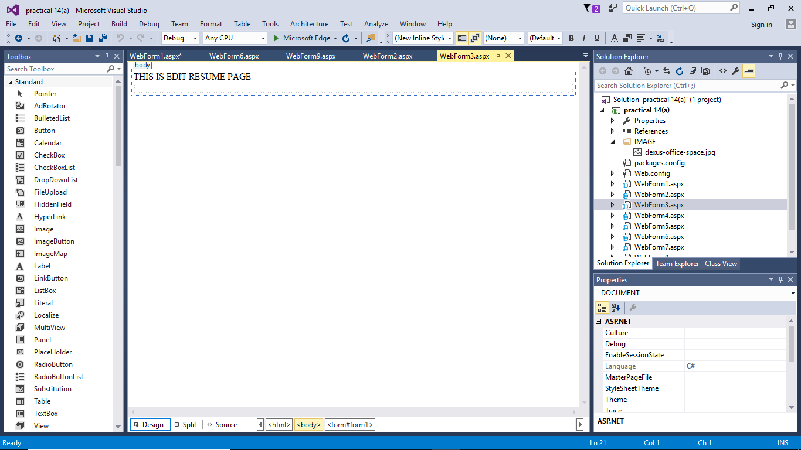

**EditResume.aspx:**

<%@ Page Language="C#" AutoEventWireup="true" CodeBehind="WebForm3.aspx.cs" Inherits="practical_14_a_.WebForm3" %>

<!DOCTYPE html>

<html xmlns="http://www.w3.org/1999/xhtml">

<head runat="server">

<title></title>

</head>

<body>

<form id="form1" runat="seKrver">

THIS IS EDIT RESUME PAGE

<div>

</div>

</form>

</body>

</html>

**ADD OTHER WEB PAGE ALSO LIKE THIS (VIEW RESUME,UPLOAD JOB,EDIT JOB, ADD USER,EDIT USER,VIEW USER)**

**OUTPUT:**

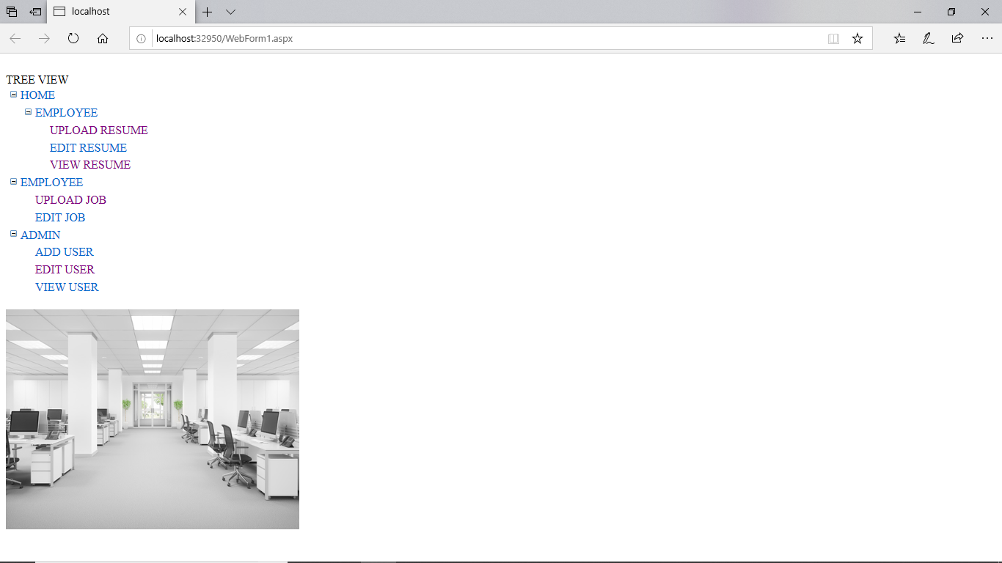

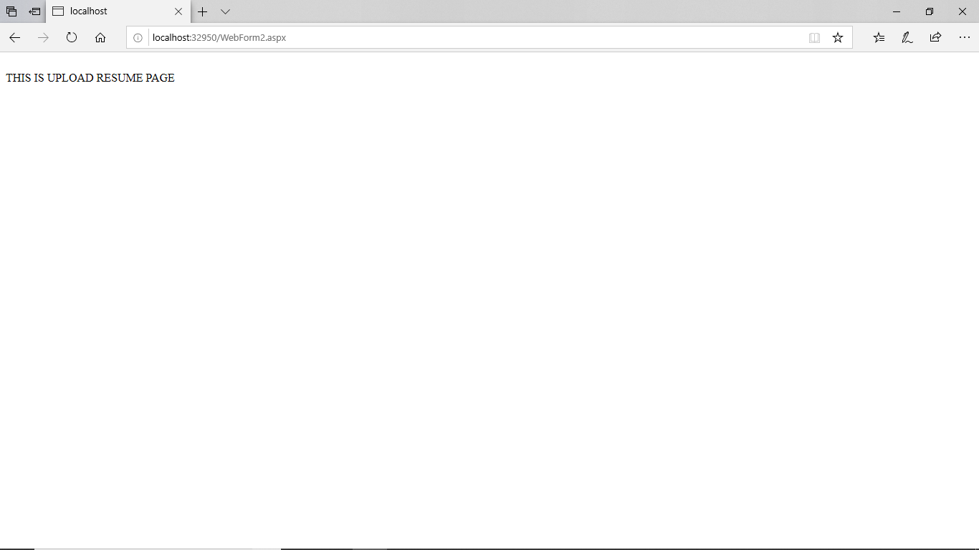



**B) Menu Control.**

**DESIGN PAGE:**

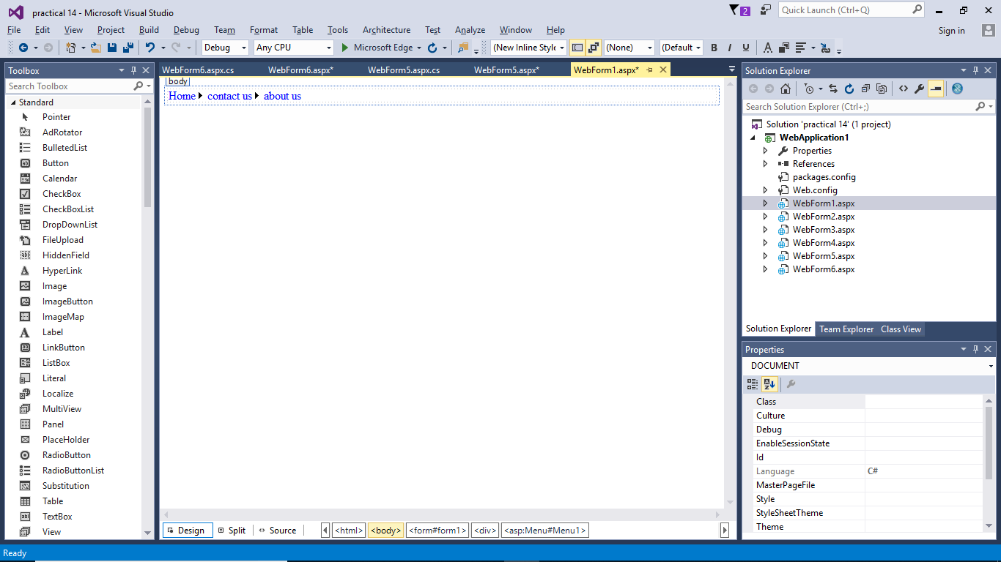

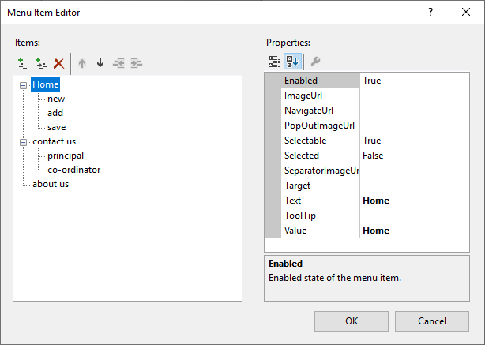

**WebForm1.aspx:**

<%@ Page Language="C#" AutoEventWireup="true" CodeBehind="WebForm1.aspx.cs" Inherits="WebApplication1.WebForm1" %>

<!DOCTYPE html>

<html xmlns="http://www.w3.org/1999/xhtml">

<head runat="server">

<title></title>

</head>

<body>

<form id="form1" runat="server">

<div>

<asp:Menu ID="Menu1" runat="server" Orientation="Horizontal">

<Items>

<asp:MenuItem Text="Home" Value="Home">

<asp:MenuItem NavigateUrl="~/WebForm2.aspx" Text="new " Value="new "></asp:MenuItem>

<asp:MenuItem NavigateUrl="~/WebForm3.aspx" Text="add" Value="add"></asp:MenuItem>

<asp:MenuItem NavigateUrl="~/WebForm4.aspx" Text="save" Value="save"></asp:MenuItem>

</asp:MenuItem>

<asp:MenuItem Text="contact us" Value="contact us">

<asp:MenuItem NavigateUrl="~/WebForm5.aspx" Text="principal" Value="principal"></asp:MenuItem>

<asp:MenuItem NavigateUrl="~/WebForm6.aspx" Text="co-ordinator" Value="co-ordinator"></asp:MenuItem>

</asp:MenuItem>

<asp:MenuItem Text="about us" Value="about us"></asp:MenuItem>

</Items>

</asp:Menu>

</div>

</form>

</body>

</html>

**ADD OTHER WEB PAGE ALSO LIKE THIS (NEW PAGE,ADD PAGE ,SAVE PAGE, PRINCIPAL CONTACT PAGE,CO ORDINATOR PAGE)**

**OUTPUT:**

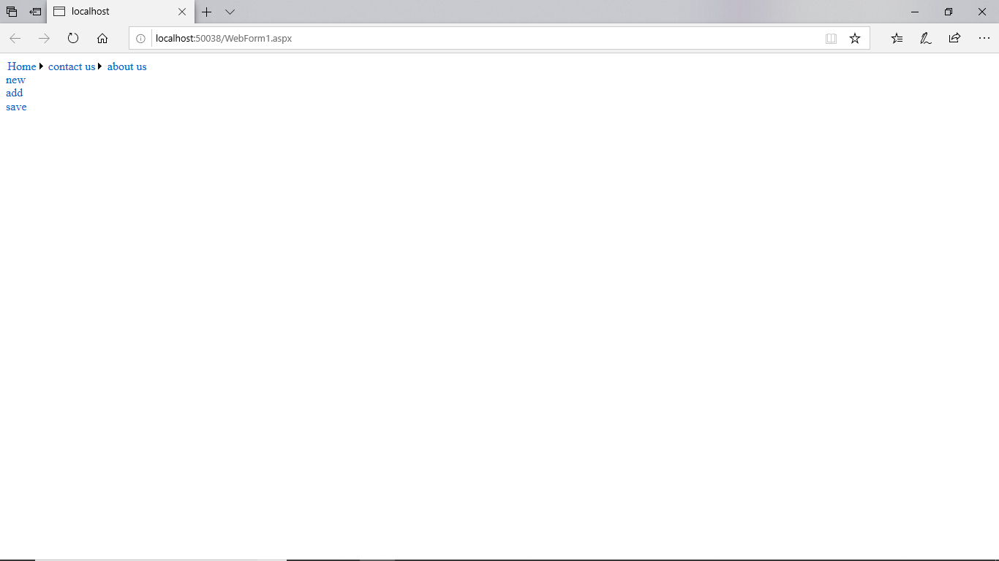 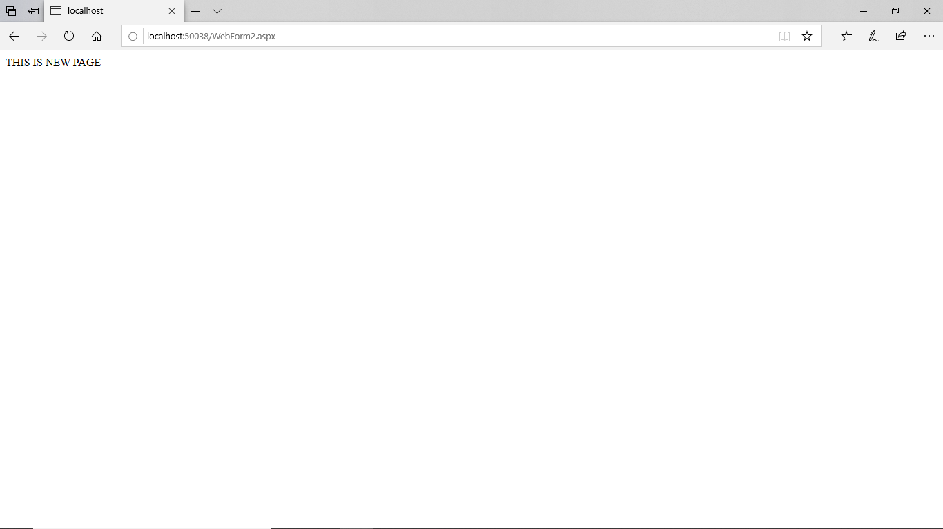

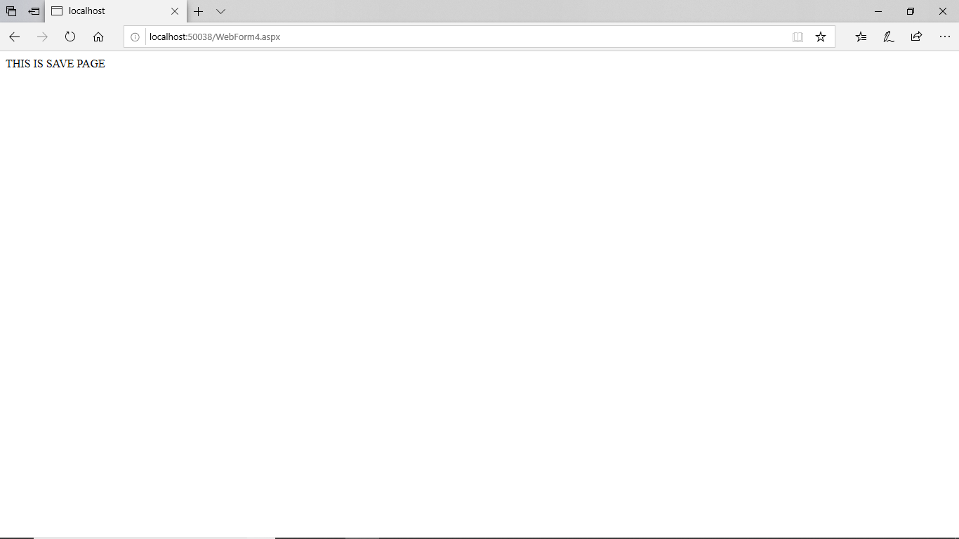 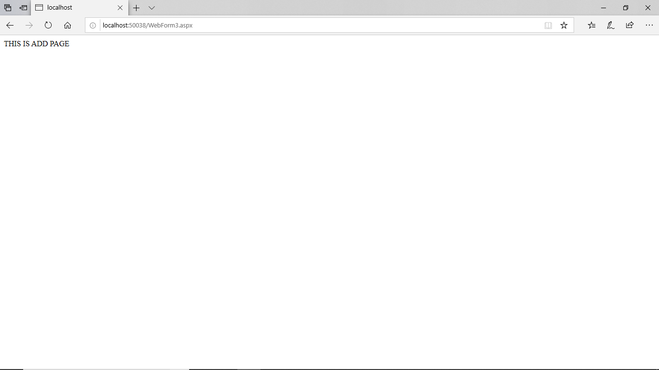

# PRACTICAL NO: 15

**Q) Performing ADO.NET data access in ASP.NET for**

**Simple Data Binding over Label control**

**Repeated Value Data Binding over DropdownList and GridView Control.**

<%@ Page Language="C#" AutoEventWireup="true" CodeBehind="databinding2.aspx.cs" Inherits="MasterPageDemo.databinding2" %>

<!DOCTYPE html>

<html xmlns="http://www.w3.org/1999/xhtml">

<head runat="server">

<title></title>

</head>

<body>

<form id="form1" runat="server">

<div>

</div>

<asp:GridView ID="GridView1" runat="server" AutoGenerateColumns="False" DataKeyNames="roll_no" DataSourceID="SqlDataSource1">

<Columns>

<asp:BoundField DataField="roll_no" HeaderText="roll_no" ReadOnly="True" SortExpression="roll_no" />

<asp:BoundField DataField="name" HeaderText="name" SortExpression="name" />

<asp:BoundField DataField="age" HeaderText="age" SortExpression="age" />

</Columns>

</asp:GridView>

<asp:SqlDataSource ID="SqlDataSource1" runat="server" ConnectionString="<%$ ConnectionStrings:newconnection %>" OnSelecting="SqlDataSource1_Selecting" SelectCommand="SELECT * FROM [Student]"></asp:SqlDataSource>

<p>

&nbsp; Select Roll Number of students from the following dropdown list :</p>

<p>

<asp:DropDownList ID="DropDownList1" runat="server" AutoPostBack="True" DataSourceID="SqlDataSource1" DataTextField="roll_no" DataValueField="name" OnSelectedIndexChanged="DropDownList1_SelectedIndexChanged">

</asp:DropDownList>

</p>

<p>

You have selected Roll no. <asp:Label ID="Label1" runat="server"></asp:Label>

&nbsp;whose Name&nbsp; is&nbsp; <asp:Label ID="Label2" runat="server"></asp:Label>

</p>

</form>

</body>

</html>

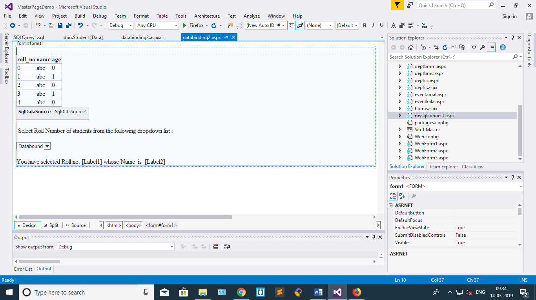

Databinding2.aspx.cs:-

using System;

using System.Collections.Generic;

using System.Configuration;

using System.Data.SqlClient;

using System.Linq;

using System.Web;

using System.Web.UI;

using System.Web.UI.WebControls;

namespace MasterPageDemo

{

public partial class databinding2 : System.Web.UI.Page

{

SqlConnection con;

SqlCommand cmd;

protected void DropDownList1_SelectedIndexChanged(object sender, EventArgs e)

{

try

{

con = new SqlConnection(ConfigurationManager.ConnectionStrings["newconnection"].ConnectionString);

con.Open();

String i= DropDownList1.SelectedItem.ToString();

cmd = new SqlCommand("select name from Student where roll_no="+i, con);

Object a = cmd.ExecuteScalar();

Label1.Text = i.ToString();

Label2.Text = a.ToString();

}

catch { }

}

}

}

# PRACTICAL NO: 16

**DESIGN:**

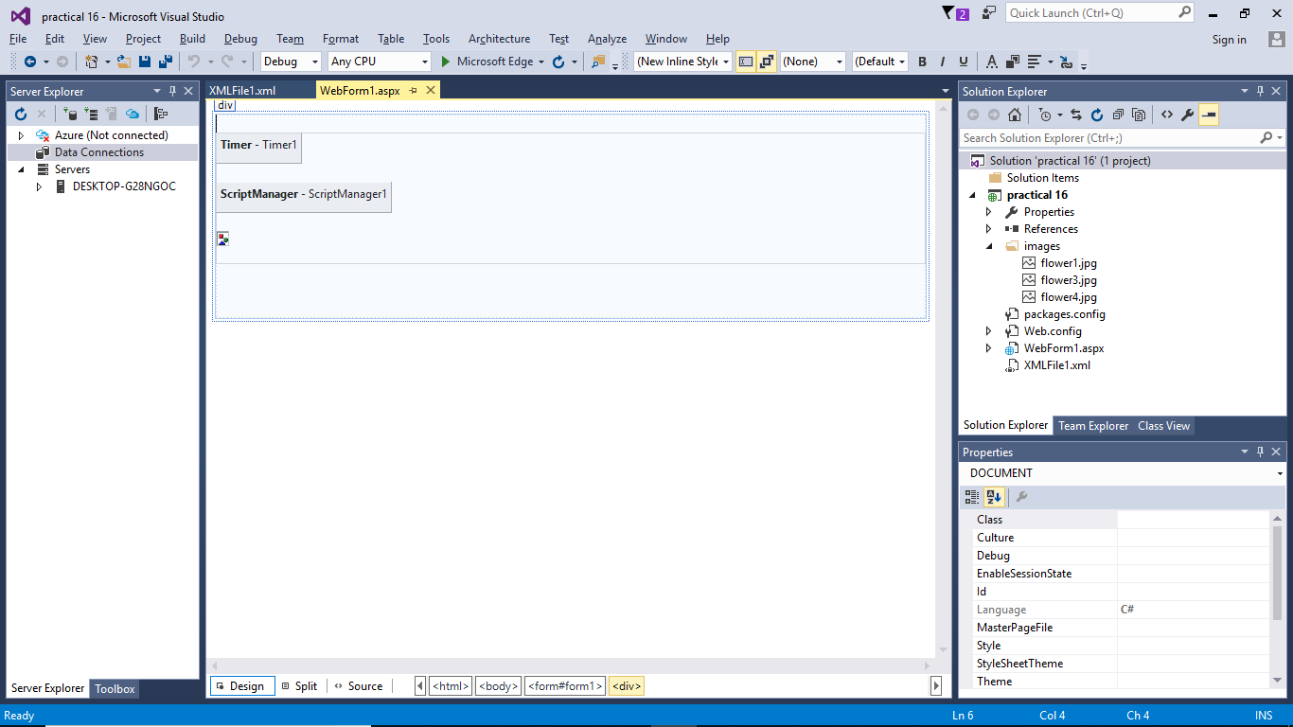

**WebForm.aspx:**

<%@ Page Language="C#" AutoEventWireup="true" CodeBehind="WebForm1.aspx.cs" Inherits="practical_10_b_.WebForm1" %>

<!DOCTYPE html>

<html xmlns="http://www.w3.org/1999/xhtml">

<head runat="server">

<title></title>

</head>

<body>

<form id="form1" runat="server">

<div>

<br />

<br />

<br />

<asp:UpdatePanel ID="UpdatePanel1" runat="server">

<ContentTemplate>

<asp:Timer ID="Timer1" runat="server" Interval="600">

</asp:Timer>

<br />

<asp:ScriptManager ID="ScriptManager1" runat="server">

</asp:ScriptManager>

<br />

<br />

<asp:AdRotator ID="AdRotator1" runat="server" AdvertisementFile="~/XMLFile1.xml" Height="300px" Width="500px" />

<br />

<br />

<br />

<br />

<br />

<br />

<br />

</ContentTemplate>

</asp:UpdatePanel>

<br />

<br />

<br />

<br />

</div>

</form>

</body>

</html>

**XMlFIle.xml:**

<?xml version="1.0" encoding="utf-8" ?>

<Advertisements>

<Ad>

<ImageUrl>~/images/flower1.jpg</ImageUrl>

</Ad>

<Ad>

<ImageUrl>~/images/flower3.jpg</ImageUrl>

</Ad>

<Ad>

<ImageUrl>~/images/flower4.jpg</ImageUrl>

</Ad>

</Advertisements>

**OUTPUT:**

 



# PRACTICAL NO: 17

**Q) Design ASP.NET application to query a Database (External Data Source).**

**Create a database ‘sycs’ and a table Student (id, name). Connect the front end with backend database.**

**Create a table Student (id, name). Keep a ‘Show’ button to display the entire Student table on the webpage, a ‘Insert’ button to insert records in the table, a ‘Search’ button to look for student name with id as input, an ‘Edit’ button to edit student name for the given id, ’Delete’ button to delete a student record.**

**DESIGN:**

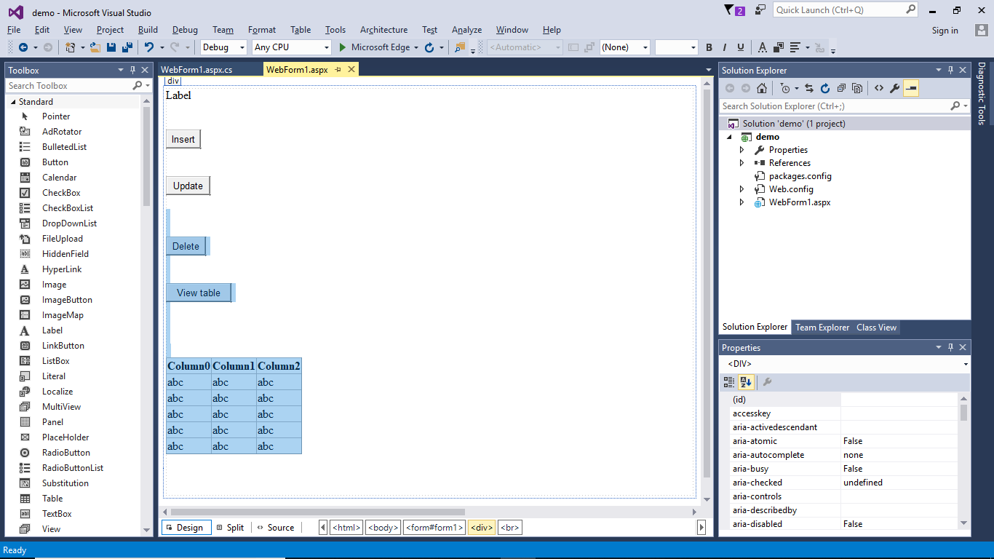

**WebForm.aspx.cs:**

using MySql.Data.MySqlClient;

using System;

using System.Collections.Generic;

using System.Data;

using System.Linq;

using System.Web;

using System.Web.UI;

using System.Web.UI.WebControls;

namespace demo

{

public partial class WebForm1 : System.Web.UI.Page

{

MySqlConnection con;

MySqlCommand cmd;

public string ConnectionString { get; private set; }

protected void Page_Load(object sender, EventArgs e)

{

try

{

ConnectionString = "Server=127.0.0.1;Port=3306;Database=sycs;Uid=root;Pwd=jammy;";

con = new MySqlConnection(ConnectionString);

con.Open();

Label1.Text = "Database Connected...";

}

catch (Exception ex)

{

}

}

protected void Button1_Click(object sender, EventArgs e)

{

cmd = new MySqlCommand("insert into student values('cs13','PQR')");

cmd.Connection = con;

cmd.ExecuteNonQuery();

Response.Write("Row Inserted.");

}

protected void Button3_Click(object sender, EventArgs e)

{

cmd = new MySqlCommand("delete from student where id='cs12'");

cmd.Connection = con;

cmd.ExecuteNonQuery();

Response.Write("Record deleted.");

}

protected void Button2_Click(object sender, EventArgs e)

{

cmd = new MySqlCommand("update student set name='MNO' where id='cs12'");

cmd.Connection = con;

cmd.ExecuteNonQuery();

Response.Write("Row Updated.");

}

protected void Button4_Click(object sender, EventArgs e)

{

MySqlCommand cmd = new MySqlCommand("select * from student");

MySqlDataAdapter ad = new MySqlDataAdapter();

cmd.Connection = con;

ad.SelectCommand = cmd;

DataTable dt = new DataTable();

ad.Fill(dt);

GridView1.DataSource = dt;

GridView1.DataBind();

con.Close();

}

}

}

**OUTPUT:**

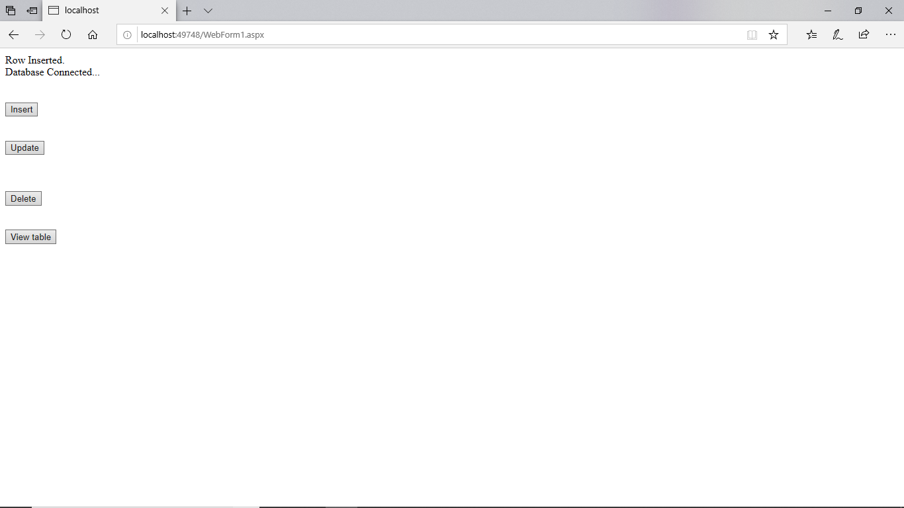 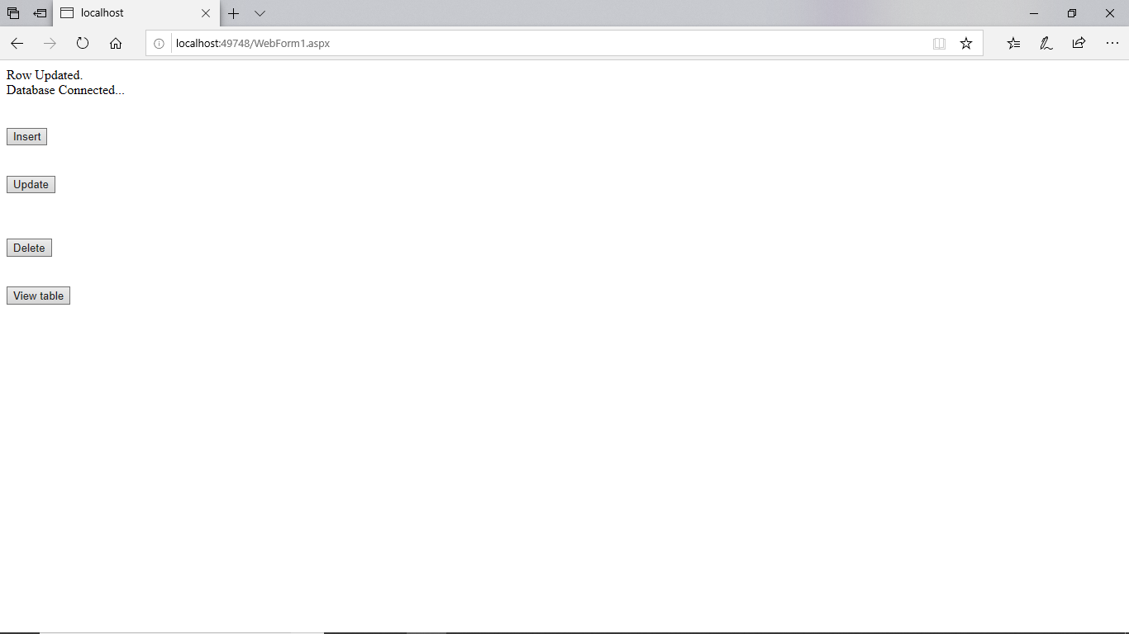

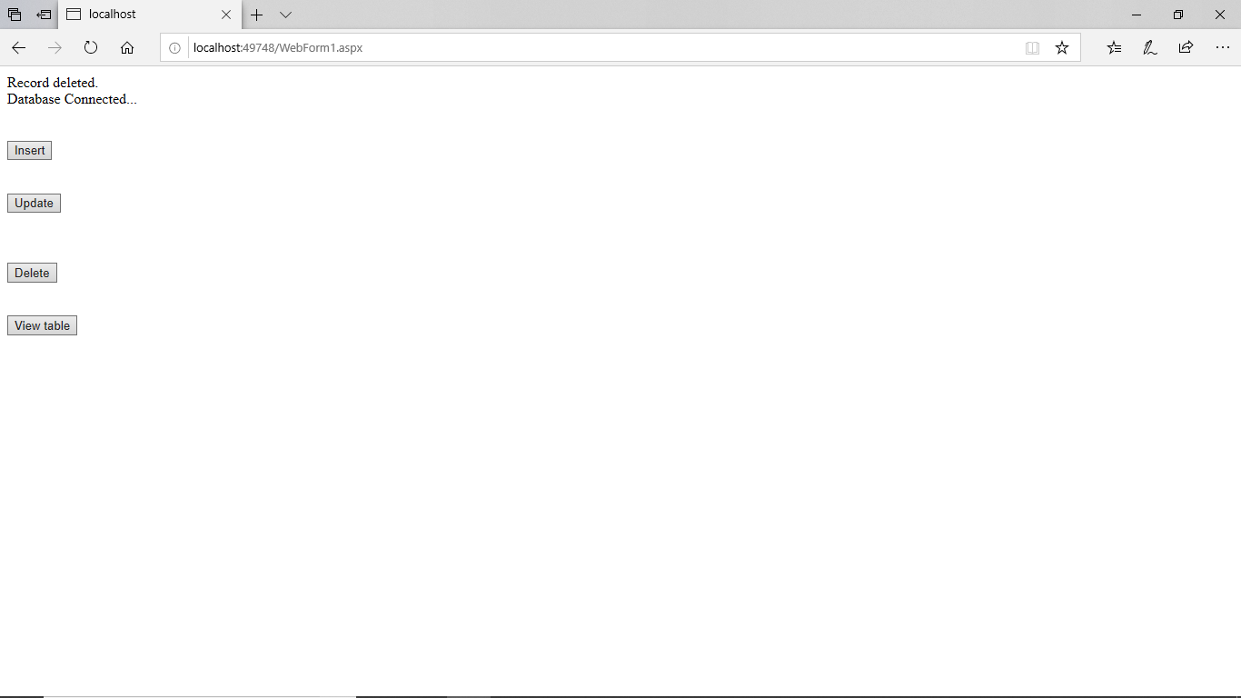 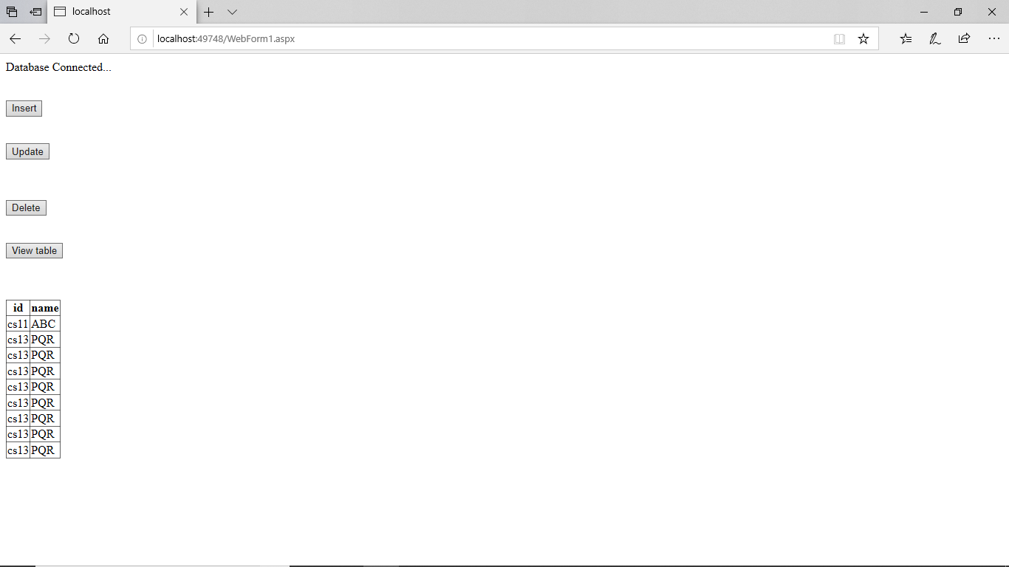

# PRACTICAL NO: 18

**Q)Assuming that there are 2 tables –**

**Customer(accno,name,phoneno,address) where Accno is the Primary Key, Account(accno,type,balance) where accno is the foreign key referencing Customer(accno)**

**Design ASP.NET pages for Customer, Account and checking for balance details.**

Input:

Bank.aspx

<%@ Page Language="C#" AutoEventWireup="true" CodeBehind="Bank.aspx.cs"

Inherits="PracticalsPractise.Bank" %>

<!DOCTYPE html>

<html xmlns="http://www.w3.org/1999/xhtml">

<head runat="server">

<title></title>

</head>

<body>

<form id="form1" runat="server">

<div>

<br /><br /><br />

Account

No:&nbsp;&nbsp;&nbsp;&nbsp;&nbsp;&nbsp;&nbsp;&nbsp;&nbsp;&nbsp;&nbsp;&nbsp

;

<asp:TextBox ID="TextBox1" runat="server"></asp:TextBox>

<br /><br />

&nbsp;&nbsp;&nbsp;&nbsp;&nbsp;&nbsp;&nbsp;&nbsp;&nbsp;&nbsp;&nbsp;&nbsp;&n bsp;&nbsp;

<asp:Button ID="Button1" runat="server"

OnClick="Button1_Click" Text="Submit" />

<br /><br />

&nbsp;&nbsp;&nbsp;&nbsp;&nbsp;&nbsp;&nbsp;&nbsp;&nbsp;&nbsp;&nbsp;&nbsp;&n bsp;&nbsp;

<br /><br />

<asp:Label ID="Label3" runat="server" Text="Label"></asp:Label>

<asp:Label ID="Label1" runat="server"

Text="Label"></asp:Label>

<br />

<asp:Label ID="Label4" runat="server"

Text="Label"></asp:Label>

<asp:Label ID="Label2" runat="server"

Text="Label"></asp:Label>

<br /><br />

<asp:SqlDataSource ID="SqlDataSource1" runat="server"

ConnectionString="<%$ ConnectionStrings:ConnectionString %>"

SelectCommand="select * from Customer where AccNo=@TextBox1;"> <SelectParameters>

<asp:ControlParameter ControlID="TextBox1"

Name="TextBox1" PropertyName="Text" />

</SelectParameters>

</asp:SqlDataSource>

</div>

</form>

</body>

</html> Bank.aspx.cs

using System;

using System.Collections.Generic; using System.Configuration; using System.Linq; using System.Web; using System.Web.UI; using System.Web.UI.WebControls; using System.Data.SqlClient; namespace PracticalsPractise

{

public partial class Bank : System.Web.UI.Page

{

String conn =

ConfigurationManager.ConnectionStrings["MyDb"].ConnectionString;

SqlCommand cmd;

protected void Page_Load(object sender, EventArgs e)

{

}

protected void Button1_Click(object sender, EventArgs e)

{

SqlConnection c = new SqlConnection(conn);

c.Open();

String query = "select Balance from Account where AccNo="+TextBox1.Text;

cmd = new SqlCommand(query, c);

SqlDataReader dr = cmd.ExecuteReader();

dr.Read();

Label3.Text = "Your balance is:";

Label1.Text = dr["Balance"].ToString();

c.Close();

SqlConnection c1 = new SqlConnection(conn);

c1.Open();

String query1 = "select AccName from Customer where AccNo=" + TextBox1.Text;

cmd = new SqlCommand(query1, c1);

SSqlDataReader dr1 = cmd.ExecuteReader();

dr1.Read();

Label4.Text = "Your Name is:";

Label2.Text = dr1["AccName"].ToString(); c1.Close();

}

}

}

**Output:**

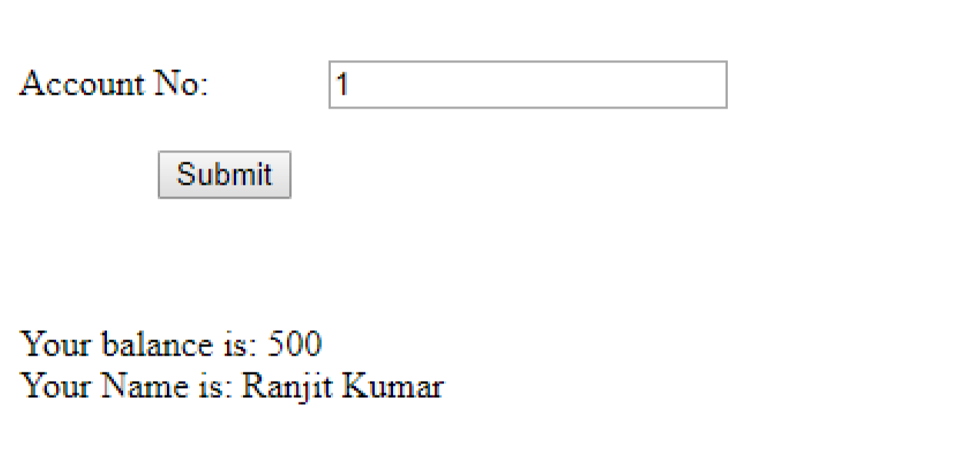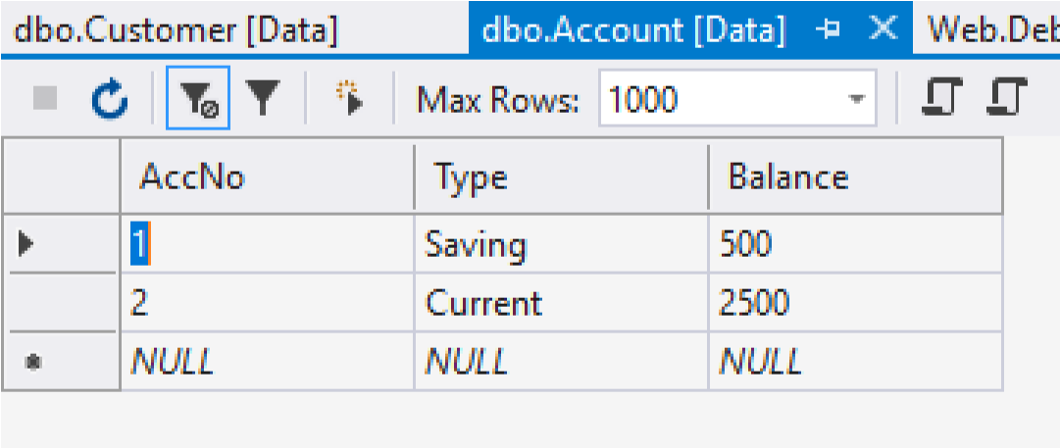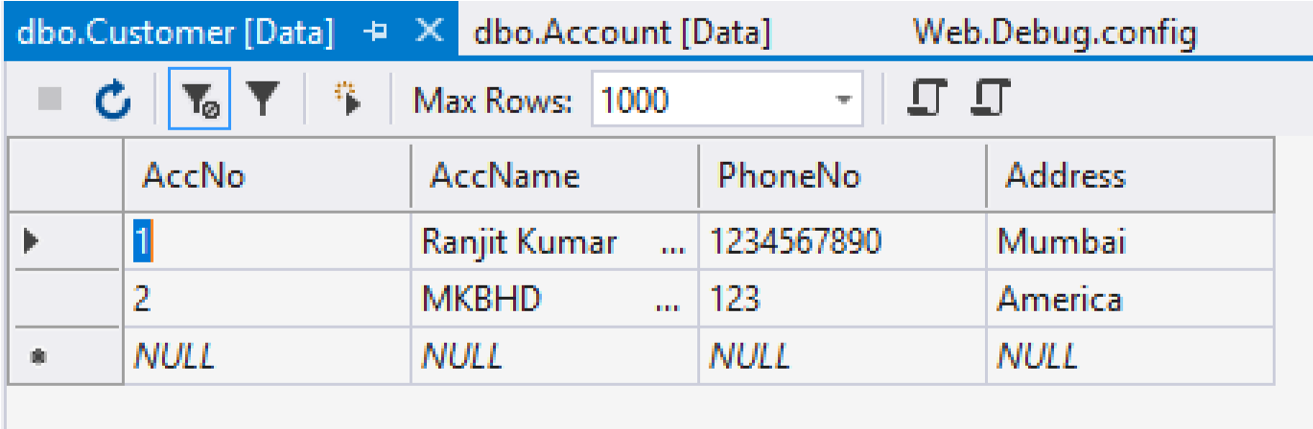

# PRACTICAL NO: 19

**Q)Assuming that there are 2 tables – Cust(AccNo, AccName, Passwd, CurrBal) & Transactions(TransId, AccNo, Date, Amt, TransType, Client) where TransType can be Debit or Credit. User should input AccNo and password. For successful login, it should show welcome message with the user’s name, current balance and transactions of the current month in table.**

Input:

Account.aspx

<%@ Page Language="C#" AutoEventWireup="true" CodeBehind="Account.aspx.cs"

Inherits="Practs14._Account" %>

<!DOCTYPE html>

<html xmlns="http://www.w3.org/1999/xhtml">

<head runat="server">

<title></title>

</head>

<body>

<form id="form1" runat="server">

<div>

Account No. :&nbsp;&nbsp;

<asp:TextBox ID="TextBox1" runat="server"></asp:TextBox>

<br />

<br />

Password :&nbsp;&nbsp;&nbsp;&nbsp;&nbsp;&nbsp;&nbsp;

<asp:TextBox ID="TextBox2" runat="server"

TextMode="Password"></asp:TextBox>

<br />

<br />

&nbsp;&nbsp;&nbsp;&nbsp;&nbsp;&nbsp;&nbsp;

<asp:Button ID="Button1" runat="server" OnClick="Button1_Click"

Text="Get Detail" />

<br />

<br />

<asp:Label ID="Label1" runat="server"></asp:Label>

<br />

<br />

<asp:Label ID="Label2" runat="server"></asp:Label>

<br />

<br />

Transactions of this month <br />

<br />

<asp:GridView ID="GridView1" runat="server">

</asp:GridView>

<br />

</div>

</form>

</body>

</html>

Account.aspx.cs using System;

using System.Collections.Generic; using System.Linq; using System.Web; using System.Web.UI; using System.Web.UI.WebControls; using System.Data;

using MySql.Data.MySqlClient;

namespace Practs14

{

public partial class Account : System.Web.UI.Page

{

MySqlConnection conn;

String ConnectionString;

String sql;

protected void Page_Load(object sender, EventArgs e)

{

Label1.Text = "";

Label2.Text = "";

ConnectionString =

"Server=127.0.0.1;Port=3306;Database=SYCS;Uid=root;Pwd=8543998287;"; conn = new MySqlConnection(ConnectionString);

}

protected void Button1_Click(object sender, EventArgs e)

{ try {

conn.Open();

sql = "Select * from cust where accno="+TextBox1.Text+" and password='"+TextBox2.Text+"';";

Label1.Text = sql;

MySqlDataAdapter mydata = new MySqlDataAdapter(sql, conn);

DataTable ds = new DataTable();

mydata.Fill(ds);

if (ds.Rows.Count > 0)

{

foreach (DataRow row in ds.Rows)

{

Label1.Text="Welcome, "+row["AccName"].ToString();

Label2.Text= "Current balance : "+row["CurrBal"].ToString();

} } else

{

Response.Write("<script language=javascript>alert('Wrong account no. or password')</script>");

}

sql = "Select * from transactions where accno=" + TextBox1.Text + ";";

mydata = new MySqlDataAdapter(sql, conn);

ds = new DataTable();

mydata.Fill(ds);

GridView1.DataSource = ds;

GridView1.DataBind();

conn.Close();

}

catch (Exception ex)

{

Label2.Text = ex.ToString();

}

}

}

}

Output-

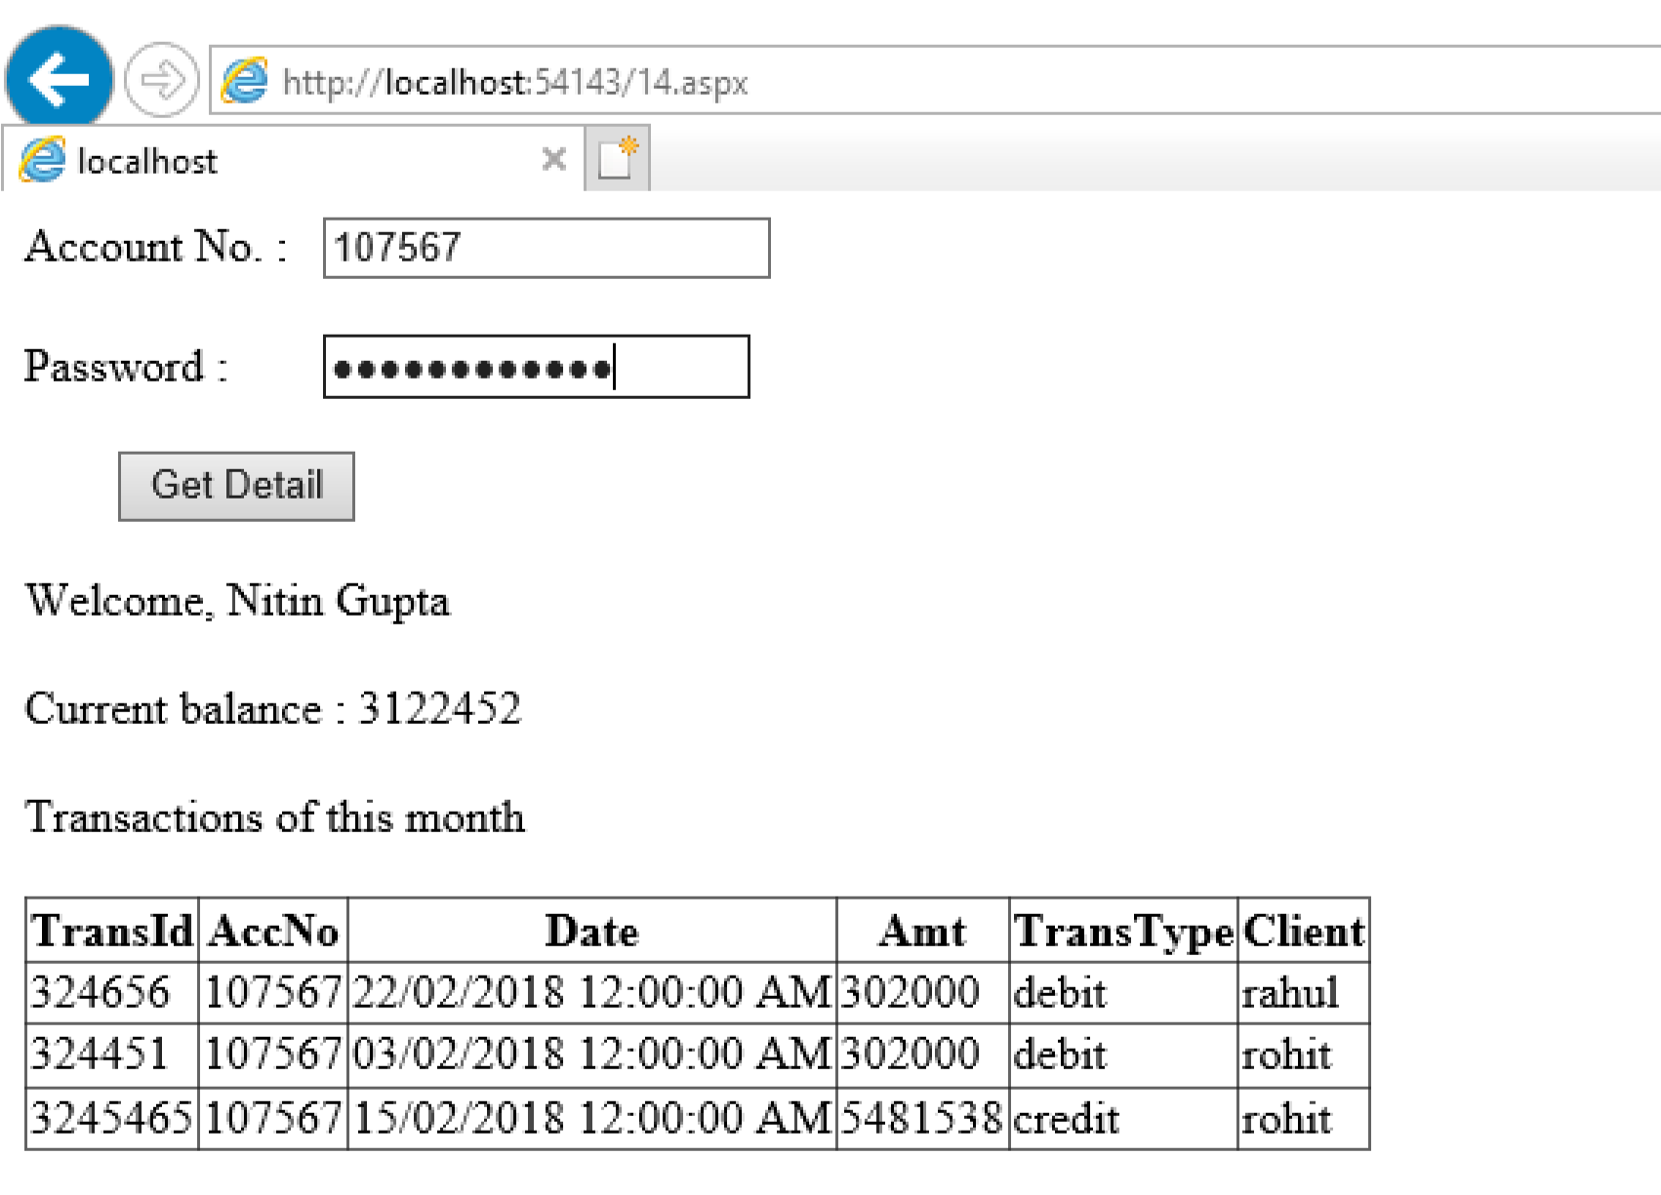

# PRACTICAL NO: 20

**Q) Develop a web page for a real estate firm. The user after visiting the site, selects the name of city from combo-box. In return, the user gets information about all the flats from that city such as No. of Rooms, Expected Price in a grid. At a time, information of only 5 flats should be visible. [Use data binding and sql data source].**

RealEstate.aspx

<%@ Page Language="C#" AutoEventWireup="true"

CodeBehind="RealEstate.aspx.cs" Inherits="Practs1415.RealEstate" %>

<!DOCTYPE html>

<html xmlns="http://www.w3.org/1999/xhtml">

<head runat="server">

<title></title>

</head>

<body>

<form id="form1" runat="server">

<div>

Select City :

<asp:DropDownList ID="DropDownList1" runat="server"

AutoPostBack="True"

OnSelectedIndexChanged="GridView1_SelectedIndexChanged">

<asp:ListItem>Varanasi</asp:ListItem>

<asp:ListItem>Pune</asp:ListItem>

<asp:ListItem>Chennai</asp:ListItem>

<asp:ListItem>Mumbai</asp:ListItem>

<asp:ListItem>Delhi</asp:ListItem>

</asp:DropDownList>

<br />

<br />

<asp:Label ID="Label1" runat="server"></asp:Label>

<asp:GridView ID="GridView1" runat="server"

OnSelectedIndexChanged="GridView1_SelectedIndexChanged">

</asp:GridView>

<br />

</div>

</form>

</body>

</html>

RealEstate.aspx.cs using System;

using System.Collections.Generic; using System.Linq; using System.Web; using System.Web.UI; using System.Web.UI.WebControls; using System.Data;

using MySql.Data.MySqlClient; namespace Practs1415

{

public partial class RealEstate : System.Web.UI.Page

{

MySqlConnection conn;

String ConnectionString;

String sql;

protected void Page_Load(object sender, EventArgs e)

{

ConnectionString =

"Server=127.0.0.1;Port=3306;Database=SYCS;Uid=root;Pwd=8543998287;"; conn = new MySqlConnection(ConnectionString);

}

protected void GridView1_SelectedIndexChanged(object sender,

EventArgs e) { try {

conn.Open();

sql = "Select * from RealEstate where city='" +

DropDownList1.SelectedValue + "';";

MySqlDataAdapter mydata = new MySqlDataAdapter(sql, conn);

DataTable ds = new DataTable(); mydata.Fill(ds);

GridView1.DataSource = ds; GridView1.DataBind(); conn.Close();

}

catch (Exception ex)

{

Label1.Text = ex.ToString();

}

}

}

}

Output-

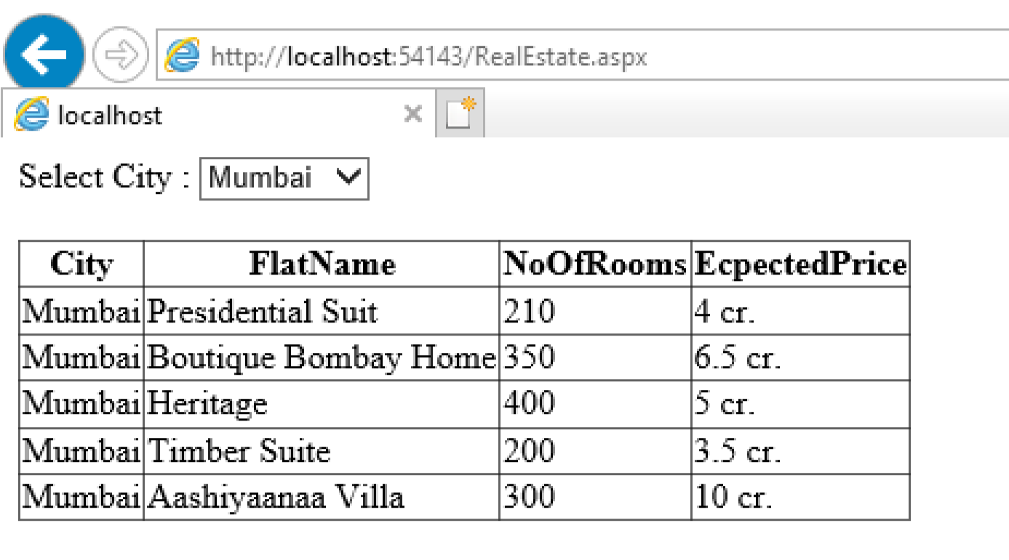

# PRACTICAL NO :21

**Q)Design a page that contains some list of theaters of Famous Cinemas in list box. It should also contain a link button that navigates to a page that displays time table of movies of selected theatre. Store the output of the first page in cache. When user selects theatre, the time table should be read from cache if it exists(Use Output & Data Cache).**

**Page1**

<%@ Page Language="C#" AutoEventWireup="true" CodeBehind="MovieTheater.aspx.cs" Inherits="p7.MovieTheater" %>

<!DOCTYPE html>

<html xmlns="http://www.w3.org/1999/xhtml">

<head runat="server">

<title></title>

</head>

<body>

<form id="form1" runat="server">

<div>

<asp:Label ID="Label1" runat="server" Font-Size="X-Large" Text="Threater"></asp:Label>

&nbsp;&nbsp;&nbsp;&nbsp;&nbsp;

<asp:DropDownList ID="ddl1" runat="server" AutoPostBack="True"

Font-Size="X-Large" onselectedindexchanged="ddl1_SelectedIndexChanged">

<asp:ListItem>Cinemax</asp:ListItem>

<asp:ListItem>FunRepublic</asp:ListItem>

<asp:ListItem>Growels</asp:ListItem>

<asp:ListItem></asp:ListItem>

</asp:DropDownList>

&nbsp;&nbsp;

<br /><br /><br /><br /><br /><br /><br /><br /><br />

&nbsp;&nbsp;&nbsp;&nbsp;&nbsp;&nbsp;&nbsp;&nbsp;&nbsp;&nbsp;&nbsp;&nbsp;&nbsp;&nbsp;&nbsp;

<asp:HyperLink ID="hyp1" runat="server" Font-Size="X-Large"

NavigateUrl="~/Page2.aspx">Display Schedule</asp:HyperLink>

&nbsp;

</div></form></body>

**Page 1 C# Code**

using System;

using System.Collections.Generic;

using System.Linq;

using System.Web;

using System.Web.UI;

using System.Web.UI.WebControls;

namespace p7

{

public partial class MovieTheater : System.Web.UI.Page

{

protected void Page_Load(object sender, EventArgs e)

{

}

protected void ddl1_SelectedIndexChanged(object sender, EventArgs e)

{

Session["thr"] = ddl1.SelectedItem;

}

}

}

**Page 2**

<%@ Page Language="C#" AutoEventWireup="true" CodeBehind="page2.aspx.cs" Inherits="p7.page2" %>

<!DOCTYPE html>

<html xmlns="http://www.w3.org/1999/xhtml">

<head runat="server">

<title></title>

</head>

<body>

<form id="form1" runat="server">

<div>

<asp:Label ID="Label1" runat="server" Text="Label"></asp:Label>

</div>

</form>

</body>

</html>

**Page 2 C# code**

using System;

using System.Collections.Generic;

using System.Linq;

using System.Web;

using System.Web.UI;

using System.Web.UI.WebControls;

namespace p7

{

public partial class page2 : System.Web.UI.Page

{

protected void Page_Load(object sender, EventArgs e)

{

String t;

String tname = Session["thr"].ToString();

if (tname == "Cinemax")

{

if (Cache["myCache"] == null)

{

t = "<table>";

t += "<tr>";

t += "<td>10AM to 12.30PM</td>";

t += "<td>12.30PM to 3PM</td>";

t += "<td>3PM to 6PM</td>";

t += "</tr>";

t += "<tr>";

t += "<td>Annabelle</td>";

t += "<td>Jab Harry Met Sejal</td>";

t += "<td>ABCD</td>";

t += "</tr>";

t += "<tr>";

t += "<td>Devdas</td>";

t += "<td>Annabelle</td>";

t += "<td>Two States</td>";

t += "</tr>";

t += "</table>";

Label1.Text = t;

Cache.Insert("myCache", t, null, DateTime.Now.AddSeconds(30), TimeSpan.Zero);

}

else

{

Response.Write("Reading from Cache");

Label1.Text = Cache["myCache"].ToString();

}

}

else if(tname == "FunRepublic")

{

if (Cache["myCache"] == null)

{

t = "<table>";

t += "<tr>";

t += "<td>10AM to 12.30PM</td>";

t += "<td>12.30PM to 3PM</td>";

t += "<td>3PM to 6PM</td>";

t += "</tr>";

t += "<tr>";

t += "<td>Annabelle</td>";

t += "<td>Jab Harry Met Sejal</td>";

t += "<td>ABCD</td>";

t += "</tr>";

t += "<tr>";

t += "<td>Devdas</td>";

t += "<td>Annabelle</td>";

t += "<td>Two States</td>";

t += "</tr>";

t += "</table>";

Label1.Text = t;

Cache.Insert("myCache", t, null, DateTime.Now.AddSeconds(30), TimeSpan.Zero);

}

else

{

Response.Write("Reading from Cache");

Label1.Text = Cache["myCache"].ToString();

}

}

else if(tname == "Growels")

{

if (Cache["myCache"] == null)

{

t = "<table>";

t += "<tr>";

t += "<td>10AM to 12.30PM</td>";

t += "<td>12.30PM to 3PM</td>";

t += "<td>3PM to 6PM</td>";

t += "</tr>";

t += "<tr>";

t += "<td>Conjuring 2</td>";

t += "<td>Anabella</td>";

t += "<td>ABCD 2</td>";

t += "</tr>";

t += "<tr>";

t += "<td>Devdas</td>";

t += "<td>Conjuring</td>";

t += "<td>Two States</td>";

t += "</tr>";

t += "</table>";

Label1.Text = t;

Cache.Insert("myCache", t, null, DateTime.Now.AddSeconds(30), TimeSpan.Zero);

}

else

{

Response.Write("Reading from Cache");

Label1.Text = Cache["myCache"].ToString();

}

}

}

}

}

**Output:**

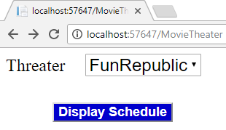

# PRACTICAL NO.22

**Q) Design ASP.NET application for Interacting (Creating and Reading) with XML documents.**

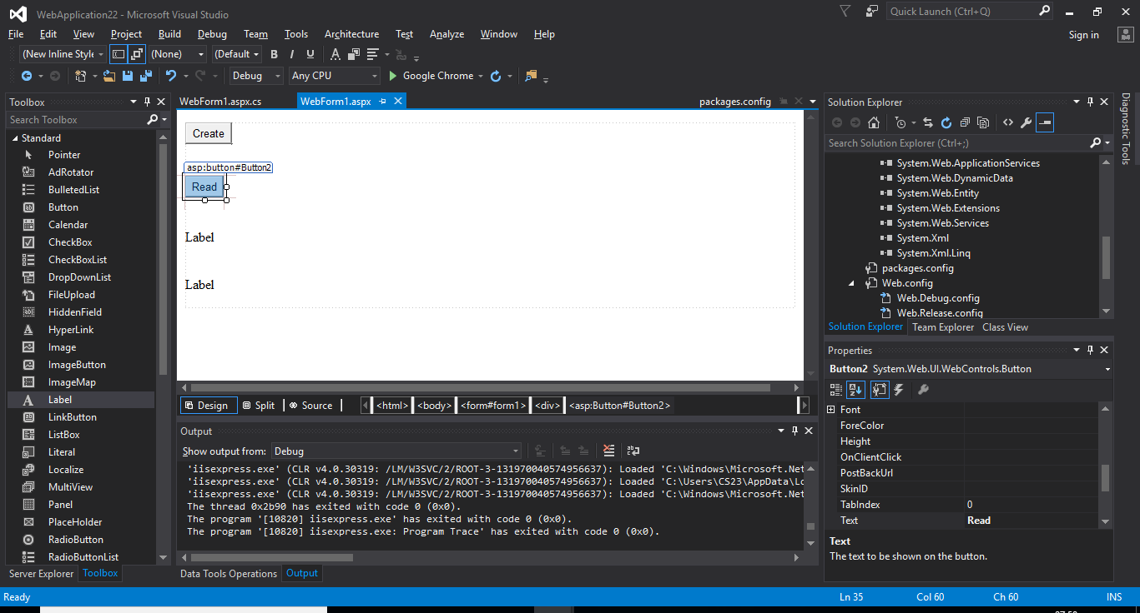

**WebForm.aspx:**

**<%@ Page Language="C#" AutoEventWireup="true" CodeBehind="WebForm1.aspx.cs" Inherits="WebApplication22.WebForm1" %>**

**<!DOCTYPE html>**

**<html xmlns="http://www.w3.org/1999/xhtml">**

**<head runat="server">**

**<title></title>**

**</head>**

**<body>**

**<form id="form1" runat="server">**

**<asp:Button ID="Button1" runat="server" OnClick="Button1_Click" Text="Create" />**

**<br />**

**<br />**

**<div>**

**<asp:Button ID="Button2" runat="server" OnClick="Button2_Click" Text="Read" />**

**<br />**

**<br />**

**<br />**

**<asp:Label ID="Label1" runat="server" Text="Label"></asp:Label>**

**<br />**

**<br />**

**<br />**

**<asp:Label ID="Label2" runat="server" Text="Label"></asp:Label>**

**<br />**

**</div>**

**</form>**

**</body>**

**</html>**

**WebForm.aspx.cs:**

**using System;**

**using System.Collections.Generic;**

**using System.Linq;**

**using System.Web;**

**using System.Web.UI;**

**using System.Web.UI.WebControls;**

**using System.Xml;**

**namespace WebApplication22**

**{**

**public partial class WebForm1 : System.Web.UI.Page**

**{**

**protected void Page_Load(object sender, EventArgs e)**

**{**

**}**

**protected void Button1_Click(object sender, EventArgs e)**

**{**

**String st="<Students>"+**

**"<rollno>01 </rollno>"+**

**"<name>SYCS</name>" +**

**"</Students>";**

**XmlDocument doc = new XmlDocument();**

**doc.LoadXml(st);**

**doc.Save(Server.MapPath("StudentsXmlDoc.xml"));**

**Label1.Text = "XML DOC Created";**

**}**

**protected void Button2_Click(object sender, EventArgs e)**

**{**

**XmlDocument doc = new XmlDocument();**

**doc.Load(Server.MapPath("StudentsXmlDoc.xml"));**

**XmlNode rn = doc.SelectSingleNode("Students/rollno");**

**XmlNode nm = doc.SelectSingleNode("Students/name");**

**Label1.Text = rn.InnerText;**

**Label2.Text = nm.InnerText;**

**}**

**}**

**}**

**OUTPUT:-**

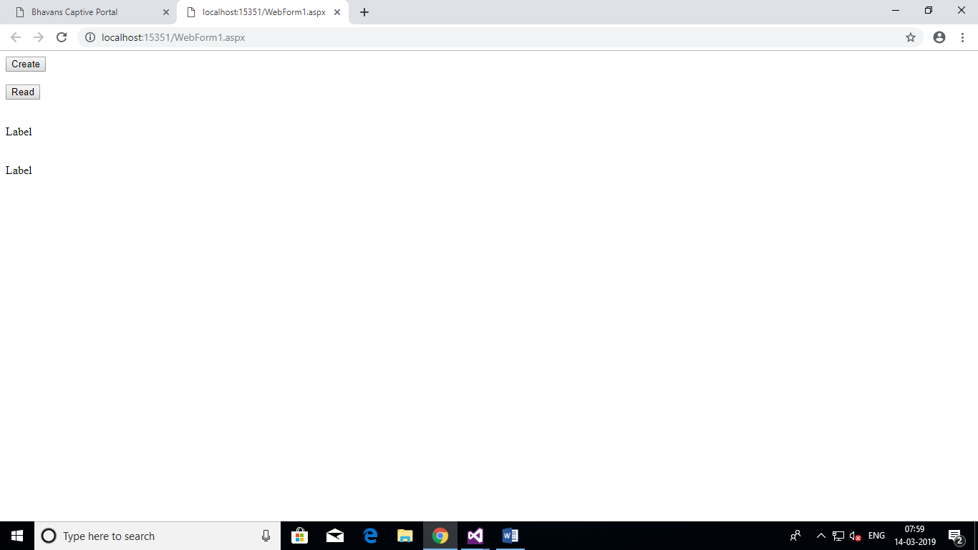

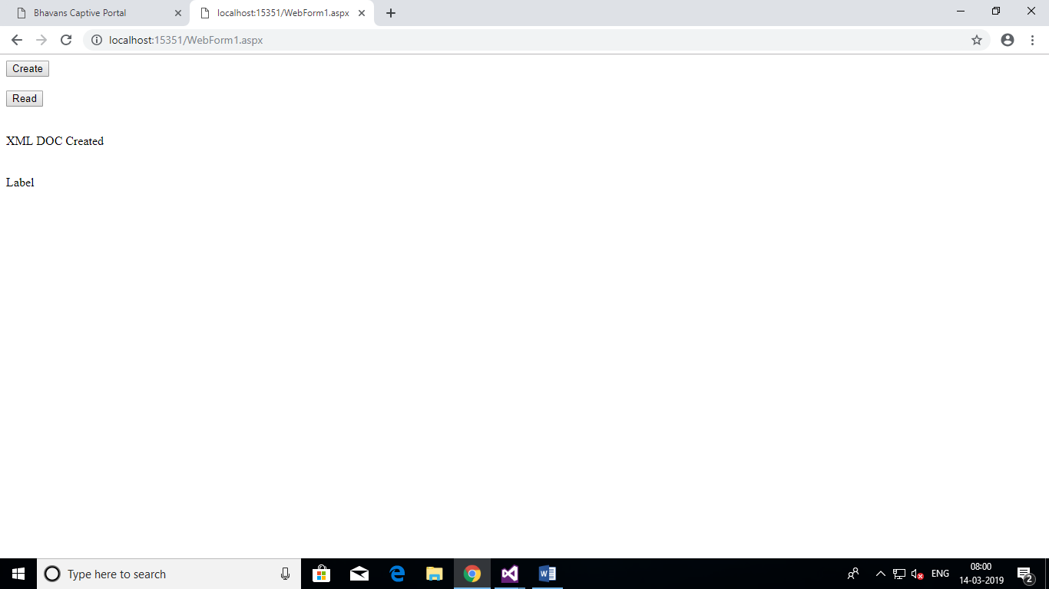

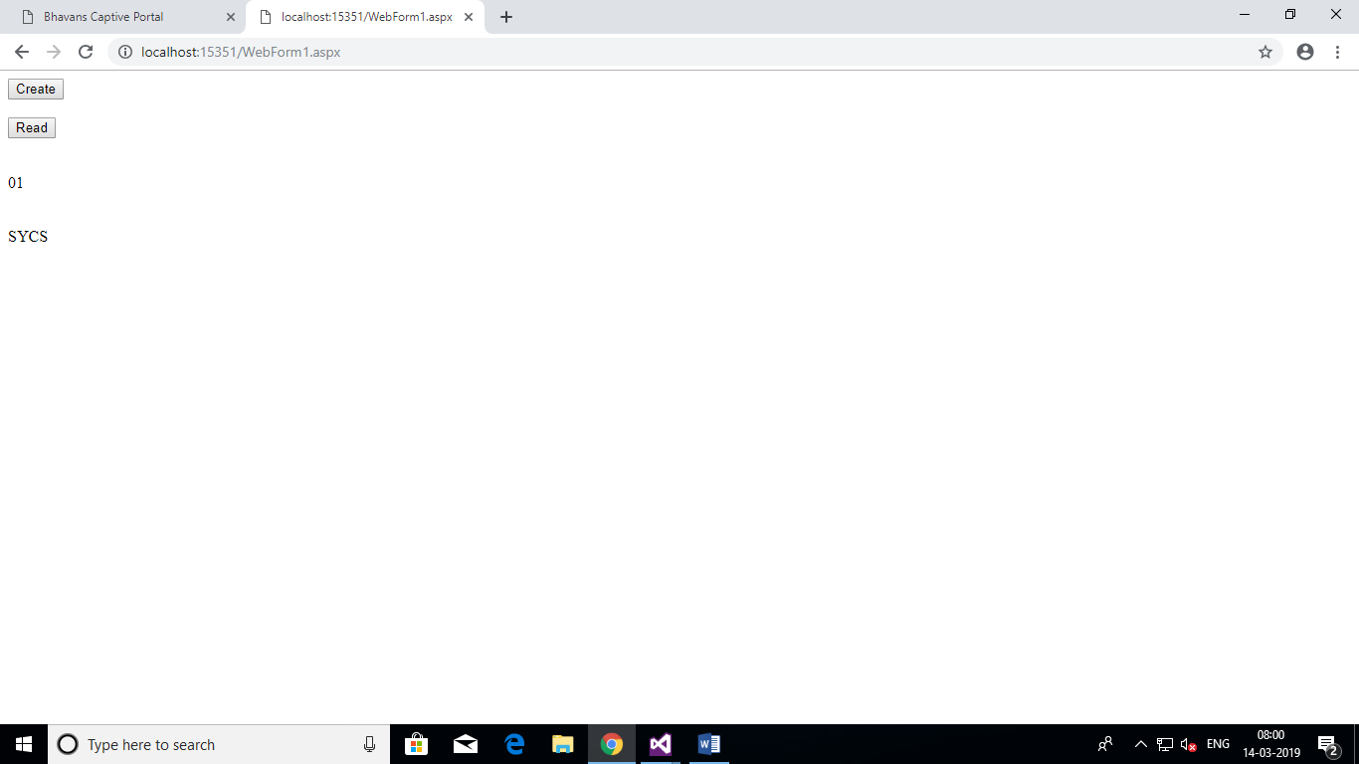

# PRACTICAL NO: 23

**Q) A Cable TV provider stores the list of channels in an XML File. For each Channel, there is an attribute “Name”. The Channel element consists of sub-elements such as Language(such as Hindi, English, Marathi etc), Category(Sports, Movies, Cartoon etc). Design an ASP.NET page that displays, the list of languages and categories in 2 combo boxes. When user clicks on a button, all the channels matching the selected criteria should be displayed**

XMLFile1.xml:

<?xml version="1.0" encoding="utf-8" ?>

<cableTv>

<channel name="SabTv">

<language>Hindi</language>

<category>Entertainment</category>

</channel>

<channel name="Hungama">

<language>English</language>

<category>kids</category>

</channel>

<channel name="news18">

<language>Marathi</language>

<category>News</category>

</channel>

<channel name="pogo">

<language>Hindi</language>

<category>kids</category>

</channel>

<channel name="FTV">

<language>English</language>

<category>Fashion</category>

</channel>

</cableTv>

WEBFORM2.aspx.cs

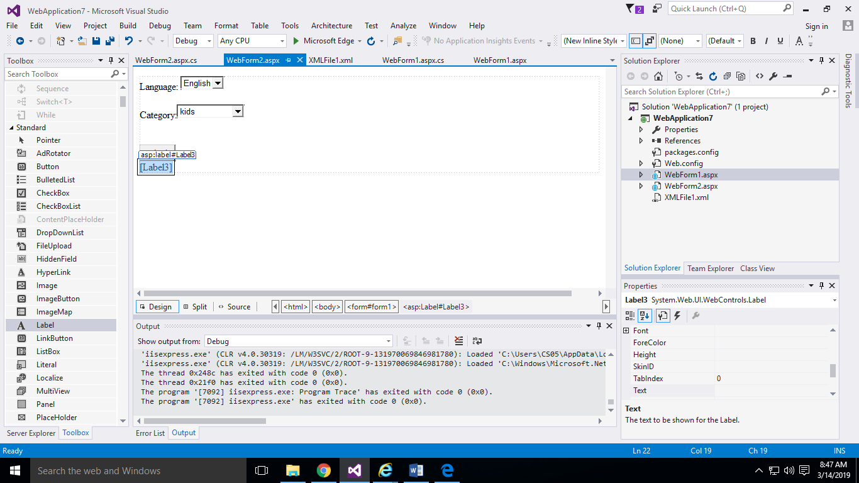

WEBFORM2.aspx.cs

using System;

using System.Collections.Generic;

using System.Linq;

using System.Web;

using System.Web.UI;

using System.Web.UI.WebControls;

using System.Xml;

namespace WebApplication7

{

public partial class WebForm2 : System.Web.UI.Page

{

protected void Page_Load(object sender, EventArgs e)

{

}

protected void Button1_Click(object sender, EventArgs e)

{

XmlDocument doc = new XmlDocument();

doc.Load("c:/users/cs05/documents/visual studio 2015/Projects/WebApplication7/WebApplication7/XMLFile1.xml");

Label3.Text = "";

foreach(XmlElement el in doc.DocumentElement.ChildNodes)

{

string ch;

ch = el.GetAttribute("name");

if(el.ChildNodes[0].InnerText==DropDownList1.Text &&

el.ChildNodes[1].InnerText==DropDownList2.Text)

{

Label3.Text +=ch;

}

}

}

}

}

**OUTPUT:**

